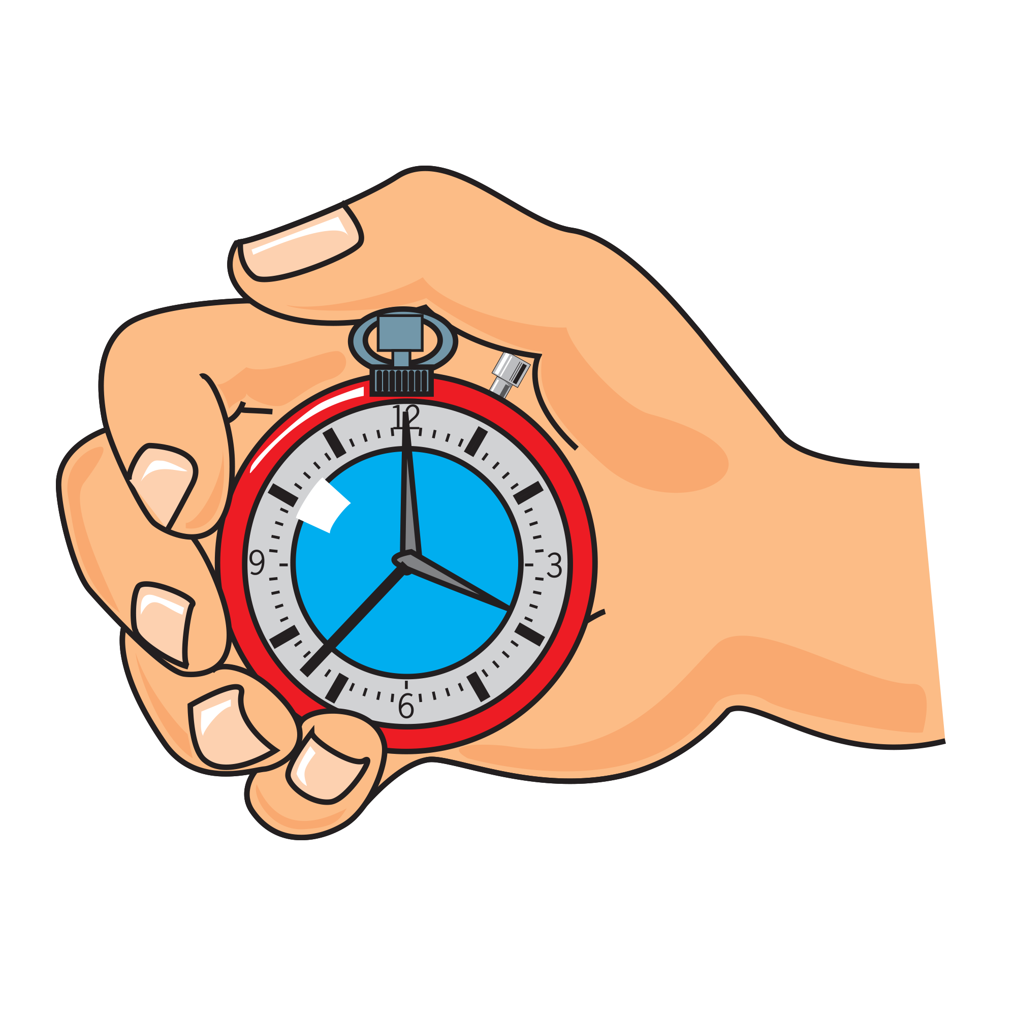
Getting active!
Fill in the activity diary for a week.

Day / Activity | Start time | Finish time
Monday

Tuesday

Wednesday

Thursday

Friday

Saturday

Sunday



