Helping in the kitchen
What do you do to help in the kitchen?
Tick the images each time you do a task.

I helped put away the shopping.

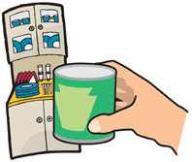

I helped wash-up.

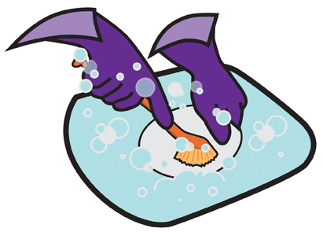

I helped clean the kitchen.

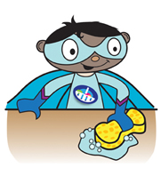

I helped recycle food packaging.

