
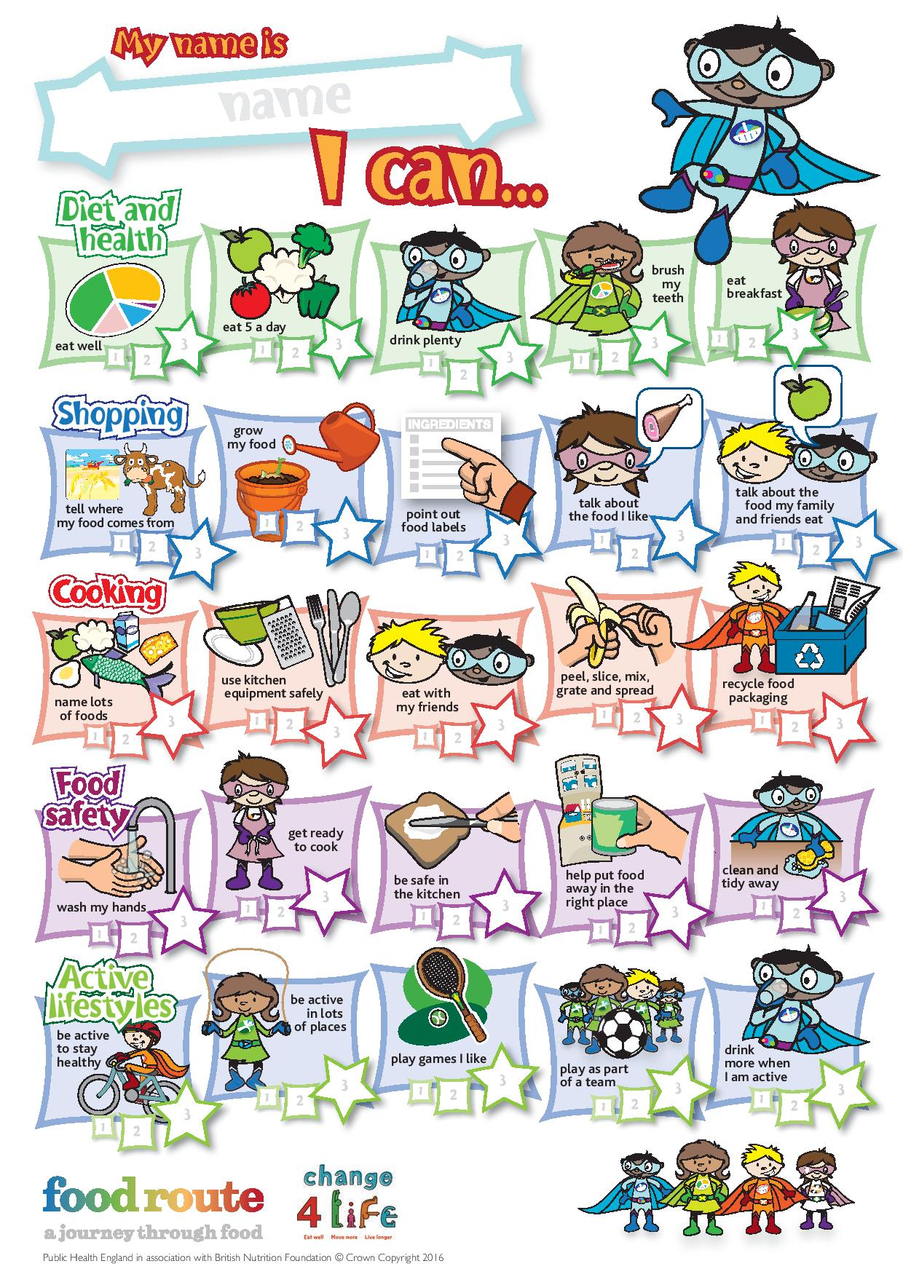

Users’ guide 5-7


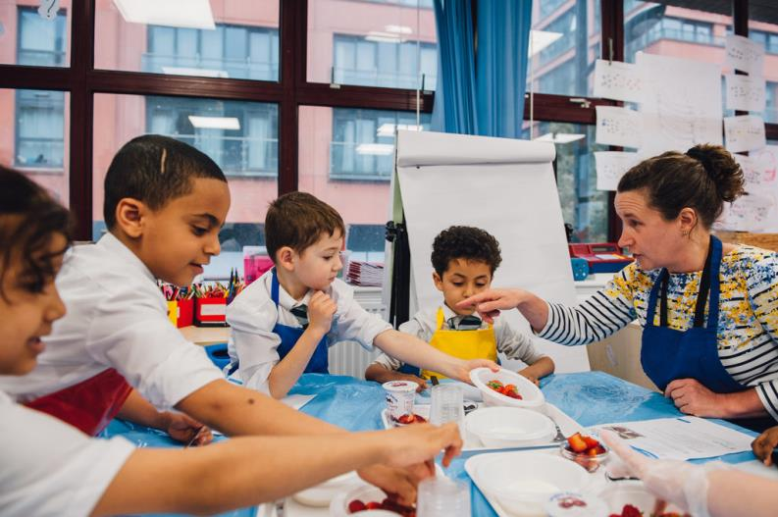

Welcome

This guide is for teachers and parents/carers who wish to use the Food route: a journey through food resources at school or at home. The resources, developed by Public Health England and British Nutrition Foundation, have been devised to help children engage with the Core Competences.

Background: Core Competences
The Core Competences were originally launched in December 2007 by the Food Standards Agency and the British Nutrition Foundation,, and have since been reviewed and updated in 2014 by Public Health England, FSA Northern Ireland, FSA Scotland, the Welsh Government and the British Nutrition Foundation. An additional review was carried out in 2016 following the launch of the new UK Healthy Eating Model – the Eatwell Guide. They comprise a progressive series of food, nutrition and activity related competence statements for children and young people aged 5 to 16+ years. The competences are based around five themes: diet and health, consumer awareness (shopping), cooking, food safety and physical activity.

The Core Competences can help young people to choose, cook and eat safe, healthy food and lead an active lifestyle. They are set out as a framework of core skills and knowledge, providing essential building blocks so that parents/carers, schools and community-based organisations can provide young people with a consistent set of food skills and knowledge.

Because the competences are progressive and cumulative from one age stage to the next, they can help young people make healthier choices that benefit them now and in later life. Importantly, the competences apply to all learning experiences, both within and outside the school setting, and can be met at home or through other activities. For further information, go to: www.nutrition.org.uk/foodinschools/competences.

Food route – a journey through food
To help children and young people engage with the Core Competences, a series of focus groups and workshops were arranged throughout the UK. The original competences were rephrased in an age appropriate way, and tested to ensure that children understand what they mean and how they can be achieved. The focus group session informed the language and design of the resources.

What resources are available?
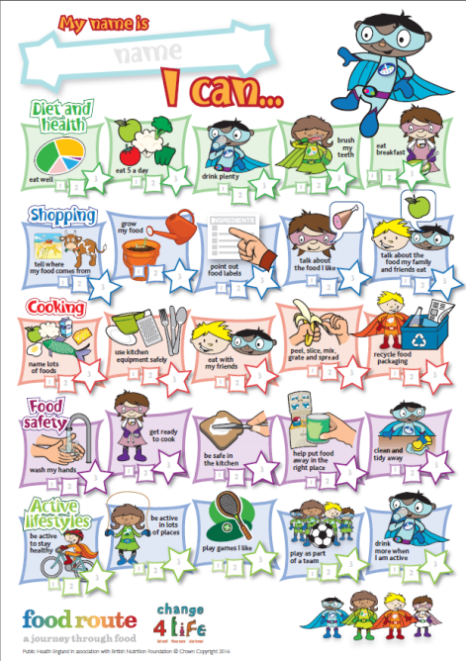
To support children aged 5 to 7 years, the following resources are available:

Complete chart
This chart provides all the competences for the five areas. The chart is similar to a target chart, often used in schools for literacy and numeracy.

Individual charts
Five charts are provided, one for each competence area.
The charts are:
- Diet and health;
- Shopping;
- Cooking;
- Food safety;
- Active lifestyles.

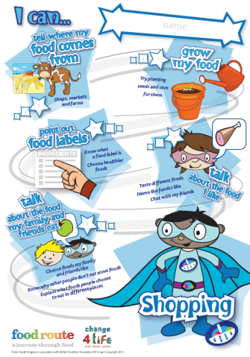
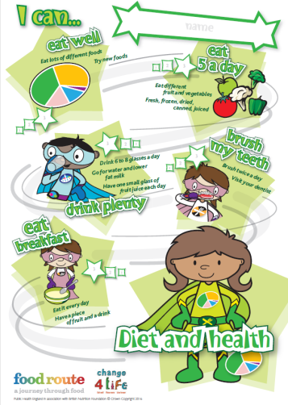
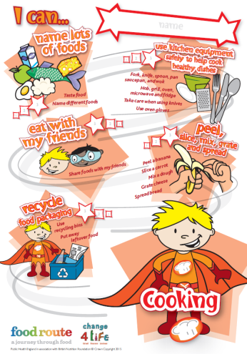
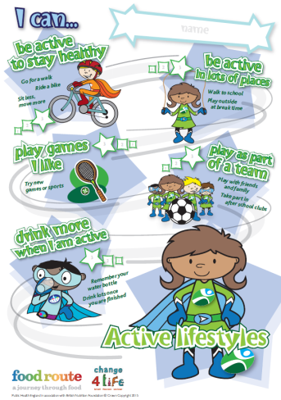
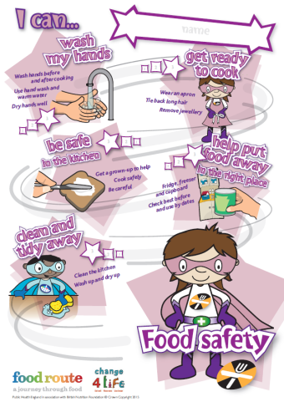
Worksheets
Worksheets are provided to help support children to achieve a number of the competences. These could be used at school or at home.

- My taste chart – tasting new foods;
- Different ways to get 5 A DAY – naming different ways to get 5 A DAY;
- Drink plenty – recording the drinks they have in a day;
- My breakfast diary – recording when they have breakfast and what they eat and drink;
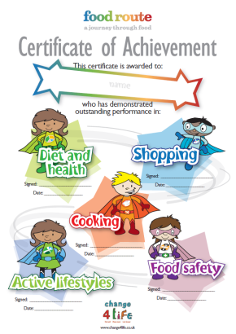
- Where does my food come from? – investigating where food comes from;
- My kitchen equipment – naming pieces of kitchen equipment;
- Let’s get ready to cook! – getting ready to cook;
- My apron – designing an apron (cooking);
- Helping in the kitchen – recording how they help in the kitchen;
- Getting active! – keeping an activity diary for a week;
- My activity chart – recording and rating different activities they try.

Certificate
A bright, colourful certificate is provided for this age phase. The certificate can be awarded after the child has completed all the competences, or when they have successfully completed each competence area, e.g. cooking.

How to achieve
This guide lists the competence statements that appear on the target charts and provides suggestions on how to:
- help children reach the competences;
- measure if the competences have been achieved.

Diet and Health
I can eat well.  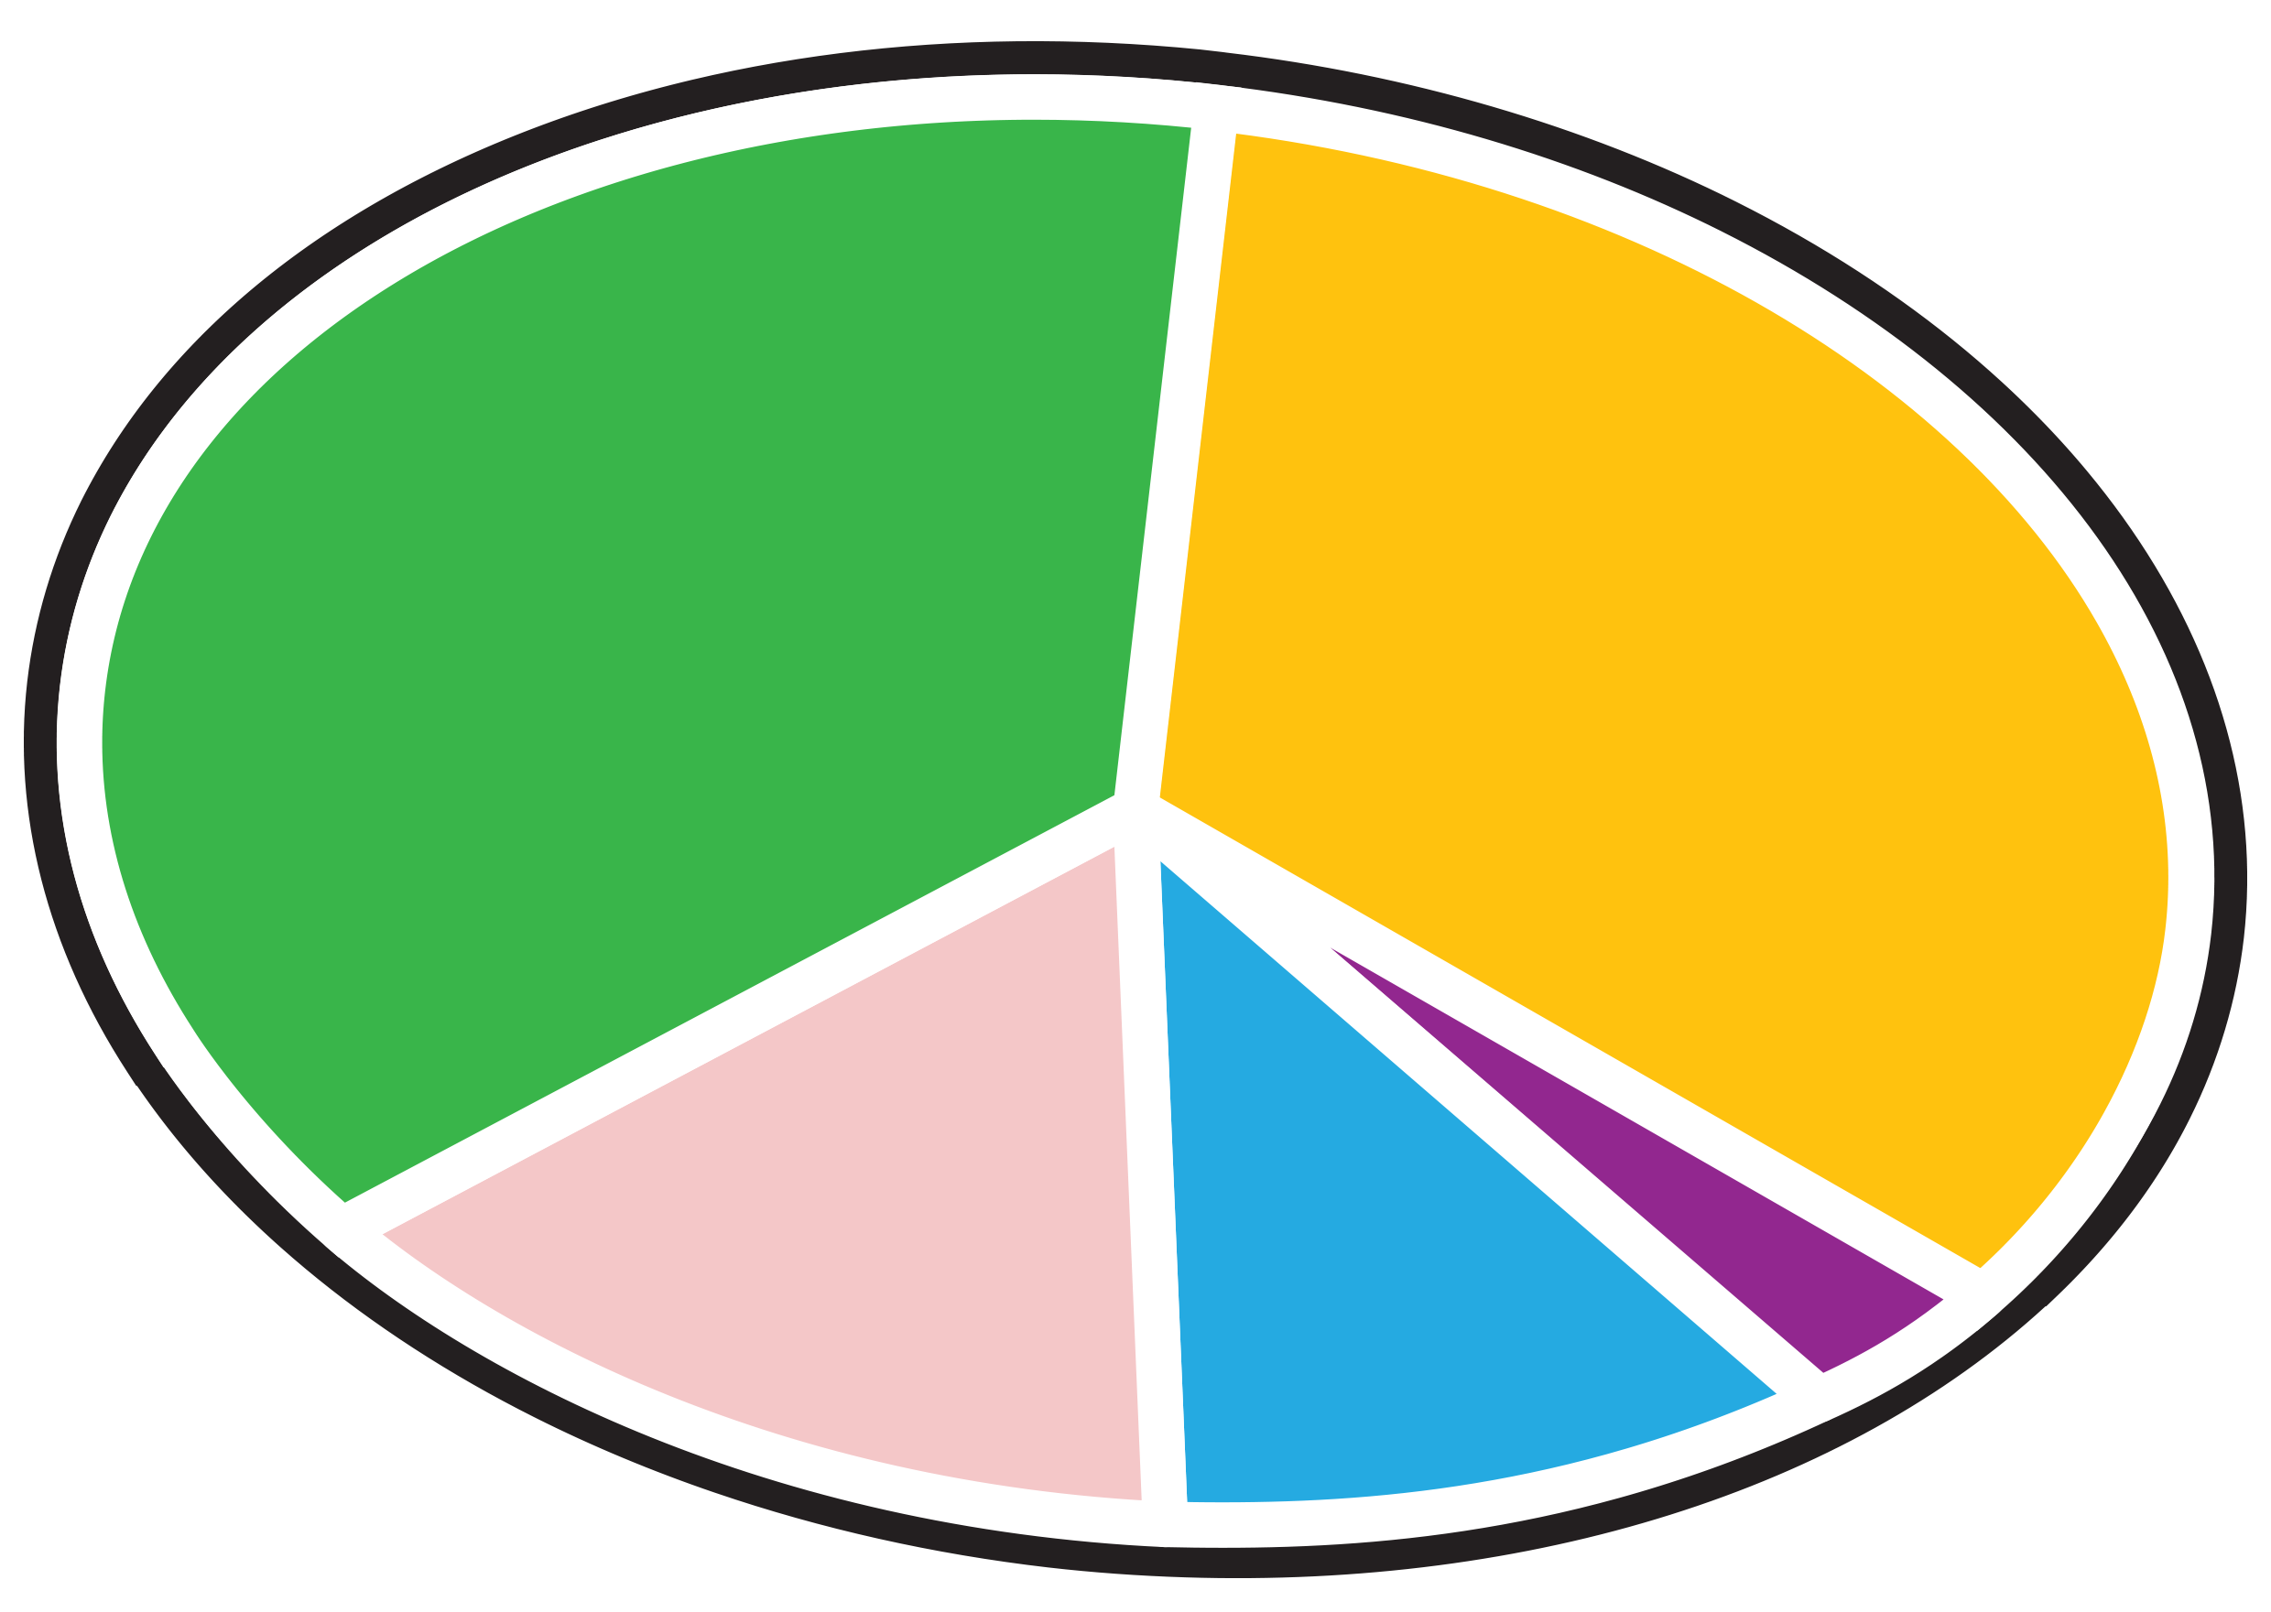 | To help children achieve this competence:  - introduce the eatwell guide and the balance of the 5 food groups, emphasising the importance of eating a balanced diet to grow, be active and maintain health;  - talk about the different food groups when you go shopping;  - prepare some foods which are new to your children for sampling and fill in a tasting chart (My taste chart worksheet).  To measure if the competence has been achieved, children should be able to:  - eat a balance of foods, in line with the eatwell guide;  - name lots of different foods and suggest how they fit with the eatwell guide;  - taste new foods.
I can eat 5-a-day.  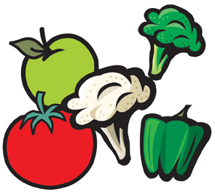 | To help children achieve this competence:  - explain what foods are considered part of your 5 a day, e.g. fresh, frozen, dried, canned, juiced (150ml unsweetened 100% fruit juice or smoothie once per day) (Different ways to get 5 A DAY worksheet);  - talk about the importance of eating at least 5 portions of fruit and vegetables a day;  - suggest different ways to encourage children to include 5 portions, e.g. one with breakfast, one for lunch, one for a snack and two for dinner;  - assist in preparing dishes and drinks with different fruit and vegetables;  - let them try different kinds of fruit and vegetables;  - talk about the size of one portion.  To measure if the competence has been achieved, children should be able to:  - eat a range of fruit and vegetables;  - eat 5 A DAY;  - name a number of fruit and vegetables;  - talk about how to achieve 5 A DAY;  - know how to increase fruit and vegetable intake at different meal times.
I can drink plenty.  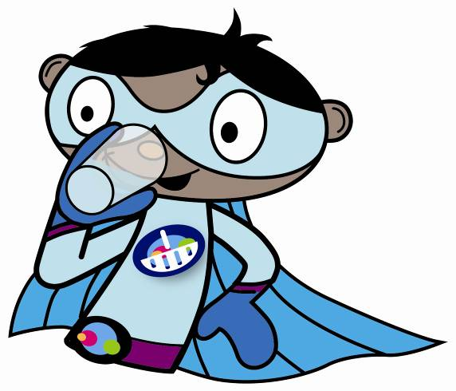 | To help children achieve this competence:  - provide healthy drinks, e.g. water, lower fat milks and 150ml unsweetened 100% fruit juice per day, instead of carbonated and sweetened ones;  - ask them to monitor how much fluids they drink (Drink plenty worksheet)and see if they meet the recommended 6-8 glasses per day;  - talk about the importance of keeping well hydrated and to avoid drinking too many carbonated drinks, especially in between meals.  To measure if the competence has been achieved, children should be able to:  - drink 6 to 8 glasses a day;  - name and choose healthier drinks.
I can brush my teeth.  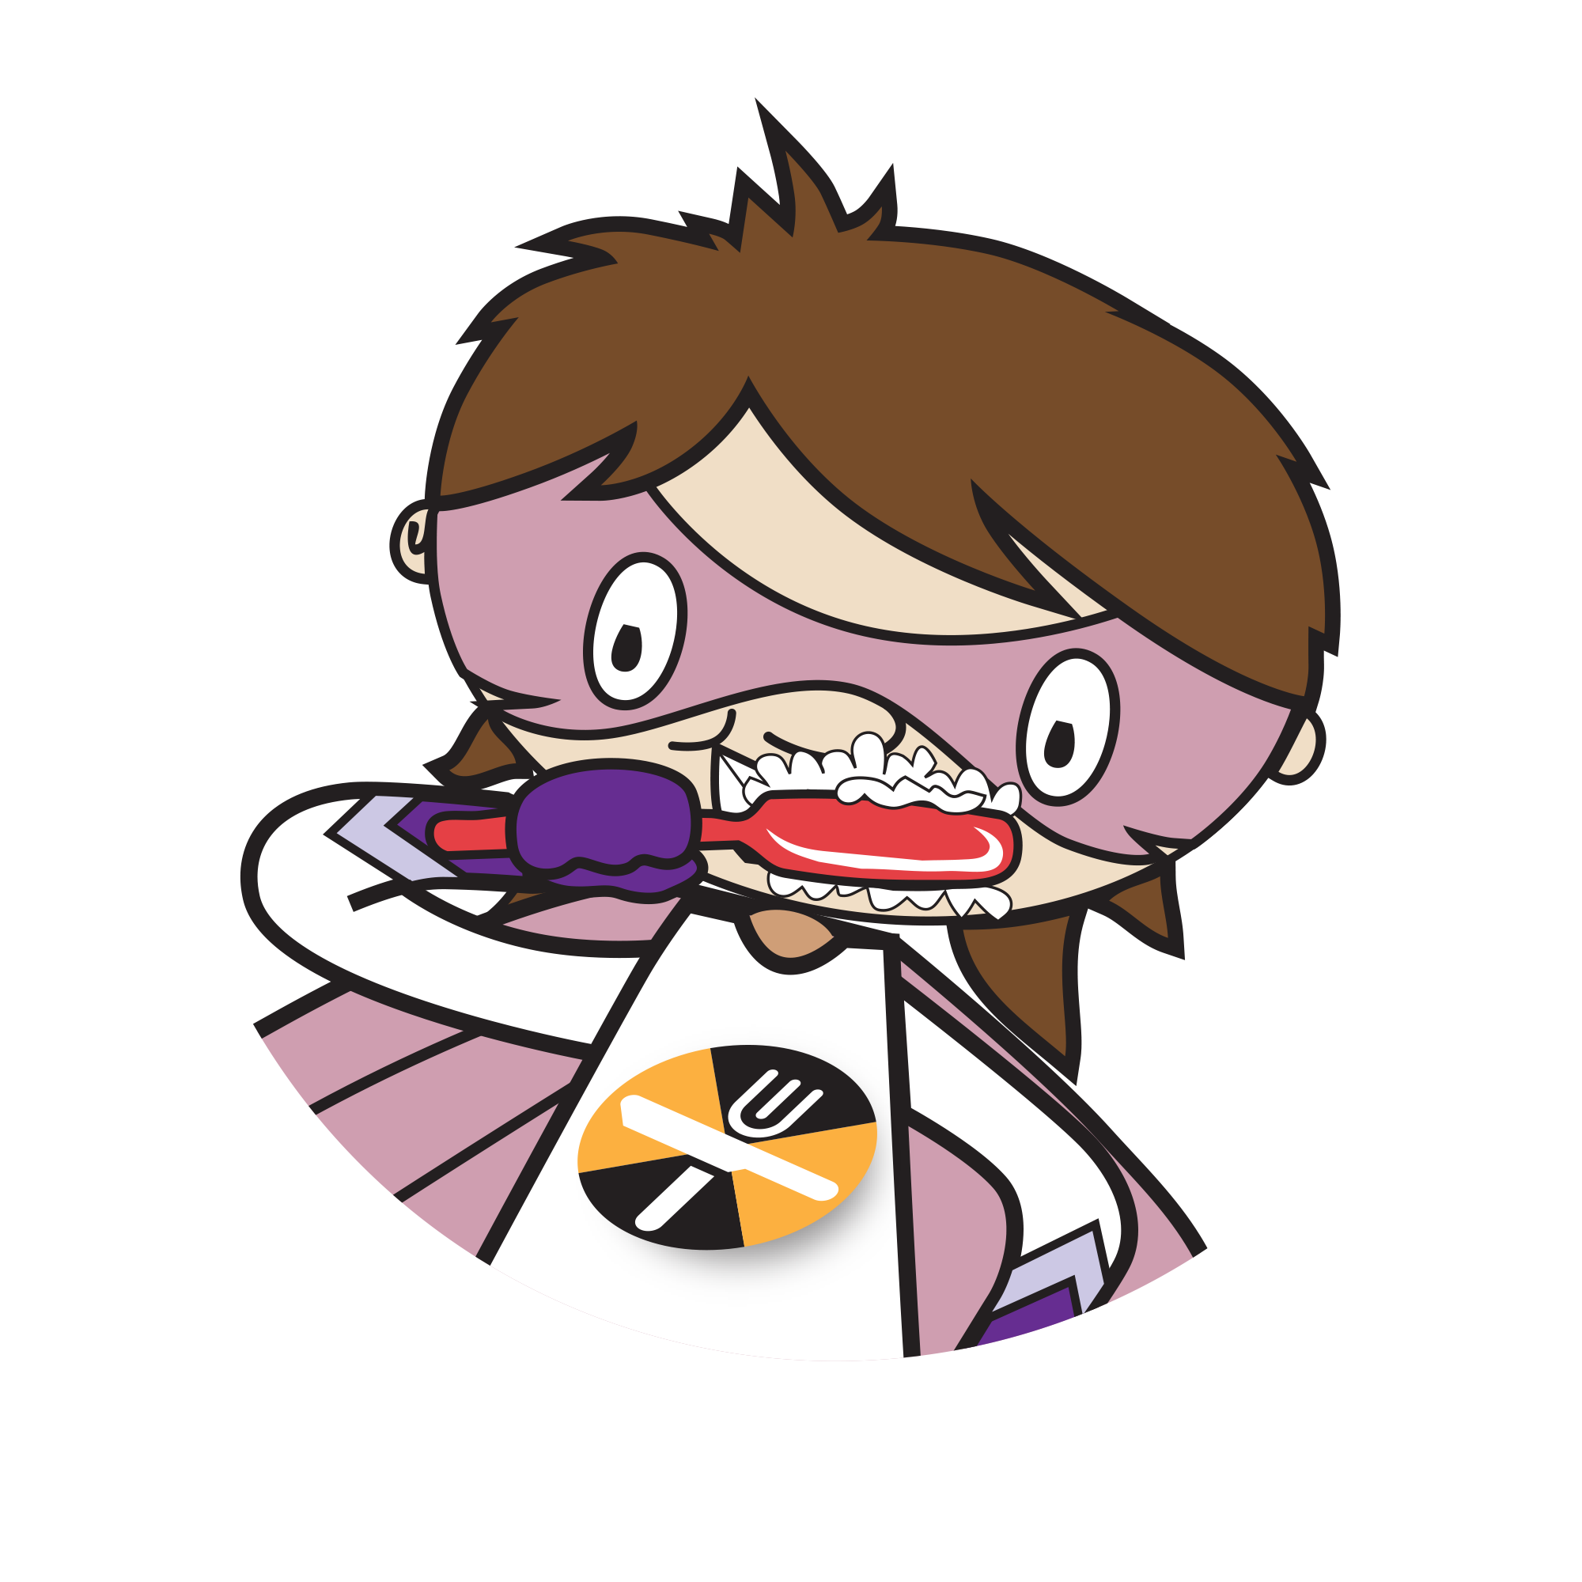 | To help children achieve this competence:  - show them how to brush their teeth correctly;  - emphasise the importance of oral health;  - ensure they are taken for a dental check-up every 6 months.  To measure if the competence has been achieved, children should be able to:  - brush their teeth twice a day, each time for two minutes;  - use a fluoride toothpaste;  - visit the dentist regularly.
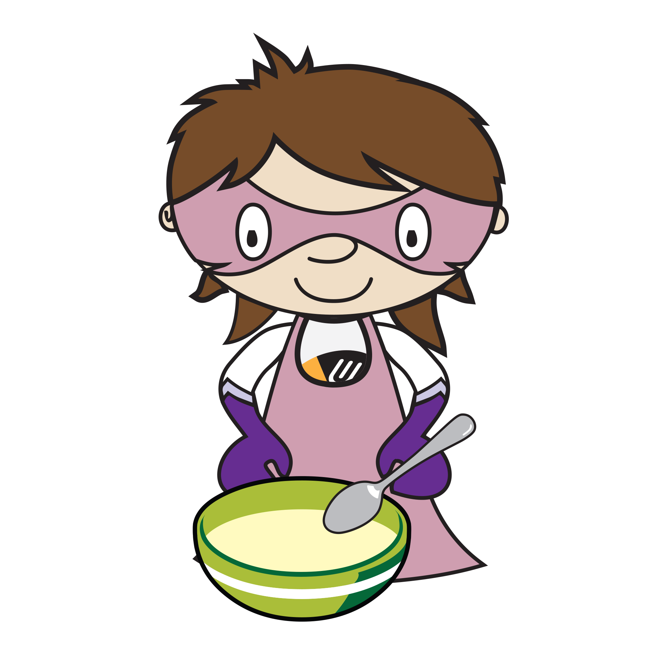  I can eat breakfast. | To help children achieve this competence:  - use a diary to record what they had for breakfast each day (Breakfast diary worksheet);  - compare breakfast choices to healthy eating messages, e.g. wholegrain varieties, fruit, and a drink;  - consider running a breakfast club;  - organise a healthy breakfast challenge.  To measure if the competence has been achieved, children should be able to:  - design a healthy breakfast;  - eat a healthy breakfast every day.

Shopping
I can tell where my food comes from.  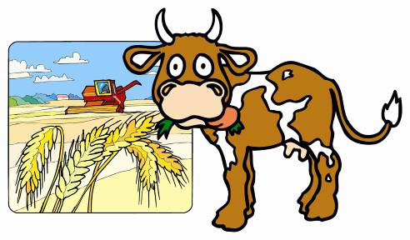 | To help children achieve this competence:  - talk about the different sources of food, i.e. plants and animals (Where does my food come from? worksheet);  - visit different places where food is from, e.g. farms, food factories;  - visit supermarkets, markets and corner stores.  To measure if the competence has been achieved, children should be able to:  - tell whether a food comes from plant or animal sources;  - talk about where their food comes from;  - name places where food is prepared or bought.
I can grow my food.  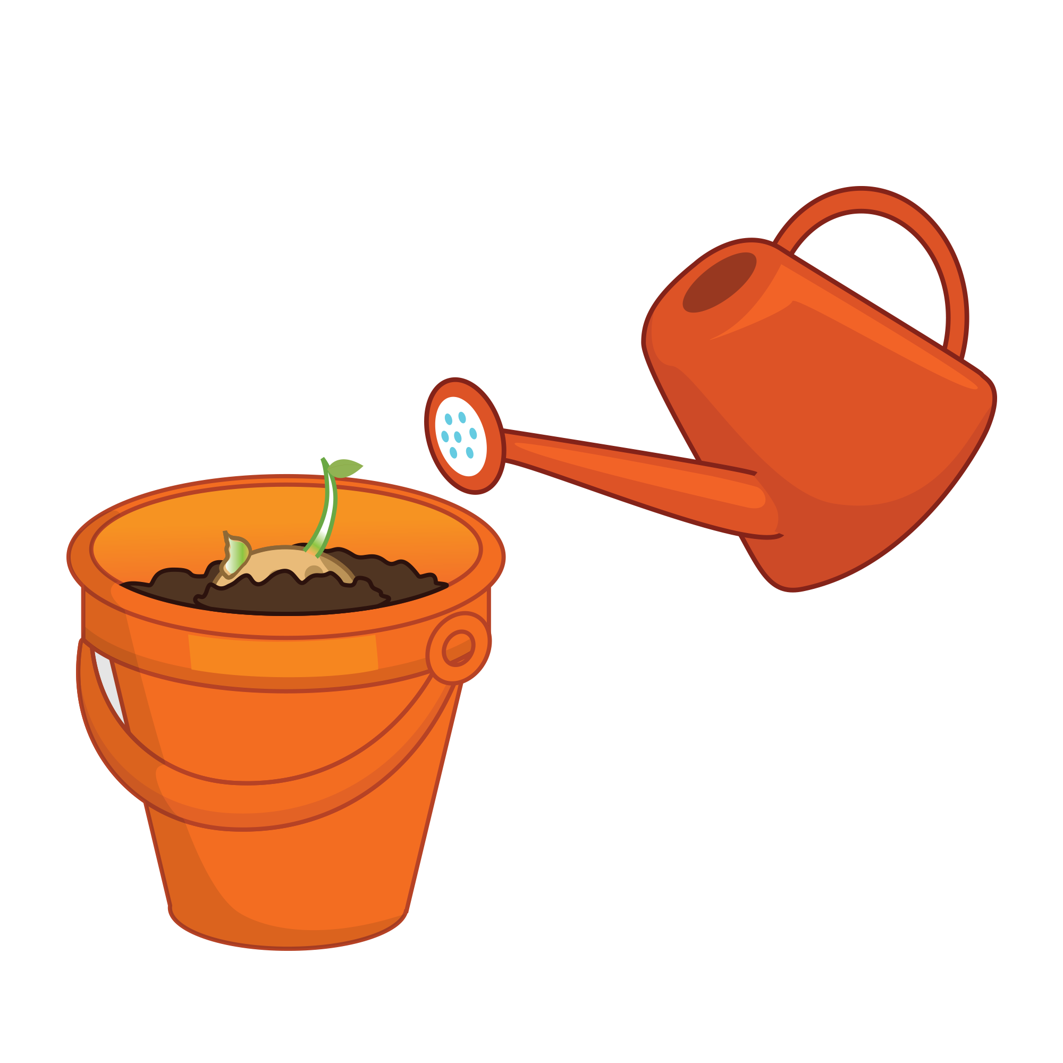 | To help children achieve this competence:  - start a gardening corner in school or at home to understand how food is grown;  - compare home grown foods to purchased items.  To measure if the competence has been achieved, children should be able to:  - grow a food plant, e.g. cress, potatoes, herbs, strawberries, tomatoes.
I can point out food labels.  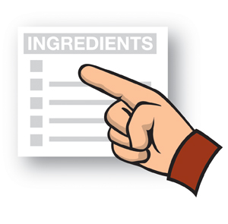 | To help children achieve this competence:  - show different food labels;  - talk about the information on food labels and explain that they are there to help consumers to know more about the food;  - ask them to collect some food labels and talk about what they see – discuss the concept of front of pack colour coding and what it shows.  To measure if the competence has been achieved, children should be able to:  - identify a food label;  - point out the main information on a food label;  - understand what the food label shows.
I can talk about the food I like.  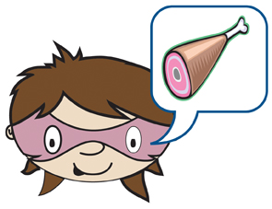 | To help children achieve this competence:  - introduce foods from around the world;  - encourage them to try different foods from each section of the eatwell guide and talk about their sensory qualities, e.g. smell, appearance, taste, texture;  - talk about the foods they like (My taste chart worksheet).  To measure if the competence has been achieved, children should be able to:  - name the foods they like;  - talk about the foods they like;  - taste different foods;  - chat with their friends about food and where they fit with the eatwell guide.
I can talk about the food my family and friends eat.  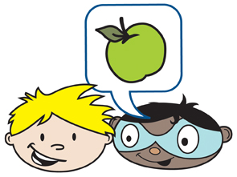 | To help children achieve this competence:  - ask them to help plan a meal or party for the family;  - talk about the foods the family or friends eat and/ or like – consider preferences, season, time of day, allergy/intolerance, religion and occasions (including celebrations). Also consider setting and how this may affect food choice – home, school, eating out.  To measure if the competence has been achieved, children should be able to:  - talk about the foods their family or friends eat and why;  - choose food for their family and friends.

Cooking
I can name lots of foods.  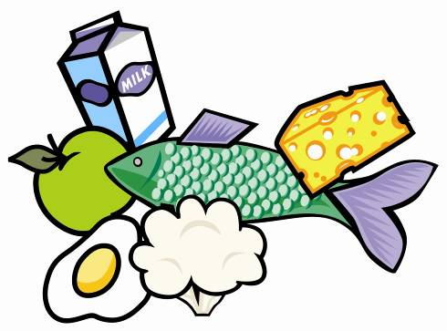 | To help children achieve this competence:  - ask them to cut out food images from newspapers or magazines, label these foods and point out which are their favourites and why;  - play a food questioning game, using foods from the store cupboard or flash cards;  - visit a supermarket and ask them to name some of the foods available.  To measure if the competence has been achieved, children should be able to:  - recognise and name different types of foods;  - explain why they like the food.
I can use kitchen equipment safely.  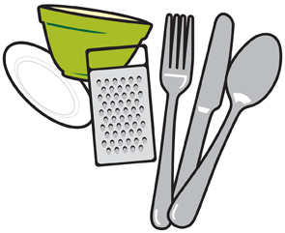 | To help children achieve this competence:  - display and ask them to name pieces of kitchen equipment (My kitchen equipment worksheet);  - cook together, demonstrating how to use kitchen equipment safely;  - show when to use different equipment when preparing or eating different foods;  - ask them to help with planning, preparing and cooking healthy meals;  - talk about how to be safe in the kitchen.  To measure if the competence has been achieved, children should be able to:  - name and use a fork, knife, spoon, pan, saucepan;  - use basic pieces of kitchen equipment safely;  - know when to use different pieces of equipment;  - help to plan and cook healthy dishes safely with an adult;  - be clean and tidy.
I can eat with my friends.  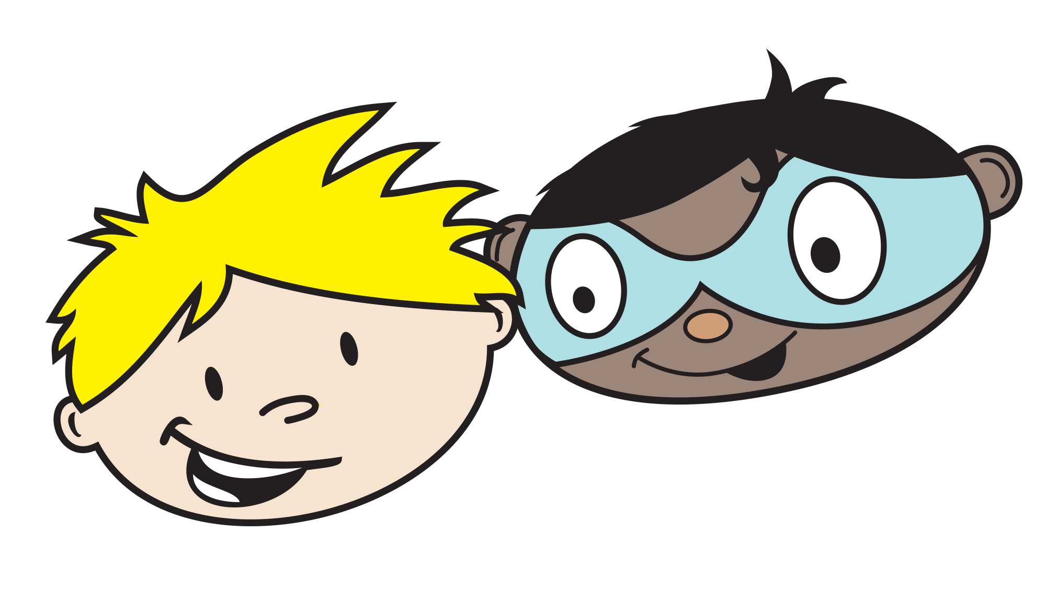 | To help children achieve this competence:  - encourage children to eat together;  To measure if the competence has been achieved, children should be able to:  - share food with one another.
I can peel, slice, mix, grate and spread.  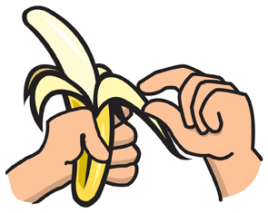 | To help children achieve this competence:  - ask what they think about these actions;  - ask them to help prepare meals, e.g. peeling a potato, slicing an onion, mixing a dough, grating cheese and spreading bread.  To measure if the competence has been achieved, children should be able to:  - peel, e.g. a banana;  - slice, e.g. a soft fruit;  - mix, e.g. a muffin mix;  - grate, e.g. cheese;  - spread, e.g. a topping on toast.
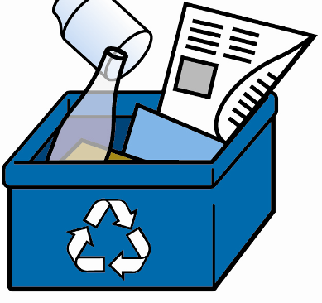  I can recycle food packaging. | To help children achieve this competence:  - talk about the importance of reducing, reusing and recycling (the 3R’s) and that different materials are recycled differently;  - take them to visit a recycling plant to understand how materials could be recycled;  - involve them when recycling at home;  - reuse food packaging, e.g. milk bottles as watering cans; cereal paper boxes as photo frames; glass jars for homemade chutney.  To measure if the competence has been achieved, children should be able to:  - name and identify the different packaging materials that can be recycled, e.g. glass, paper, cans;  - use recycling bins for used food and drink packaging.

Food safety
I can wash my hands.  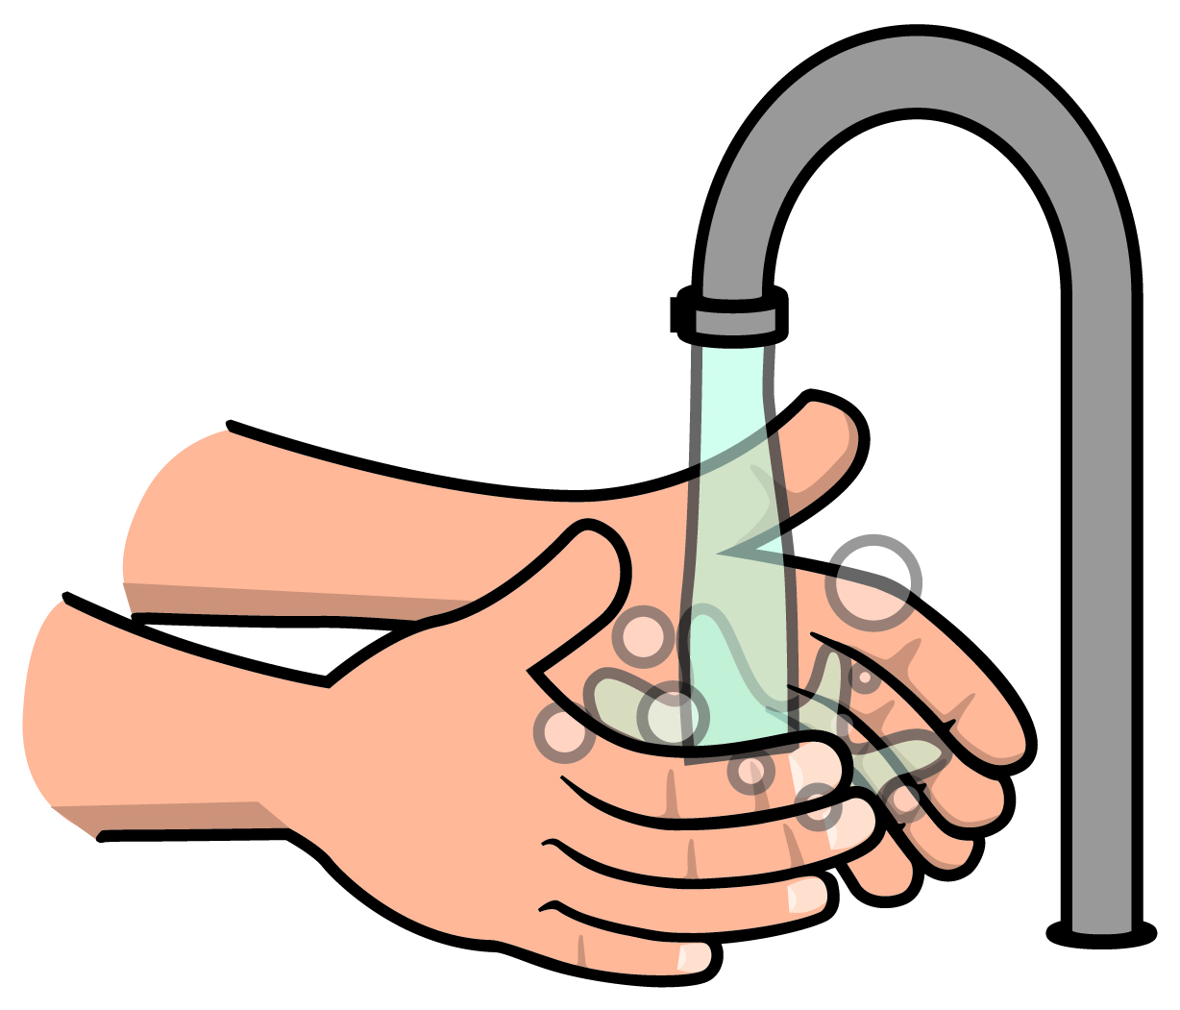 | To help children achieve this competence:  - emphasise the importance of hand-washing before, during and after cooking;  - act as a role model to wash hands properly: using antibacterial hand wash and washing thoroughly under hot running water;  - ask them to design a poster to be put up in the toilet or kitchen as a reminder to wash hands;  To measure if the competence has been achieved, children should be able to:  - wash their hands before and after cooking;  - use antibacterial hand wash and hot water;  - dry hands well.
I can get ready to cook.  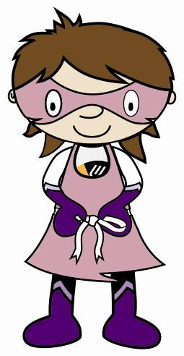 | To help children achieve this competence:  - list what they need to do to get ready to cook (Let’s get ready to cook! worksheet);  - ask them to design their own apron (My apron worksheet).  To measure if the competence has been achieved, children should be able to:  - wear a clean apron;  - tie back long hair;  - remove jewellery and nail varnish;  - roll up long sleeves;  - remove jumper;  - wash their hands;  - get ingredients ready;  - get equipment ready.
I can be safe in the kitchen.  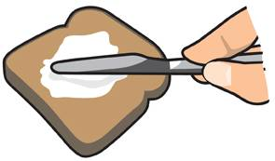 | To help children achieve this competence:  - ask them to talk about the safety precautions they should take when in the kitchen;  - talk about the consequences of being unsafe in the kitchen;  - remind them that they should be accompanied by an adult whenever in the kitchen.  To measure if the competence has been achieved, children should be able to:  - talk about ways to stay safe in the kitchen;  - get an adult to help when in the kitchen;  - be aware of safety in the kitchen;  - be careful when using kitchen equipment.
I can help put food away in the right place.  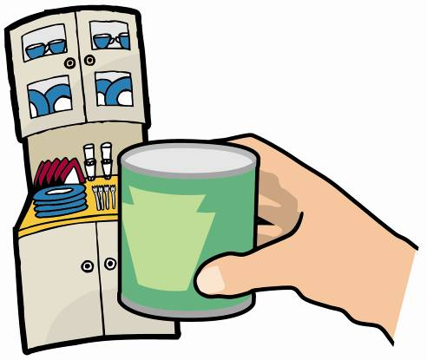 | To help children achieve this competence:  - ask them to put away food shopping, e.g. in cupboards, fridge, freezer;  - demonstrate how to cover and store leftover food;  - teach them how to read storage instructions and date-marks;  - ask them to find a food in the kitchen, e.g. Where is the cheese kept? Where would you find a can of tomatoes?  To measure if the competence has been achieved, children should be able to:  - locate where different types of foods are stored;  - help to put food away in the right place, e.g. fridge, freezer and cupboards;  - store leftover foods safely.
I can clean and tidy away.  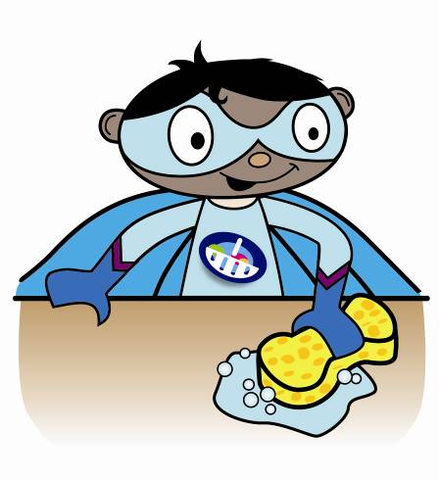 | To help children achieve this competence:  - involve them when tidying up and cleaning after cooking and mealtimes;  - talk about the importance of keeping things clean and tidy;  - use a target chart for them to keep the kitchen tidy (Helping in the kitchen worksheet).  To measure if the competence has been achieved, children should be able to:  - clean and tidy the kitchen with help;  - clear the table after eating;  - help wash up using hot soapy water or the dishwasher (under adult supervision).

Active lifestyles
I can be active to stay healthy.  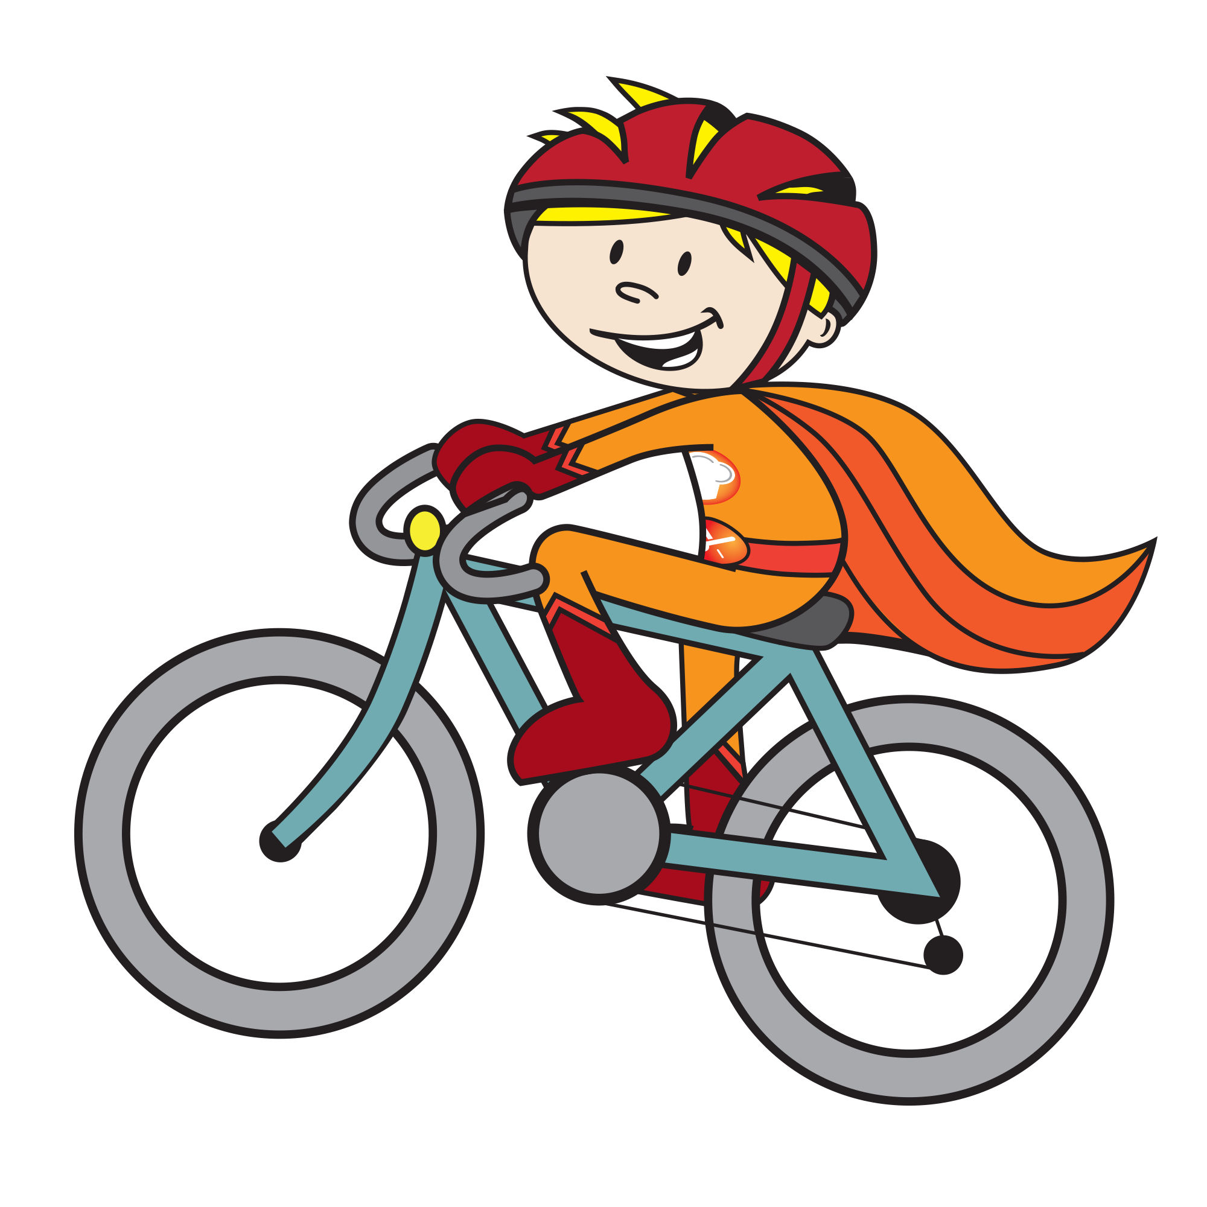 | To help children achieve this competence:  - use an activity diary for them to record what activities they did over the past week (Getting active worksheet);  - explain the importance of being active for a healthy lifestyle;  - encourage children to be active every day.  To measure if the competence has been achieved, children should be able to:  - incorporate physical activity into their daily lives;  - be active for around an hour a day, with activities such as play, walk, swim, dance and bike;  - talk about why we need to be active to stay healthy.
I can be active in lots of places.  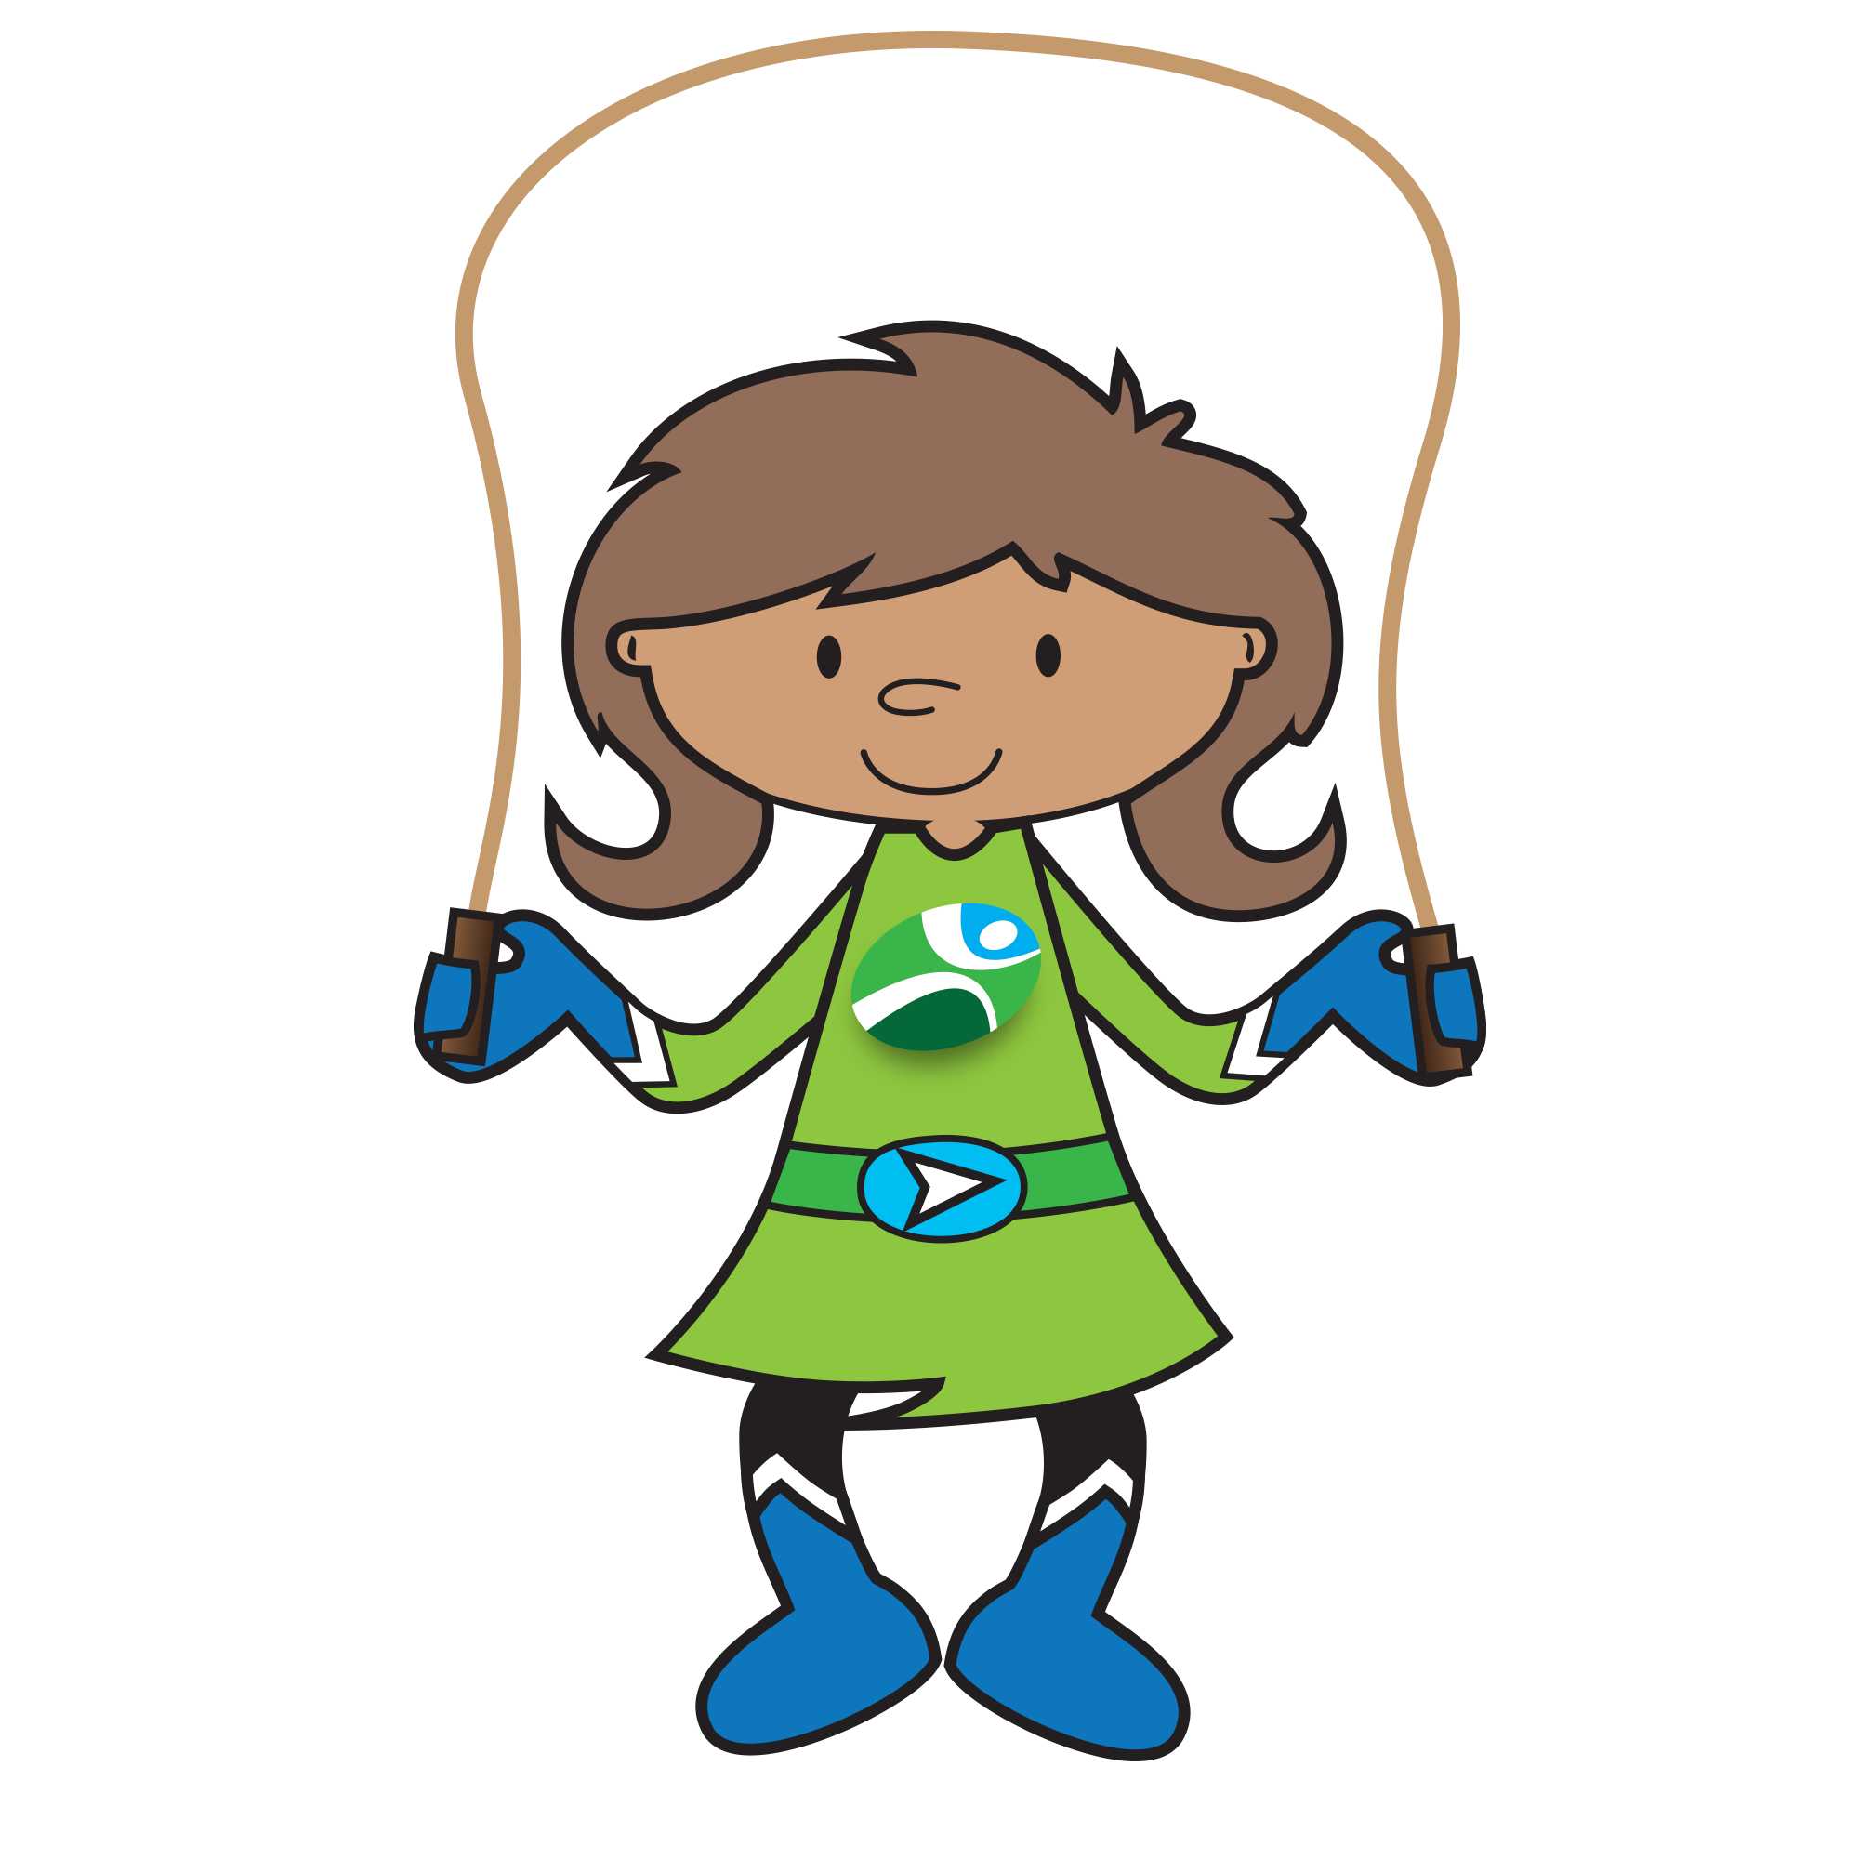 | To help children achieve this competence:  - be active with them in everyday life, e.g. ride a bicycle, have a walk in the park after dinner, play outside at break time, walk to/from school, use stairs wherever possible;  - suggest activities which would enable them to increase their activity levels either during the school day or at home.  To measure if the competence has been achieved, children should be able to:  - be active wherever possible;  - come up with ideas about how to be more active in different places.
I can play games I like.  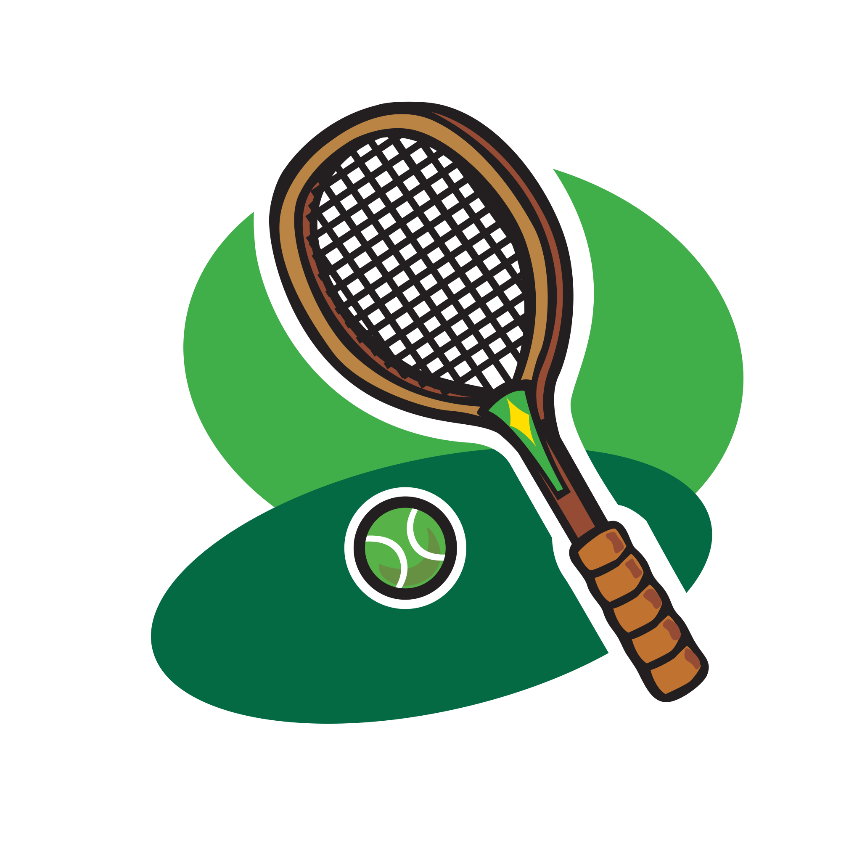 | To help children achieve this competence:  - provide them with a range of different taster activities/circuit of activities (My activity chart worksheet);  - encourage them to discuss what they like and dislike about activities;  - encourage them to participate in the activities they enjoy.  To measure if the competence has been achieved, children should be able to:  - play the games they rated highly/enjoyed;  - talk about why they enjoy some activities more than others.
I can play as part of a team.  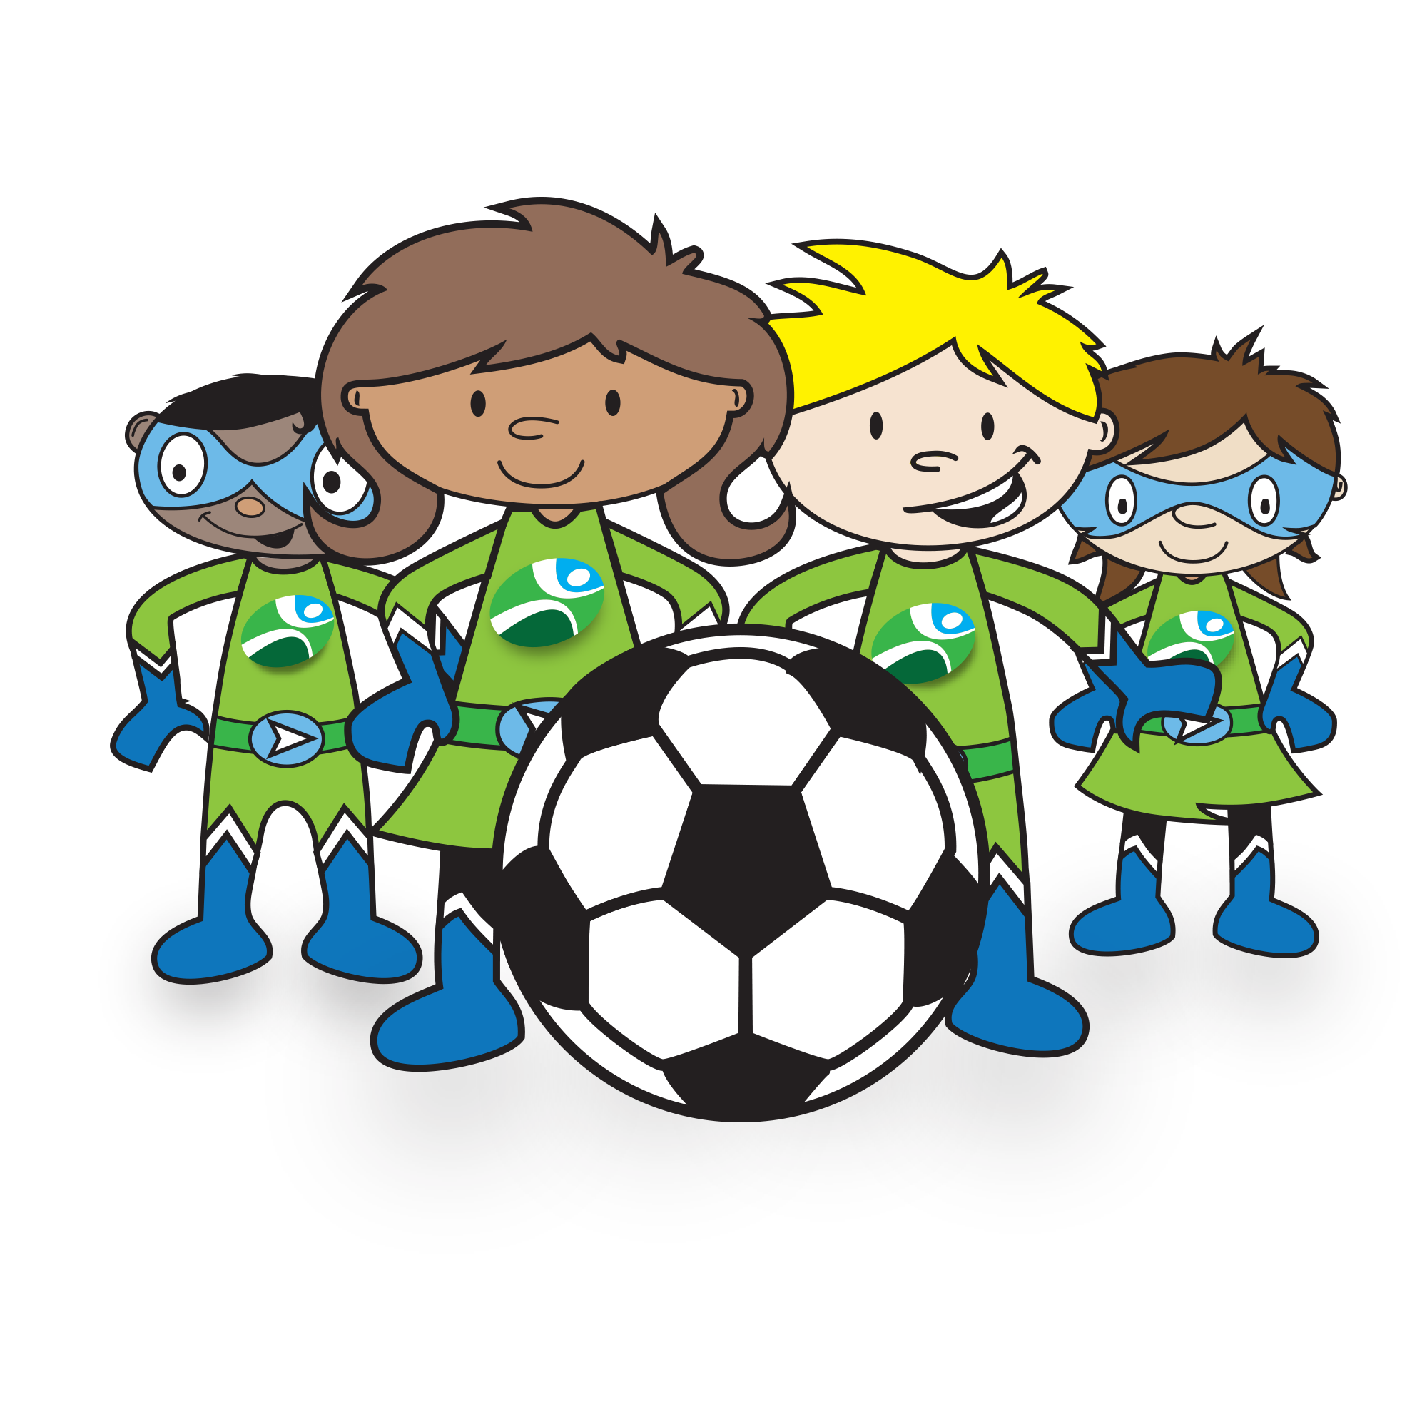 | To help children achieve this competence:  - organise group activities for them to play with or against one another, e.g. organise mini ‘inter-house’ tournaments;  - encourage them to engage in after school sports clubs;  - explain the importance of working as a team to achieve a goal.  To measure if the competence has been achieved, children should be able to:  - take part in organised activities;  - work alongside one another as part of a team.
I can drink more when I am active.  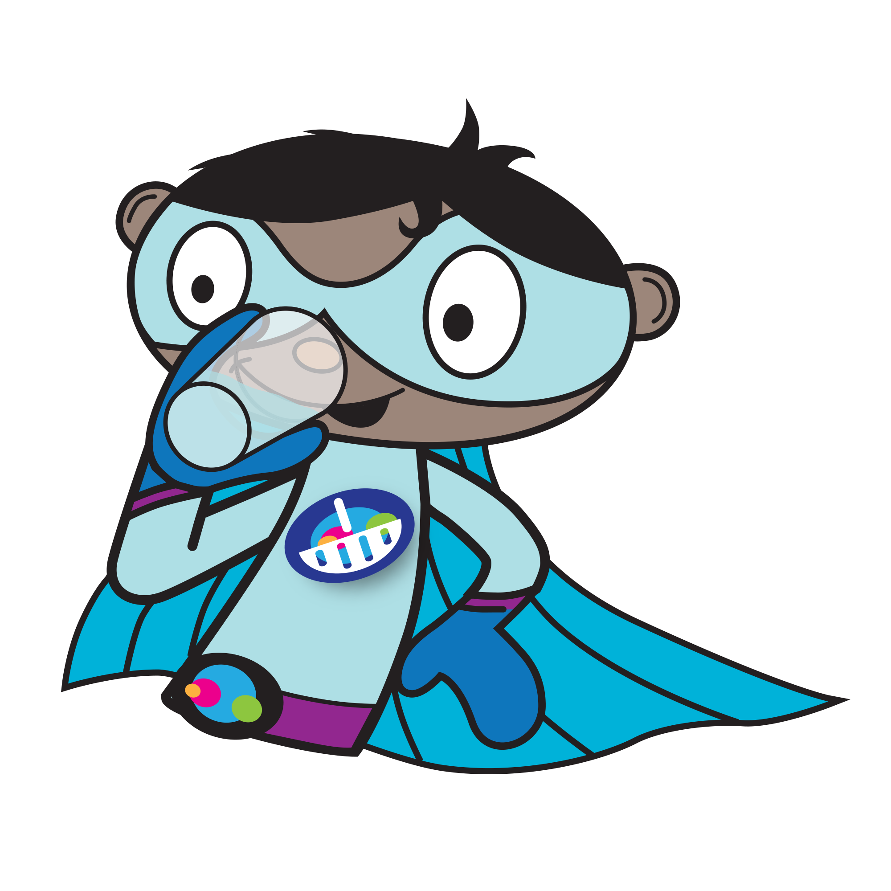 | To help children achieve this competence:  - provide healthy drinks (such as water) before, during and after activities;  - explain the importance of keeping hydrated when active;  - encourage children to carry a water bottle with them when they are taking part in activities.  To measure if the competence has been achieved, children should be able to:  - talk about the importance of keeping well hydrated;  - drink plenty during/after activities;  - carry a water bottle with them when taking part in activities.

How do the charts work?
The charts provide children with a number of targets or challenges with the five themes of the Core Competences. At home or at school, they can simply be used as target or record charts.

For each of the five themes, a series of age-appropriate competence statements is listed. Under each statement, there is the opportunity for the child to show that they have attained or experienced the competence on three separate occasions. This encourages repeat behaviour and reinforcement.
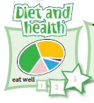
The two squares and final star could be coloured-in by the child or a sticky star could be awarded. If you wish to provide additional rewards, this is at your own discretion.
Colour-in on three occasions, or award sticky stars, to indicate that the competence has been achieved.

Worksheets also help to guide and support the child’s journey through the chart. The How to achieve guide provides additional support and guidance on how to help children attain the competences, as well as how to measure what they have done so far.

How can the charts be used?
The charts have been designed to be flexible, allowing them to be used in a variety of different settings, including home, school or out-of-school clubs and societies.

Complete chart
This chart provides all the competences for the five themes on one sheet, saving on paper. As the five themes often overlap, the chart provides the perfect opportunity for greater cross-curricular work and discussion. It also shows the child all the ‘targets’, so that they know where they are in their own personal food journey.

The chart could be used to:
- monitor the child’s food and activity journey and progression over time;
- help relate the five themes together in a coherent way;
- indicate areas for further development;
- celebrate achievement.

Individual charts
Rather than providing children with all the competences at once, the individual charts highlight each of the five competence themes. These can be used if you would rather concentrate on a particular theme in isolation, to help children concentrate, or if your curriculum dictates, e.g. healthy eating work.

These charts can be used to highlight and undertake the following activities:
 | By the age of 7-9…
Diet and health | - introduce the eatwell guide and the different food groups;  - taste different fruit and vegetables to help reach 5-a-day;  - choosing healthy drinks and drinking plenty;  - explore teeth and dental health;  - record their breakfast choices.
Shopping | - explore where food comes from;  - planting seeds and growing foods;  - look at food labels;  - talk about the food I like;  - find out what food other people like.
Cooking | - name and taste different foods;  - name and use kitchen equipment safely;  - help to cook healthy dishes safely;  - learn basic food preparation actions;  - recycle food packaging.
Food safety  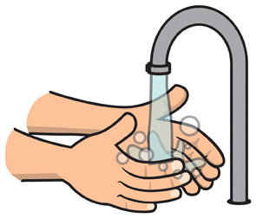 | - wash hands before, after and during cooking;  - get ready to cook;  - be safe in the kitchen;  - help to put food away in the right place;  - clean and tidy up after cooking.
Active lifestyles | - record their activities and know why it is important to be active;  - explore new ways to be active in lots of places;  - try new activities to find out what they enjoy;  - play in competitions as part of a team;  - stay hydrated when they are active.

Charts can be displayed on the classroom wall or kept by the children in their work books or drawers. If the charts are being used at home, they could be kept in the bedroom or on the fridge in the kitchen.

Curriculum links
The charts, along with the supporting worksheets, provide a strong platform for teaching children about diet and health, consumer awareness (shopping), cooking, food safety and active lifestyles. The location of these areas in the curriculum will depend on where you live in the UK. The charts can also provide support to those working in pre-school settings, particularly helping with group work around food.

England
It supports the Early Years Foundation Stage early learning goals, and Key stage 1 and Key stage 2 in Design and Technology (Cooking and nutrition), PSHE, Science and Physical Education. It can also be used in other areas such as Literacy (reading and writing recipes), Numeracy (weighing and measuring) and Religious Education (looking at, tasting and cooking different foods for special occasions).
https://www.gov.uk/government/collections/national-curriculum

Northern Ireland
It supports Foundation Stage, Key Stage 1 and Key Stage 2 in The World Around Us (Science and Technology, Geography) and Personal Development and Mutual Understanding and Physical Education. It can also be used in other areas such as Language and Literacy (reading and writing recipes), and Mathematics and Numeracy (weighing and measuring) and Religious Education (looking at, tasting and cooking different foods for special occasions).
http://www.nicurriculum.org.uk/

Scotland
It supports Pre-school to P7 in Technologies, Science, Social Studies and Health and wellbeing. It can also be used in other areas such as Languages (reading and writing recipes), Mathematics (weighing and measuring) and Religious and Moral Education (looking at, tasting and cooking different foods for special occasions).
http://www.educationscotland.gov.uk/

Wales
It supports Foundation Phase in Personal and Social Development, Well-Being, and Cultural Diversity; Knowledge and Understanding of the World, and Key Stage 2 in Design and Technology, PSE and Science. It can also be used in other areas such as English (reading and writing recipes), Mathematics (weighing and measuring) and Religious Education (looking at, tasting and cooking different foods for special occasions).
http://gov.wales/topics/educationandskills/schoolshome/curriculuminwales/arevisedcurriculumforwales/?lang=en

Acknowledgements

Food route: a journey through food was originally launched in 2009 by the Food Standards Agency (FSA) working in collaboration with the British Nutrition Foundation. Thank you to the following schools for their advice in the development of the original Food Route resources:
- England: Oak View Primary and Nursery School
- Northern Ireland: Gracehill Primary School
- Scotland: Stenhousemuir Primary School
- Wales: Waunarlwydd Primary School

The information is provided under the Open Government Licence. Terms can be found at:

http://www.nationalarchives.gov.uk/doc/open-government-licence

Published by Public Health England 2016 © Crown copyright 2016

Design by British Nutrition Foundation and ingenious

