Eight tips for healthy eating

Do you remember the eight tips for healthy eating?
Fill in the blanks below and draw a picture for each tip.

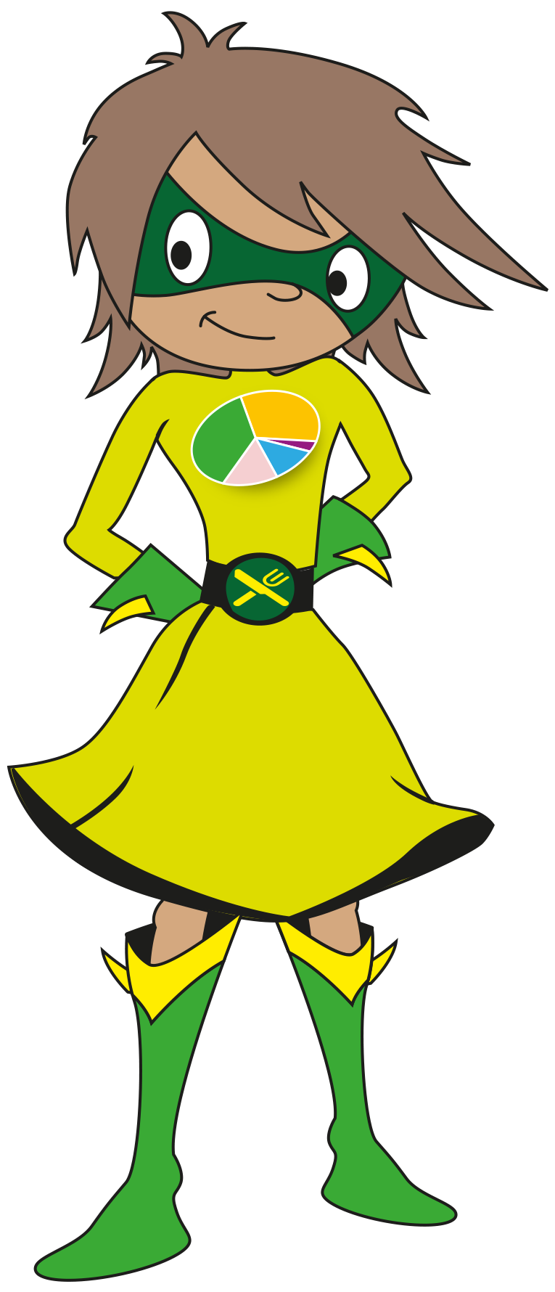
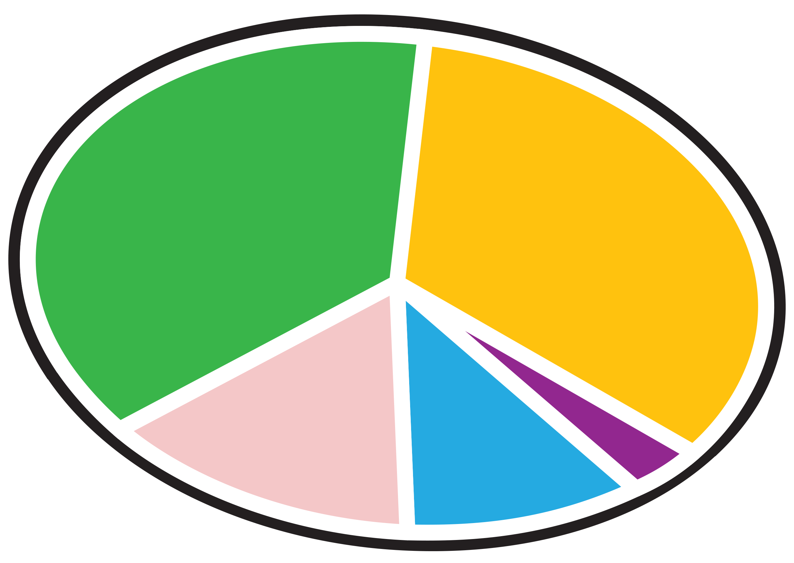
© Crown Copyright 2016

