Food advert

Design an advert for your favourite food.
What did you do to make it attractive? What do your friends think?

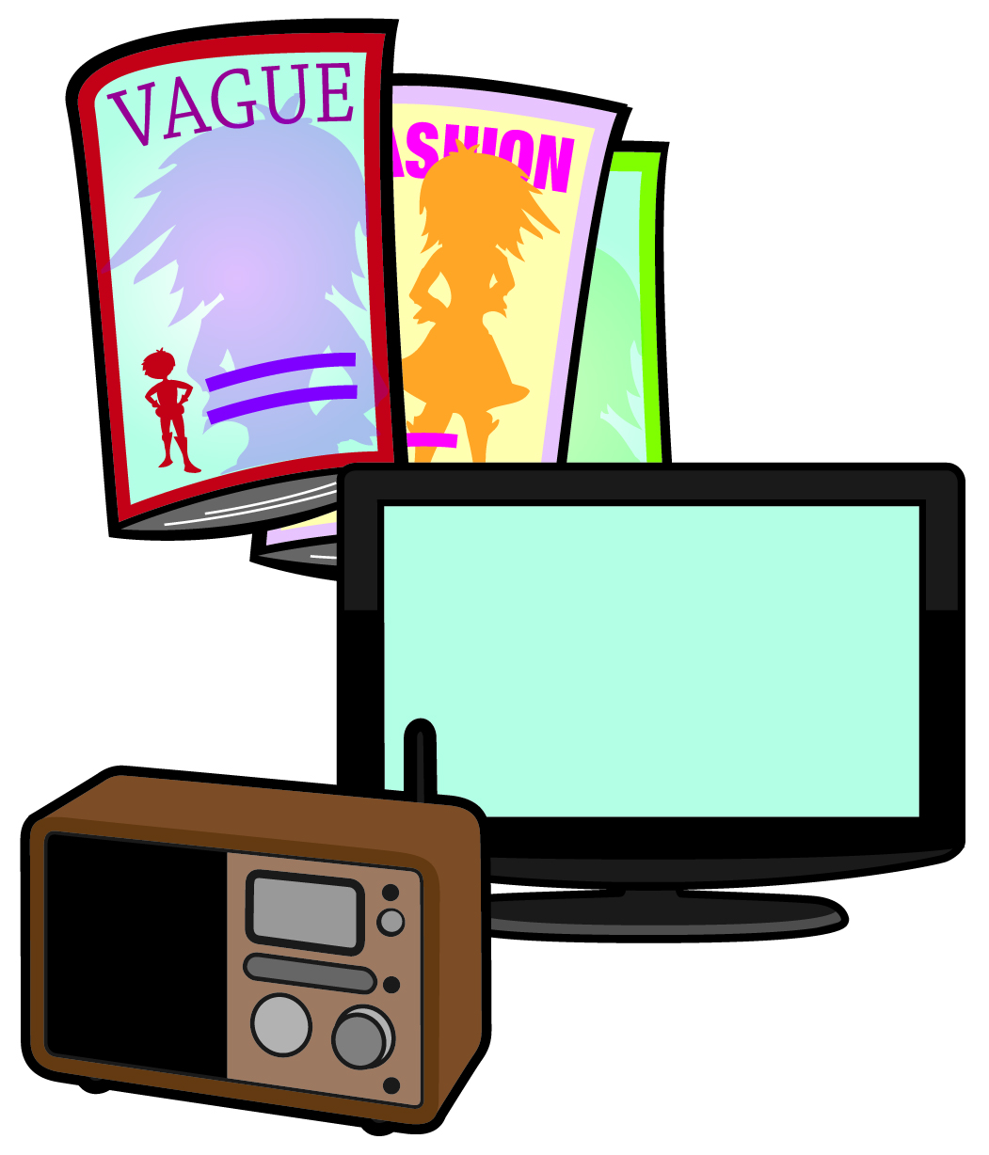
© Crown Copyright 2016

