
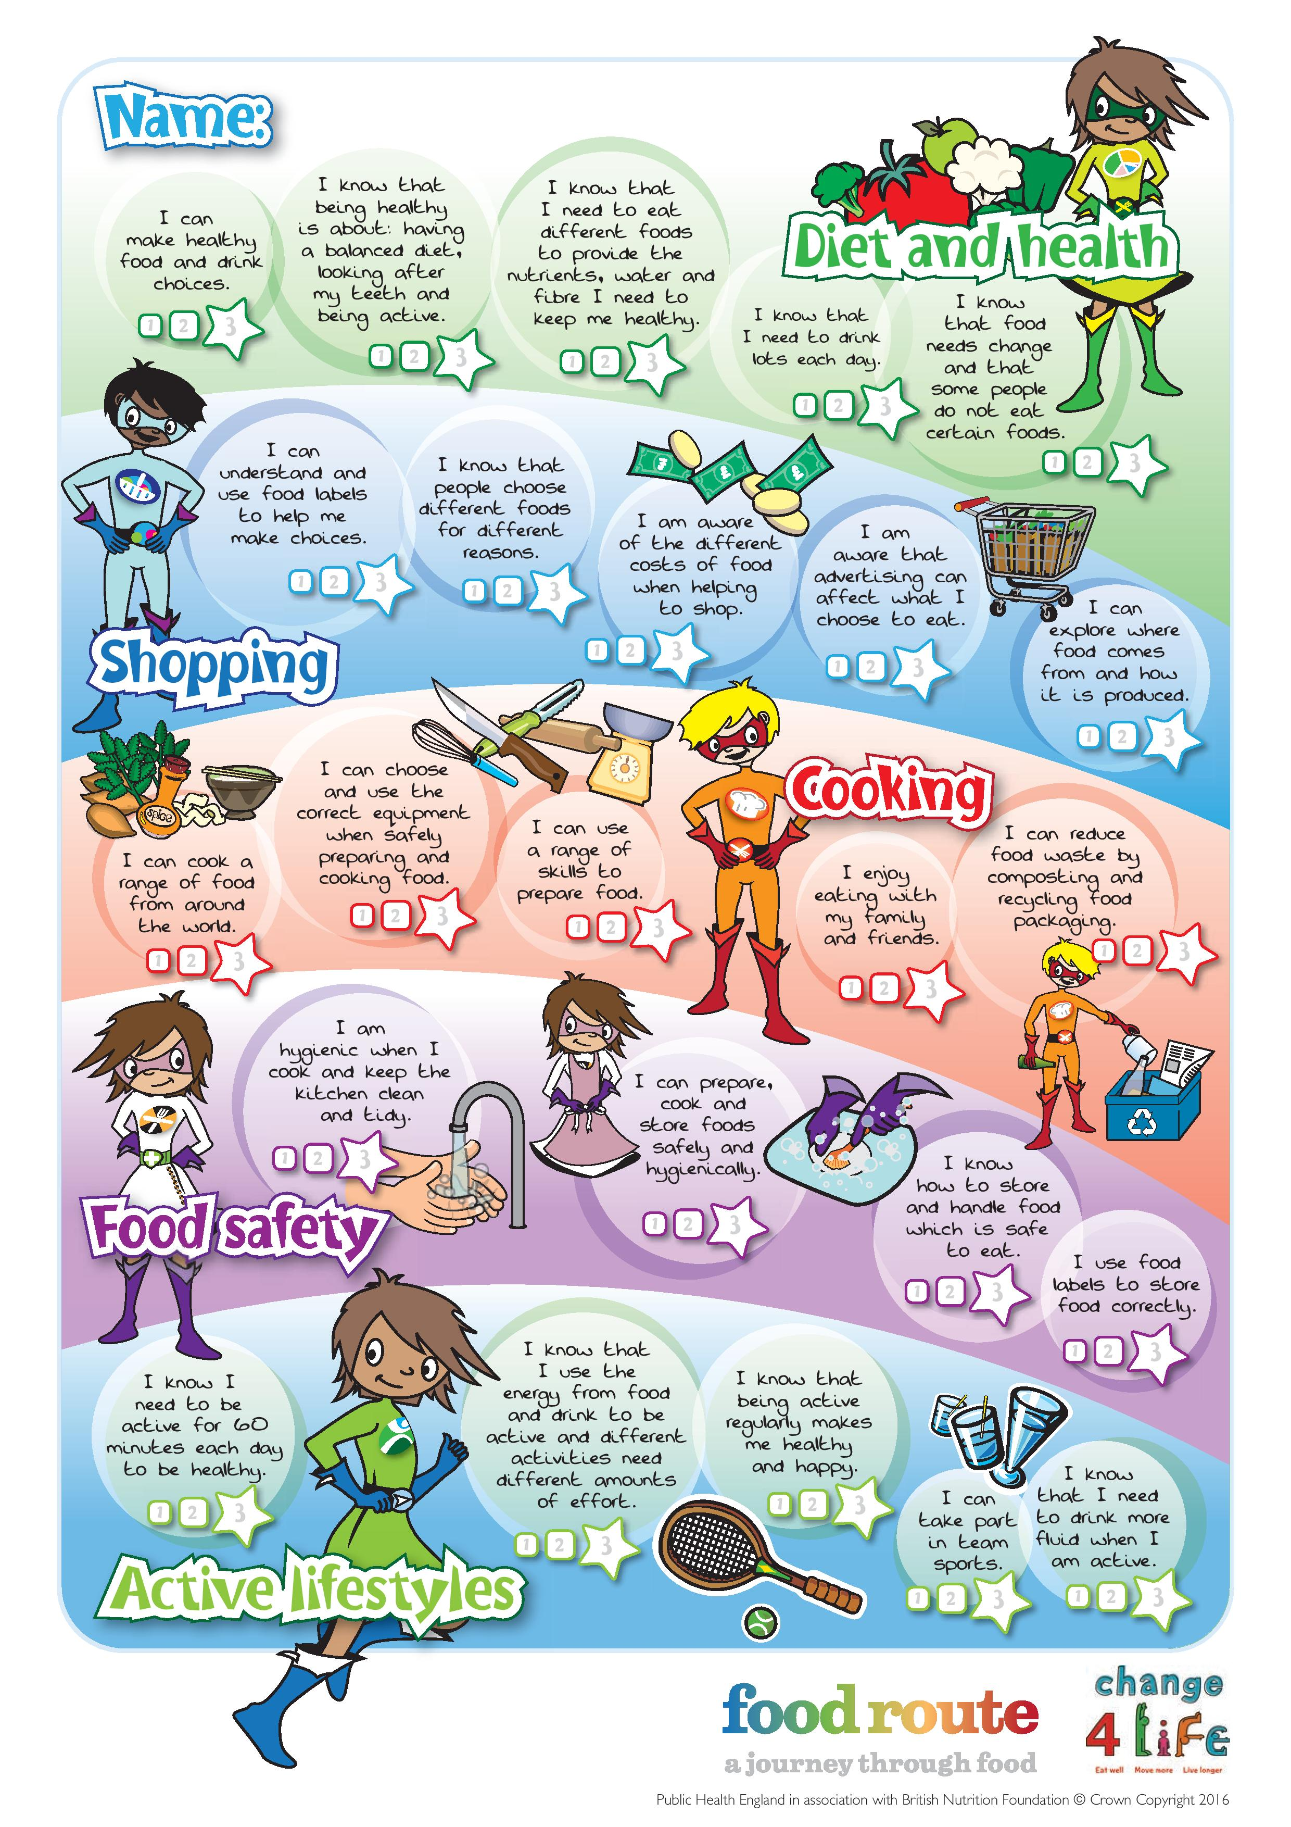

7-11 Years Users’ Guide


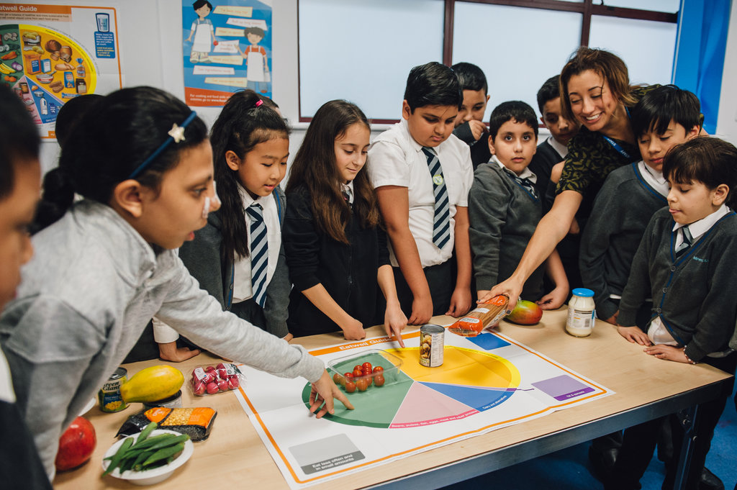

Welcome

This guide is for teachers and parents/carers who wish to use the Food route: a journey through food resources at school or at home. The resources, developed by Public Health England and British Nutrition Foundation, have been devised to help children engage with the Core Competences.

Background: Core Competences
The Core Competences were originally launched in December 2007 by the Food Standards Agency and the British Nutrition Foundation,, and have since been reviewed and updated in 2014 by Public Health England, FSA Northern Ireland, FSA Scotland, the Welsh Government and the British Nutrition Foundation. An additional review was carried out in 2016 following the launch of the new UK Healthy Eating Model – the Eatwell Guide. They comprise a progressive series of food, nutrition and activity related competence statements for children and young people aged 5 to 16+ years. The competences are based around five themes: diet and health, consumer awareness (shopping), cooking, food safety and physical activity.

The Core Competences can help young people to choose, cook and eat safe, healthy food and lead an active lifestyle. They are set out as a framework of core skills and knowledge, providing essential building blocks so that parents/carers, schools and community-based organisations can provide young people with a consistent set of food skills and knowledge.

Because the competences are progressive and cumulative from one age stage to the next, they can help young people make healthier choices that benefit them now and in later life. Importantly, the competences apply to all learning experiences, both within and outside the school setting, and can be met at home or through other activities. For further information, go to: www.nutrition.org.uk/foodinschools/competences.

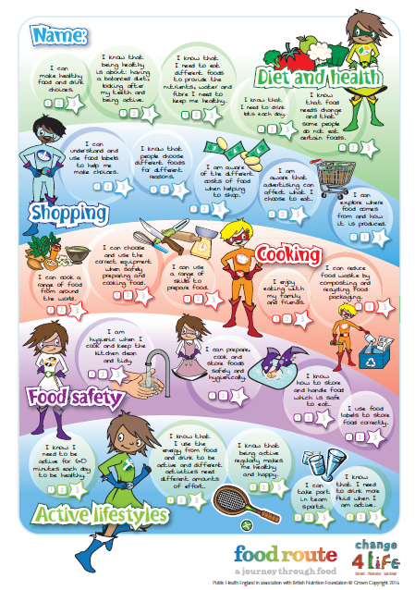
Food route – a journey through food
To help children and young people engage with the Core Competences, a series of focus groups and workshops were arranged throughout the UK. The original competences were rephrased in an age appropriate way, and tested to ensure that children understand what they mean and how they can be achieved. The focus group session informed the language and design of the resources.

To support children that are aged up to 7-11 years, the following resources are available:

Complete chart
This chart provides all the competences for the five areas. The chart is similar to a target chart, often used in schools for literacy and numeracy.

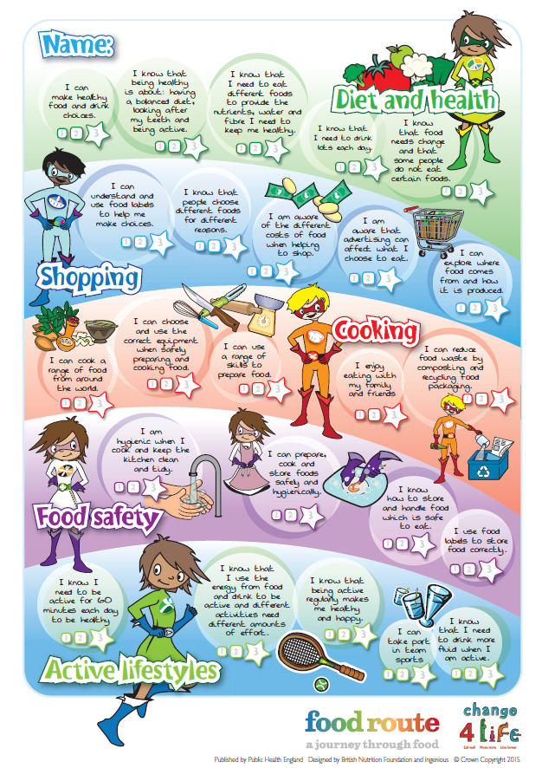
Individual charts
Five charts are provided, one for each competence area.
The charts are:
- Diet and health;
- Shopping;
- Cooking;
- Food safety;
- Active lifestyles.
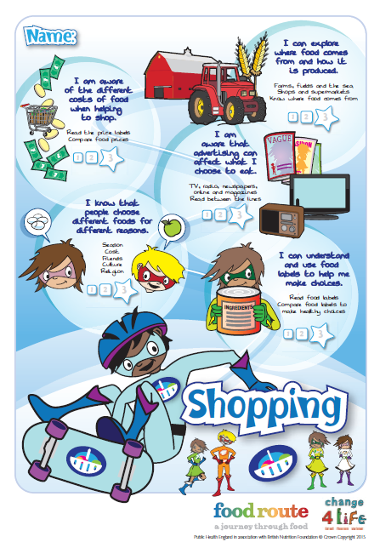
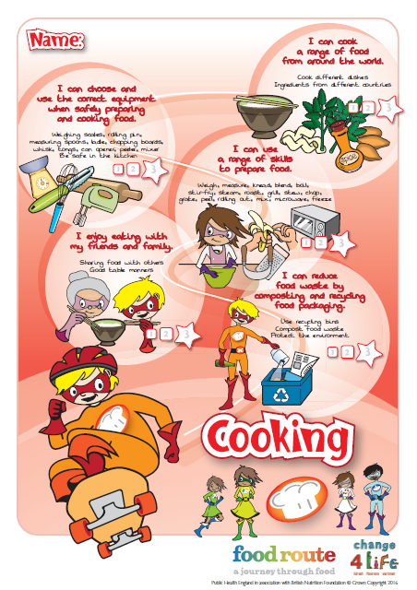
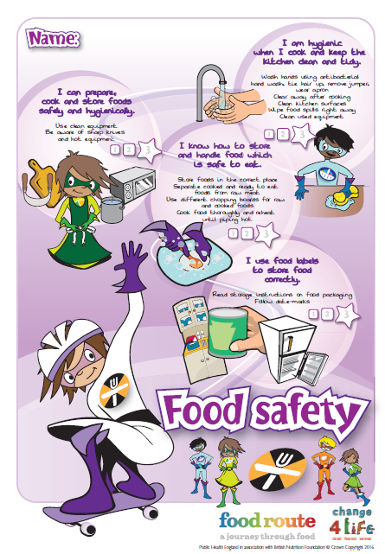
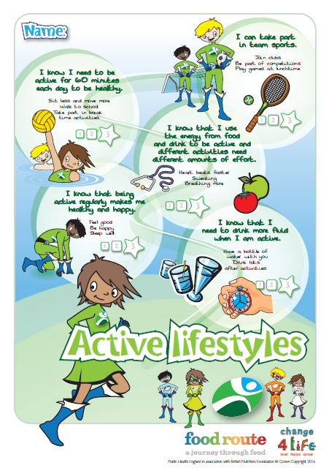
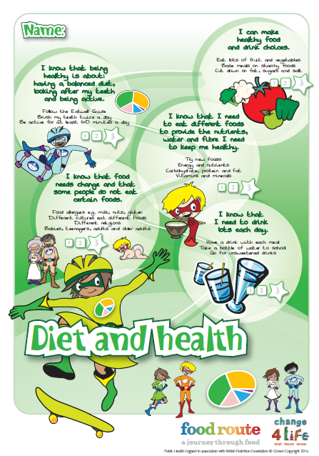

Worksheets
Worksheets are provided to help support children to achieve a number of the competences. These could be used at school or at home.
- Eight tips for healthy eating – looking at 8 tips for healthy eating;
- Food diary – recording meals, snacks and drinks over 3 days;
- Nutrient functions – explaining the main function of key nutrients;
- Food choice – investigating different reasons for food choice;
- Compare food prices – comparing different costs of food;
- Food adverts – looking at food adverts;
- My food advert – designing a food advert;
- What does a food label tell you? – reading food labels;
- Dishes from around the world– exploring food from around the world;
- Different equipment and cooking skills – investigating different cooking skills;
- Storage instructions – keeping food safe
- Food safety – keeping safe when you cook.
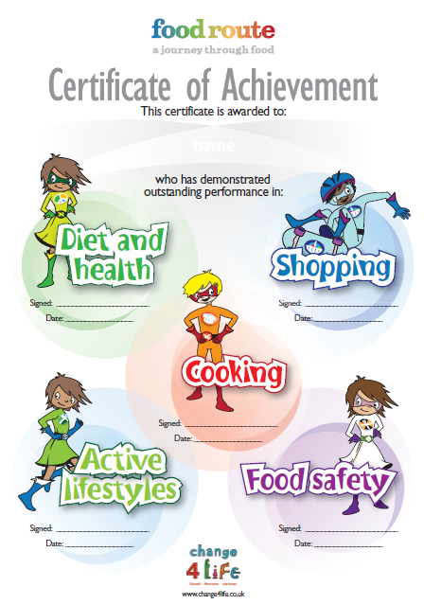
Certificate
A bright, colourful certificate is provided for this age phase. The certificate can be awarded after the child has completed all the competences, or when they have successfully completed each competence area, e.g. food safety.

How to achieve
This guide lists the competence statements that appear on the target charts and provides suggestions on how to:
- help children reach the competence;
- measure if the competence has been achieved.

Diet and Health
I can make healthy food and drink choices.  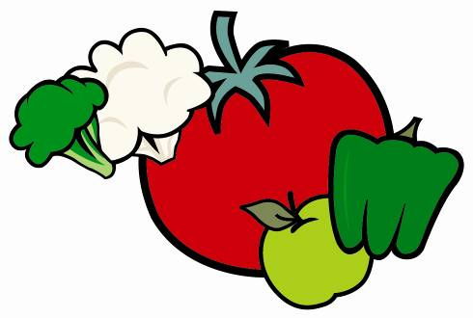 | To help children achieve this competence:  - provide healthy foods and drinks at school and home, limiting snacks high in saturated fat/sugar/salt;  - emphasise the importance of breakfast, e.g. have breakfast together at home, establish breakfast clubs in school and what a healthy breakfast is;  - talk about the eight tips for healthy eating (Eight tips for healthy eating worksheet);  - encourage children to record what they eat and drink over a three day period, and reflect on how this fits within the eatwell guide and changes they could make to be healthier (My food diary worksheet);  - provide practical examples of how to make healthier food choices, e.g. snack swaps, low or reduced fat, sugar and salt foods, and basing meals on starchy foods.  To measure if the competence has been achieved, children should be able to:  - explain simple changes they can make to their current diet to be healthier, e.g.  - have a healthy breakfast;  - eat lots of fruit and vegetables;  - base meals on starchy foods;  - cut down on foods high in fat, sugar and/or salt;  - List the 8 tips for healthy eating;  - Compare their own diet to the eatwell guide.
I know that being healthy is about having a balanced diet, looking after my teeth and being active.  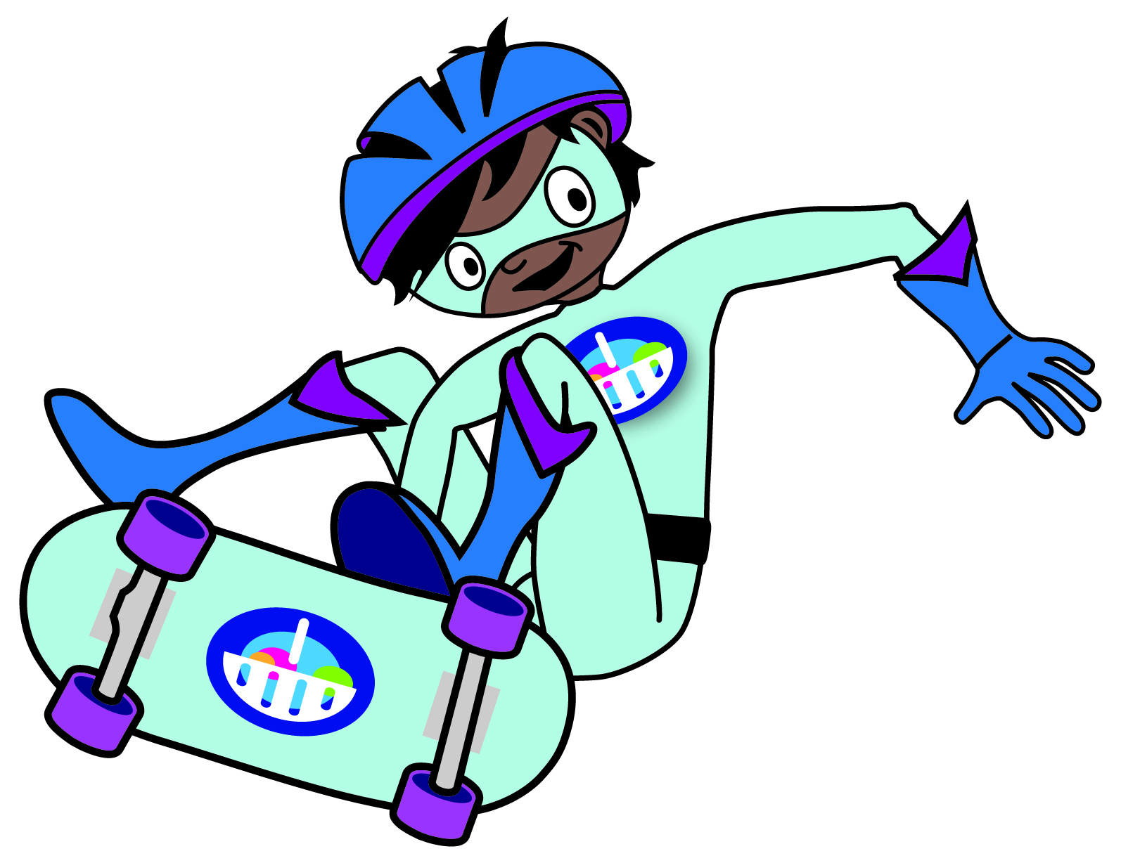 | To help children achieve this competence:  - plan a balanced meal together according to the eatwell guide, ask them to explain their choices;  - talk about the importance of looking after their teeth and how to do it, e.g. brush twice a day, visit a dentist regularly;  - plan an activity timetable together, making sure they are active for at least 60 minutes a day, and explain why this is important.  To measure if the competence has been achieved, children should be able to:  - plan a balanced meal according to the eatwell guide;  - brush their teeth twice a day;  - be active for at least 60 minutes a day;  - explain why it is important to be active every day.
I know that I need to eat different foods to provide the nutrients, water and fibre I need to keep me healthy.  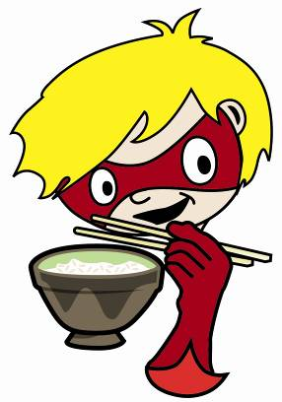 | To help children achieve this competence:  - talk about the functions of different nutrients within our body, e.g. we need protein for growth and repair (Nutrient functions worksheet);  - help them to research online to complete the nutrient functions worksheet.  To measure if the competence has been achieved, children should be able to:  - talk about the functions of nutrients (carbohydrate, protein, fat, vitamins and minerals), water and fibre;  - talk about how to get the nutrients they need to be healthy.
I know that food needs change and that some people do not eat certain foods.  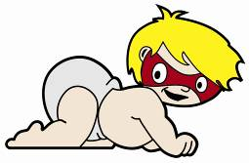  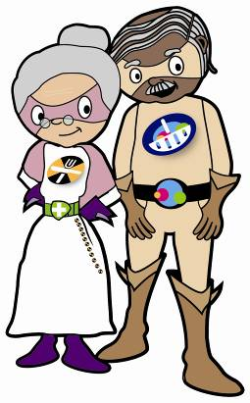 | To help children achieve this competence:  - talk about how food needs change throughout the life stages, e.g. babies, teenagers, adults, older adults;  - get them to talk to family and friends of different ages to find out what they eat;  - explain food allergy and intolerance and the reactions that may occur;  - use the internet to find out about what food people of different cultures or religion like to eat and those they may not eat;  - get them to list the foods people may not eat due to allergy, culture and religion (Food choice worksheet).  To measure if the competence has been achieved, children should be able to:  - name some special dietary needs for babies, teenagers, adults and older adults;  - explain why these people have different food requirements, e.g. teenagers need more energy for growth and development;  - name the foods which may cause allergy;  - understand that different cultures and religions may eat or avoid different foods.
I know that I need to drink lots each day.  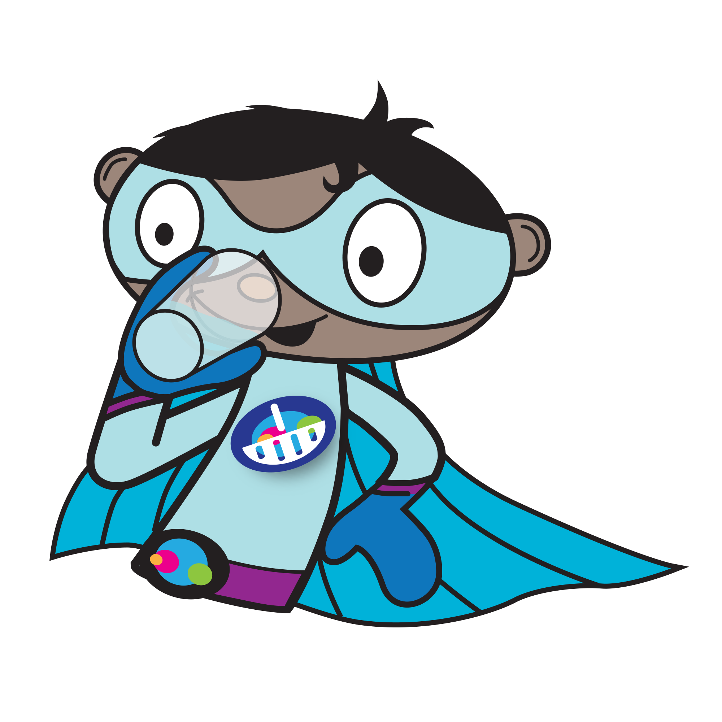 | To help children achieve this competence:  - explain the importance of keeping hydrated;  - encourage children to choose healthier drinks, i.e. water and lower fat milk;  - make sure water is available at meal times.  To measure if the competence has been achieved, children should be able to:  - explain why we need to stay hydrated;  - distinguish between healthy and unhealthy drinks;  - know we need to drink 6-8 glasses each day.

Shopping
I can explore where food comes from and how it is produced.  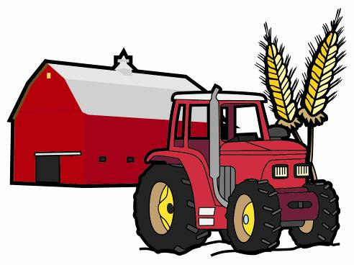 | To help children achieve this competence:  - visit local farms and shops;  - set up a gardening activity, growing fruit and vegetables at school or at home, e.g. cress, potatoes, tomatoes, herbs, strawberries;  - investigate the production of different foods and how they reach us from farm to fork, e.g. potatoes, milk, pork, bread.  To measure if the competence has been achieved, children should be able to:  - name the places where food is processed, made and sold, e.g. shops and supermarkets/ factories and farms;  - understand how foods are produced.
I am aware of the different costs of food when helping to shop.   | To help children achieve this competence:  - ask them to help set a budget and then work out a shopping list;  - visit the supermarket/ local shop or use the internet together and compare the costs of different foods (Compare food prices worksheet);  - set them a challenge to buy a list of foods within a set budget.  To measure if the competence has been achieved, children should be able to:  - compare food prices;  - start to appreciate a food budget;  - read price labels.
I am aware that advertising can affect what I choose to eat.  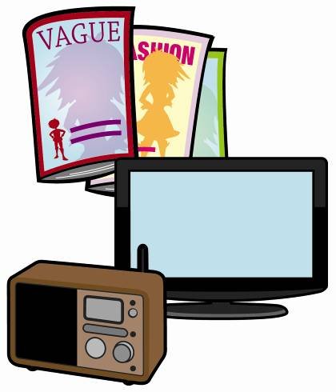 | To help children achieve this competence:  - get them to cut out some food adverts from newspapers and magazines, and discuss what they find (Food adverts worksheet);  - talk about the foods advertised on TV, in magazines, newspapers or in shops and discuss what has been done to make the advert persuasive;  - design a food advert together (My food advert worksheet).  To measure if the competence has been achieved, children should be able to:  - understand that TV, radio, newspapers and magazines influence food choices;  - point out some of the persuasive devices that have been used.
I know that people choose different foods for different reasons.  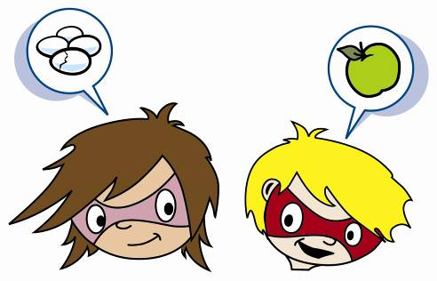 | To help children achieve this competence:  - talk to them about the foods they eat and why they choose them;  - ask them to conduct a survey about the foods their friends ate yesterday and why they chose these foods;  - talk to them about why people choose different foods, e.g. season, cost, friends, culture, religion and allergy/intolerance;  - get them to talk to other people including adults about what they buy and eat and why;  - get the children to collect data related to the reasons why people choose food and produce graphs.  To measure if the competence has been achieved, children should be able to:  - explain how food choices may be affected by season, cost, friends, culture, religion and allergy/intolerance.
I can understand and use food labels to help me make choices.  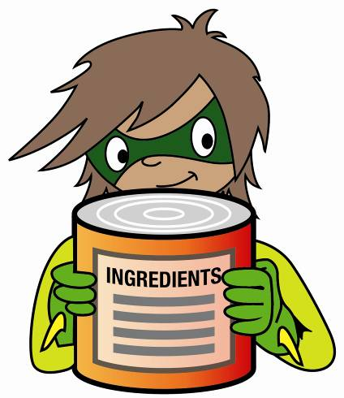 | To help children achieve this competence:  - ask them to point out all the information on a food label (What does a food label tell you? worksheet);  - talk about how they could use this information, e.g. to choose a better value or lower-fat product;  - visit a supermarket and ask them to choose healthier foods by reading and comparing the food labels per 100g.  To measure if the competence has been achieved, children should be able to:  - read food labels;  - compare similar foods using information on labels;  - know the recommended serving size.

Cooking
I can cook a range of food from around the world.  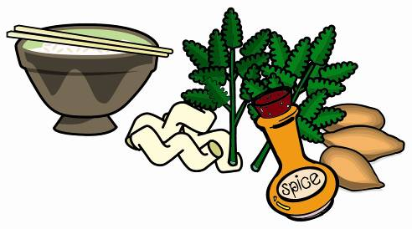 | To help children achieve this competence:  - ask them to research and list dishes found in different countries (Dishes from around the world worksheet);  - find traditional recipes from these countries and cook together;  - ask them to choose a country and design a traditional two course meal;  - take them to visit an ethnic supermarket.  To measure if the competence has been achieved, children should be able to:  - cook different dishes from around the world with help;  - discuss traditions in other cultures;  - talk about the ingredients from different countries.
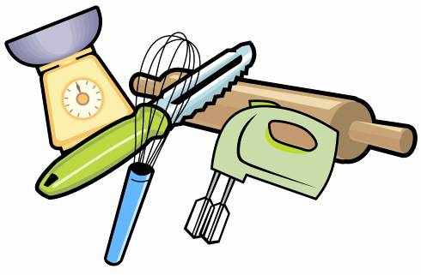  I can choose and use the correct equipment when safely preparing and cooking food. | To help children achieve this competence:  - organise a cooking session;  - ask them to take out all the equipment needed to cook the meal before beginning;  - show them the correct way of using the equipment to prepare food, e.g. weighing scales, rolling pin, can opener, peeler.  To measure if the competence has been achieved, children should be able to:  - identify a range of kitchen equipment, e.g. weighing scales, rolling pin, measuring spoons, ladle, whisk, tongs, can opener, vegetable peeler, sieve, grater;  - work safely in the kitchen under supervision.
I can use a range of skills to prepare food.  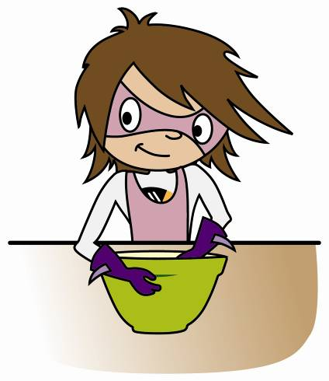 | To help children achieve this competence:  - demonstrate how to prepare and cook a variety of savoury foods, e.g. weighing, measuring, kneading;  - allow them to have hands-on experience in food preparation;  - let them use different equipment to prepare a dish;  - teach about the different skills needed to prepare different foods (Different equipment and cooking skills worksheet).  To measure if the competence has been achieved, children should be able to:  - prepare foods using different skills, e.g. chop, grate, peel, rolling out, mix, microwave, freeze blend, boil, stir-fry, steam, roast, grill, stew;  - understand the differences between these skills and when each skill is required.
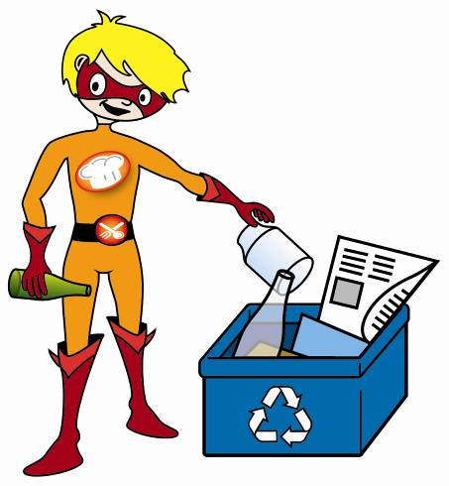  I can reduce food waste by composting and recycling food packaging. | To help children achieve this competence:  - set up a recycling area at home/ in school for recycling and composting;  - talk about the importance of reducing food waste, including awareness of portion size when preparing dishes;  - ask them to draw a poster to promote recycling.  To measure if the competence has been achieved, children should be able to:  - use recycling bins;  - compost food waste;  - understand the importance of portion size when preparing foods to help reduce food waste to help the environment.
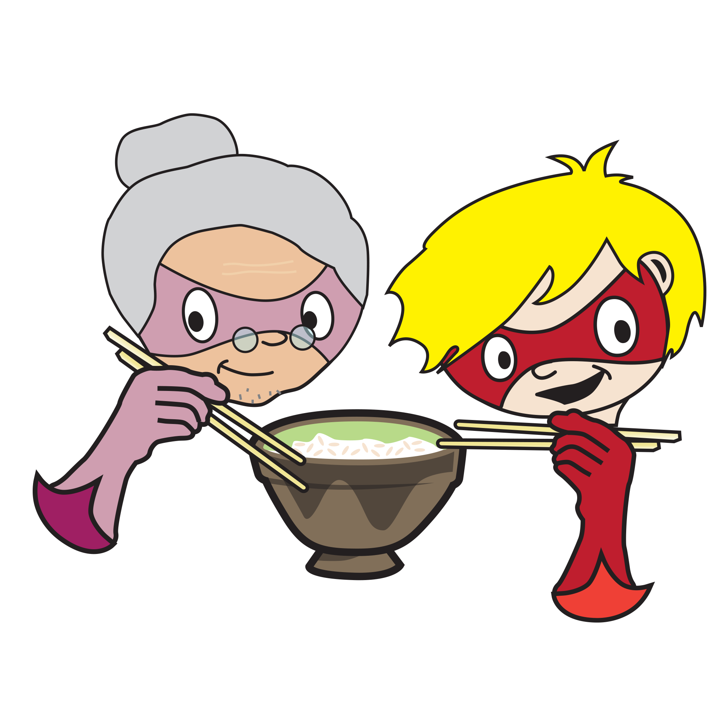  I enjoy eating with my family and friends. | To help children achieve this competence:  - encourage children to share food and eat together;  - introduce good table manners.  To measure if the competence has been achieved, children should be able to:  - share food with others;  - appreciate eating with friends and family;  - demonstrate good table manners when eating.

Food safety
I am hygienic when I cook and keep the kitchen clean and tidy.  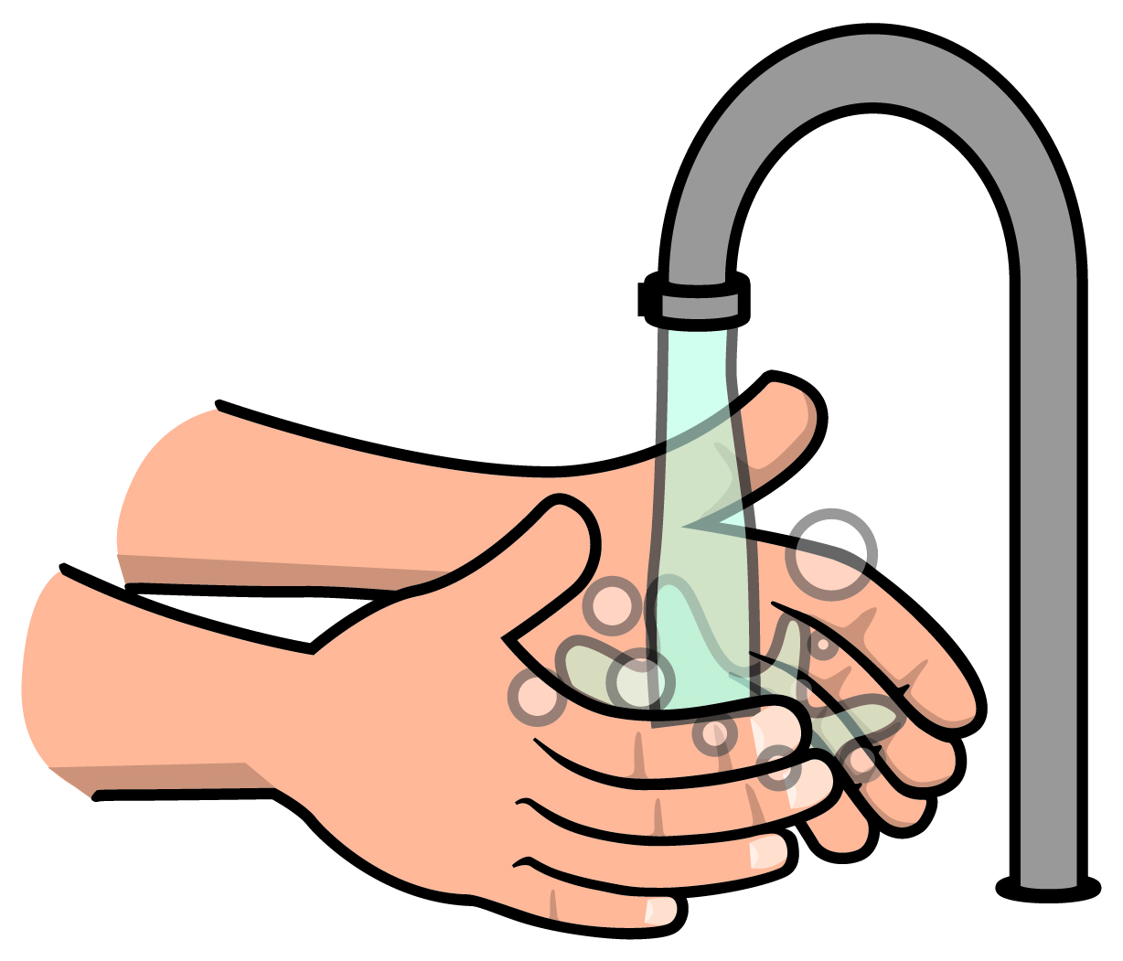 | To help children achieve this competence:  - talk about how to be hygienic, e.g. wear a clean apron, tie back long hair, remove jewellery, nail polish and jumper, wash hands with antibacterial hand wash before cooking;  - importance of keeping clean and tidy as they cook;  - talk about why it is important to be hygienic, e.g. to make sure food prepared is safe to eat;  - set up a hygiene target chart and award stickers each time they are hygienic when they cook;  - set up a cleaning schedule at home/ school and award stickers for keeping the kitchen or food preparation area clean;  - organise a ‘poster design challenge’ about keeping clean and tidy when cooking in school; the winning poster could be displayed.  To measure if the competence has been achieved, children should be able to do the following and explain why:  - wear a clean apron;  - tie back long hair;  - remove jewellery, nail polish and jumper;  - wash hands with antibacterial hand wash before cooking;  - be clean and tidy as they cook;  - clean away after cooking;  - clean kitchen surfaces;  - keep surfaces clean and tidy;  - wipe food spills straight away;  - wash up properly;  - put away equipment in the correct place.
I can prepare, cook and store foods safely and hygienically.  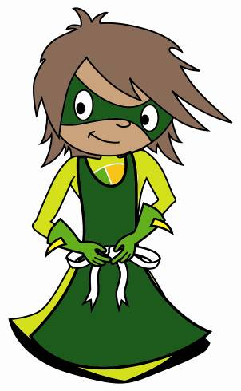 | To help children achieve this competence:  - cook a range of foods, highlighting safety and hygiene, e.g. getting ready to cook, using equipment safely; emphasise the need to separate raw and cooked foods when preparing foods, e.g. using separate chopping boards for raw and cooked foods;  - talk about how to tell whether food is cooked.  To measure if the competence has been achieved, children should be able to do the following and explain why:  - get ready to cook;  - use equipment safely;  - use different chopping boards for raw and cooked foods;  - reheat or cook foods until piping hot.
I use food labels to store food correctly.  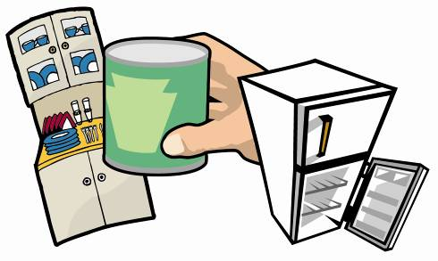 | To help children achieve this competence:  - ask them to show where different foods are stored (Storage instructions worksheet);  - explain the difference between use by and best before dates;  - talk about the consequences of not following storage instructions or date-marks, e.g. food poisoning and food spoilage.  To measure if the competence has been achieved, children should be able to do the following and explain why:  - read storage instructions on food packaging;  - follow date-marks and understand the difference between use by and best before;  - explain the consequences of not following date marks.
I know how to store and handle food which is safe to eat.  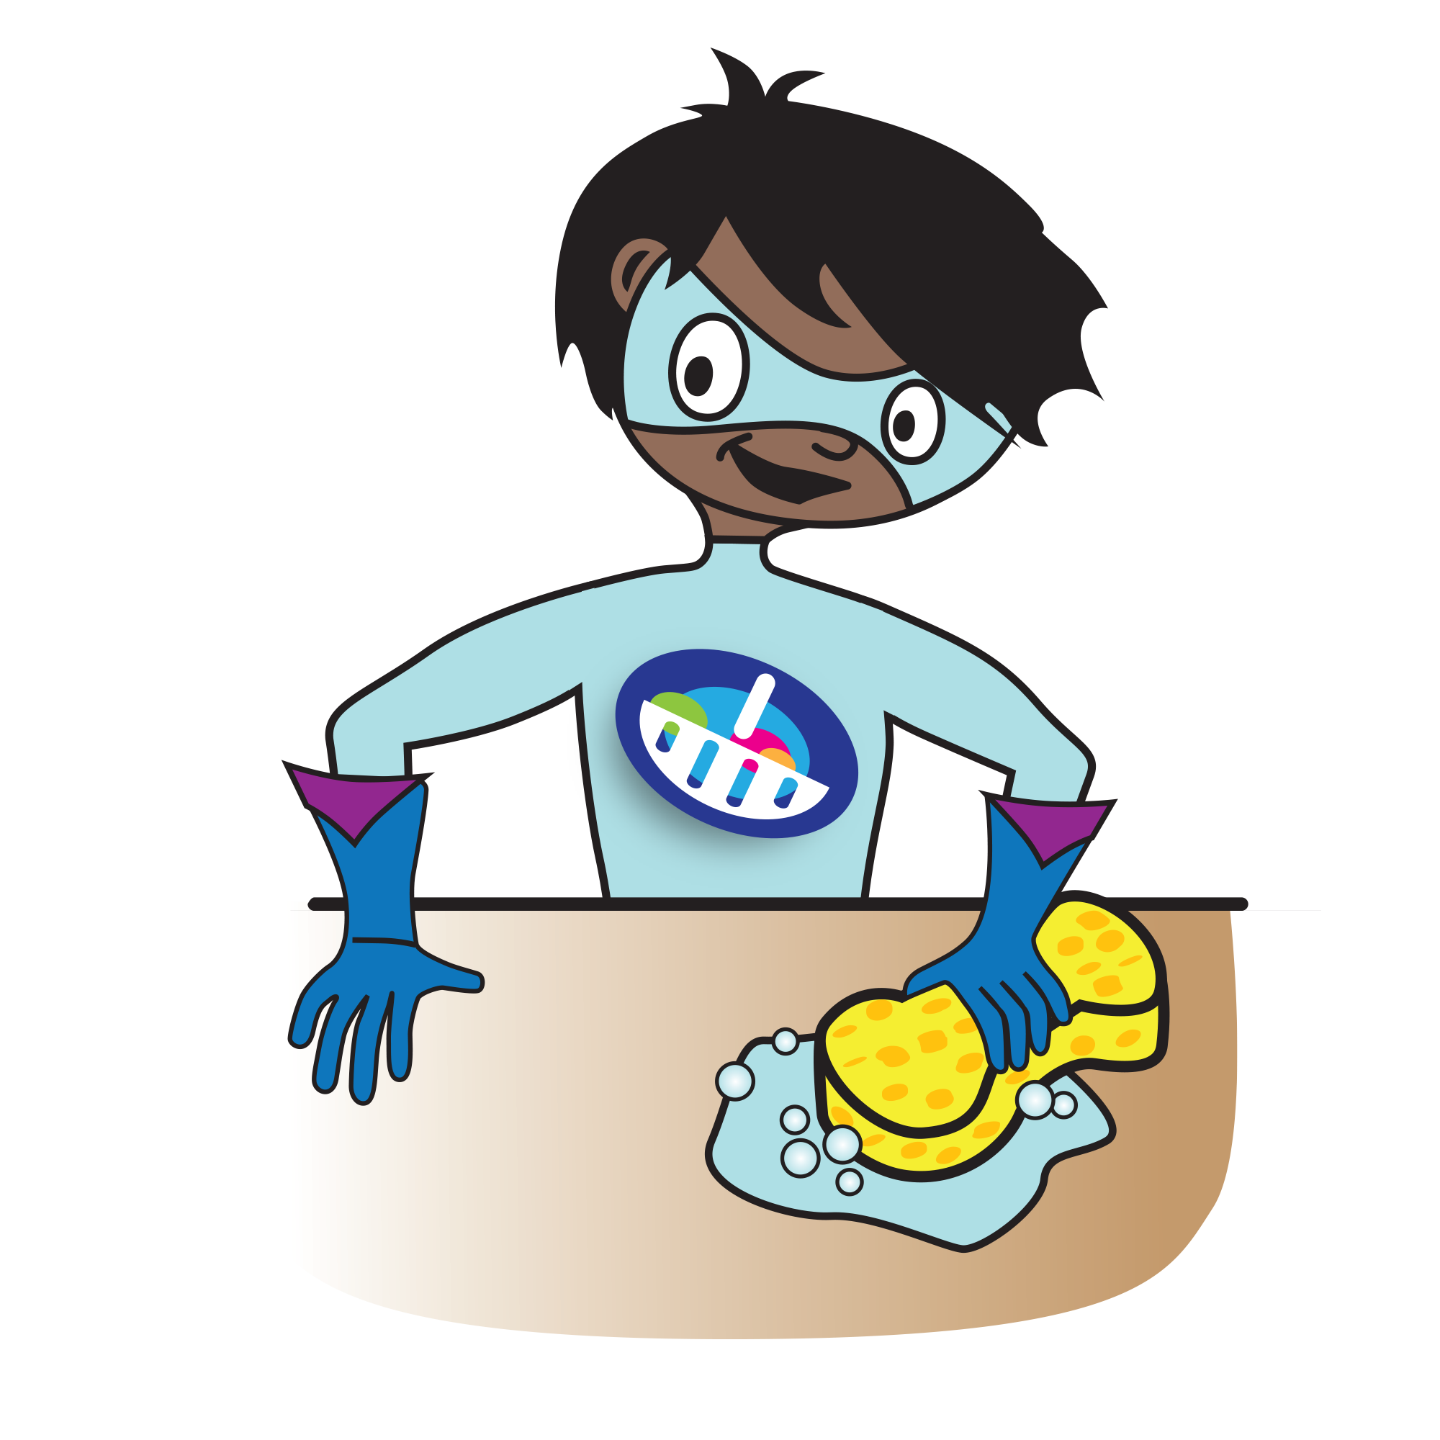 | To help children achieve this competence:  - explain why different foods need to be stored in different places to prevent contamination, spoilage and decay;  - explain the concept of cross contamination between raw and cooked foods.  To measure if the competence has been achieved, children should be able to do the following and explain why:  - store foods in the correct places and explain why;  - maintain good food hygiene throughout food preparation with raw and cooked foods.

Active lifestyles
I know I need to be active for 60 minutes each day to be healthy.  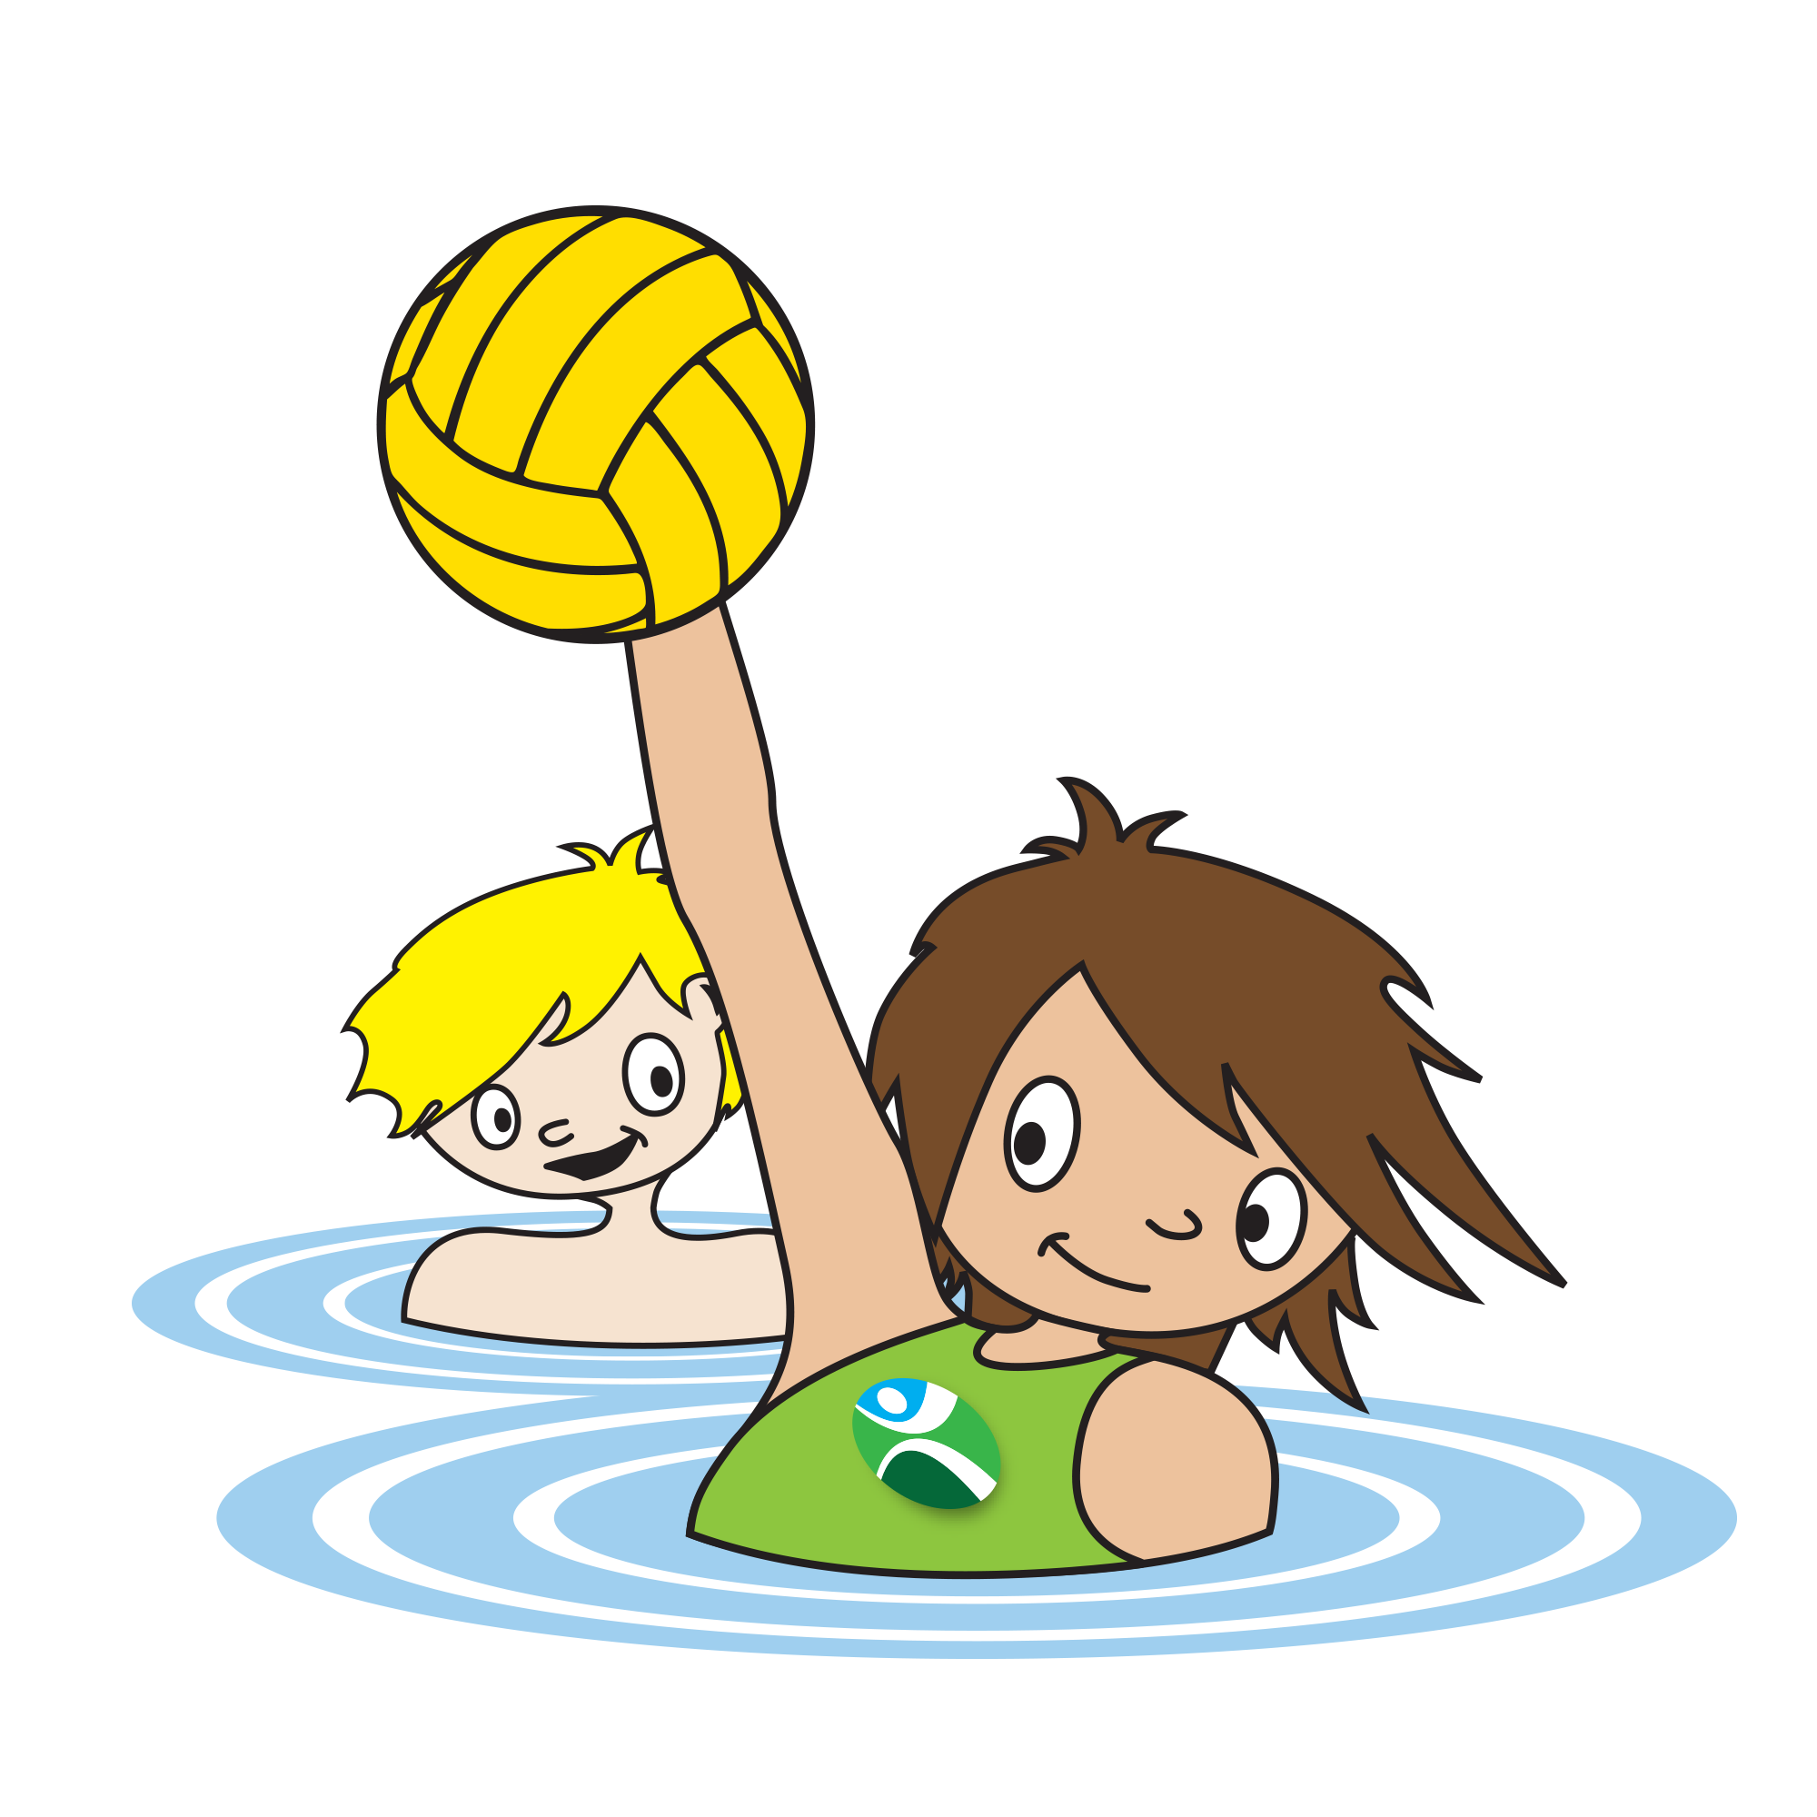 | To help children achieve this competence:  - encourage outdoor activity at break time/lunchtime;  - provide a range of lunchtime/after school clubs to engage the children;  - suggest ways to enable them to be more active, e.g. walk to/from school, bike rides, swimming lessons;  - explain the importance of being fit, e.g. healthy weight, strong bones, and heart health.  To measure if the competence has been achieved, children should be able to:  - take part in physical activities at break time and/or lunchtime;  - be active for a total of at least 60 minutes each day;  - explain why it is important to be fit.
I can take part in team sports.  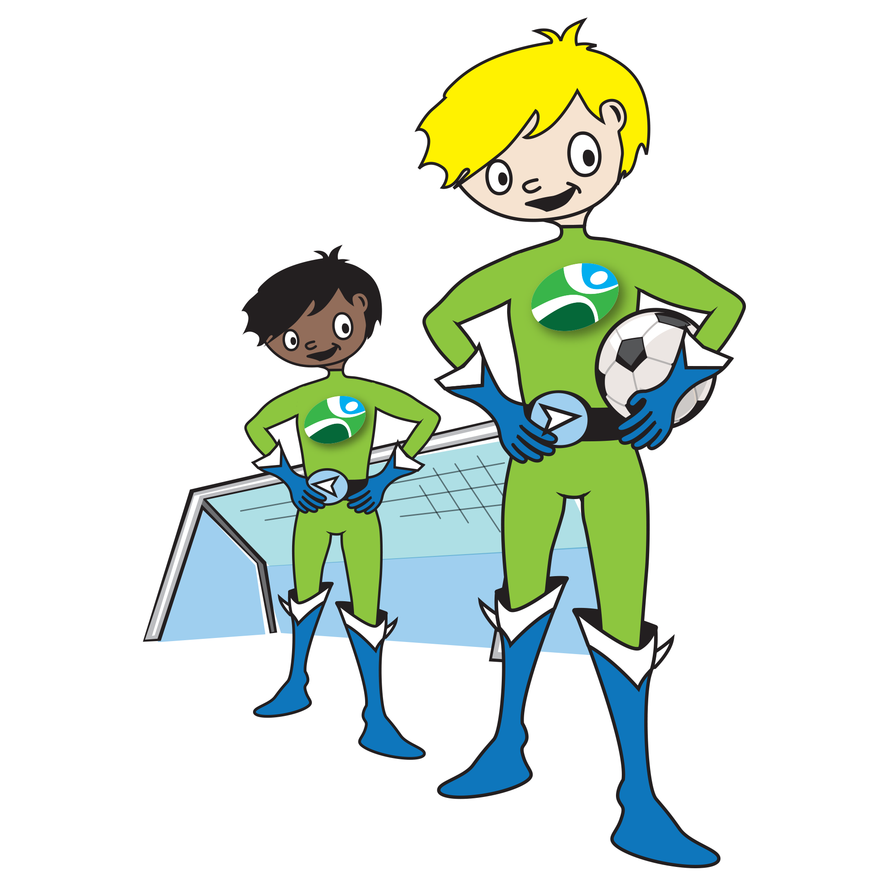 | To help children achieve this competence:  - provide a range of team sports either within PE lessons or lunchtime/after school activities;  - encourage children to take part in team sports;  - organise inter-house tournaments;  - explain the importance of playing as part of a team and working together to reach a goal.  To measure if the competence has been achieved, children should be able to:  - play as part of a team;  - take part in formalised types of physical activity.
  I know that I use the energy from food and drink to be active, and different activities need different amounts of effort. | To help children achieve this competence:  - explain how physical activity uses energy which is provided by the food and drinks consumed, e.g. increased heart rate, sweating;  - explain/demonstrate what moderate intensity activities feel like, (e.g. walking to school, playing in the playground, riding a scooter, skateboarding, rollerblading, walking the dog), and vigorous intensity activities feel like (playing chase, energetic dancing, swimming, running, gymnastics, football, rugby) and that more intense activities require more energy.  To measure if the competence has been achieved, children should be able to:  - explain why they need food and drink to be active;  - name activities of different intensities and know that more vigorous activities require more energy.
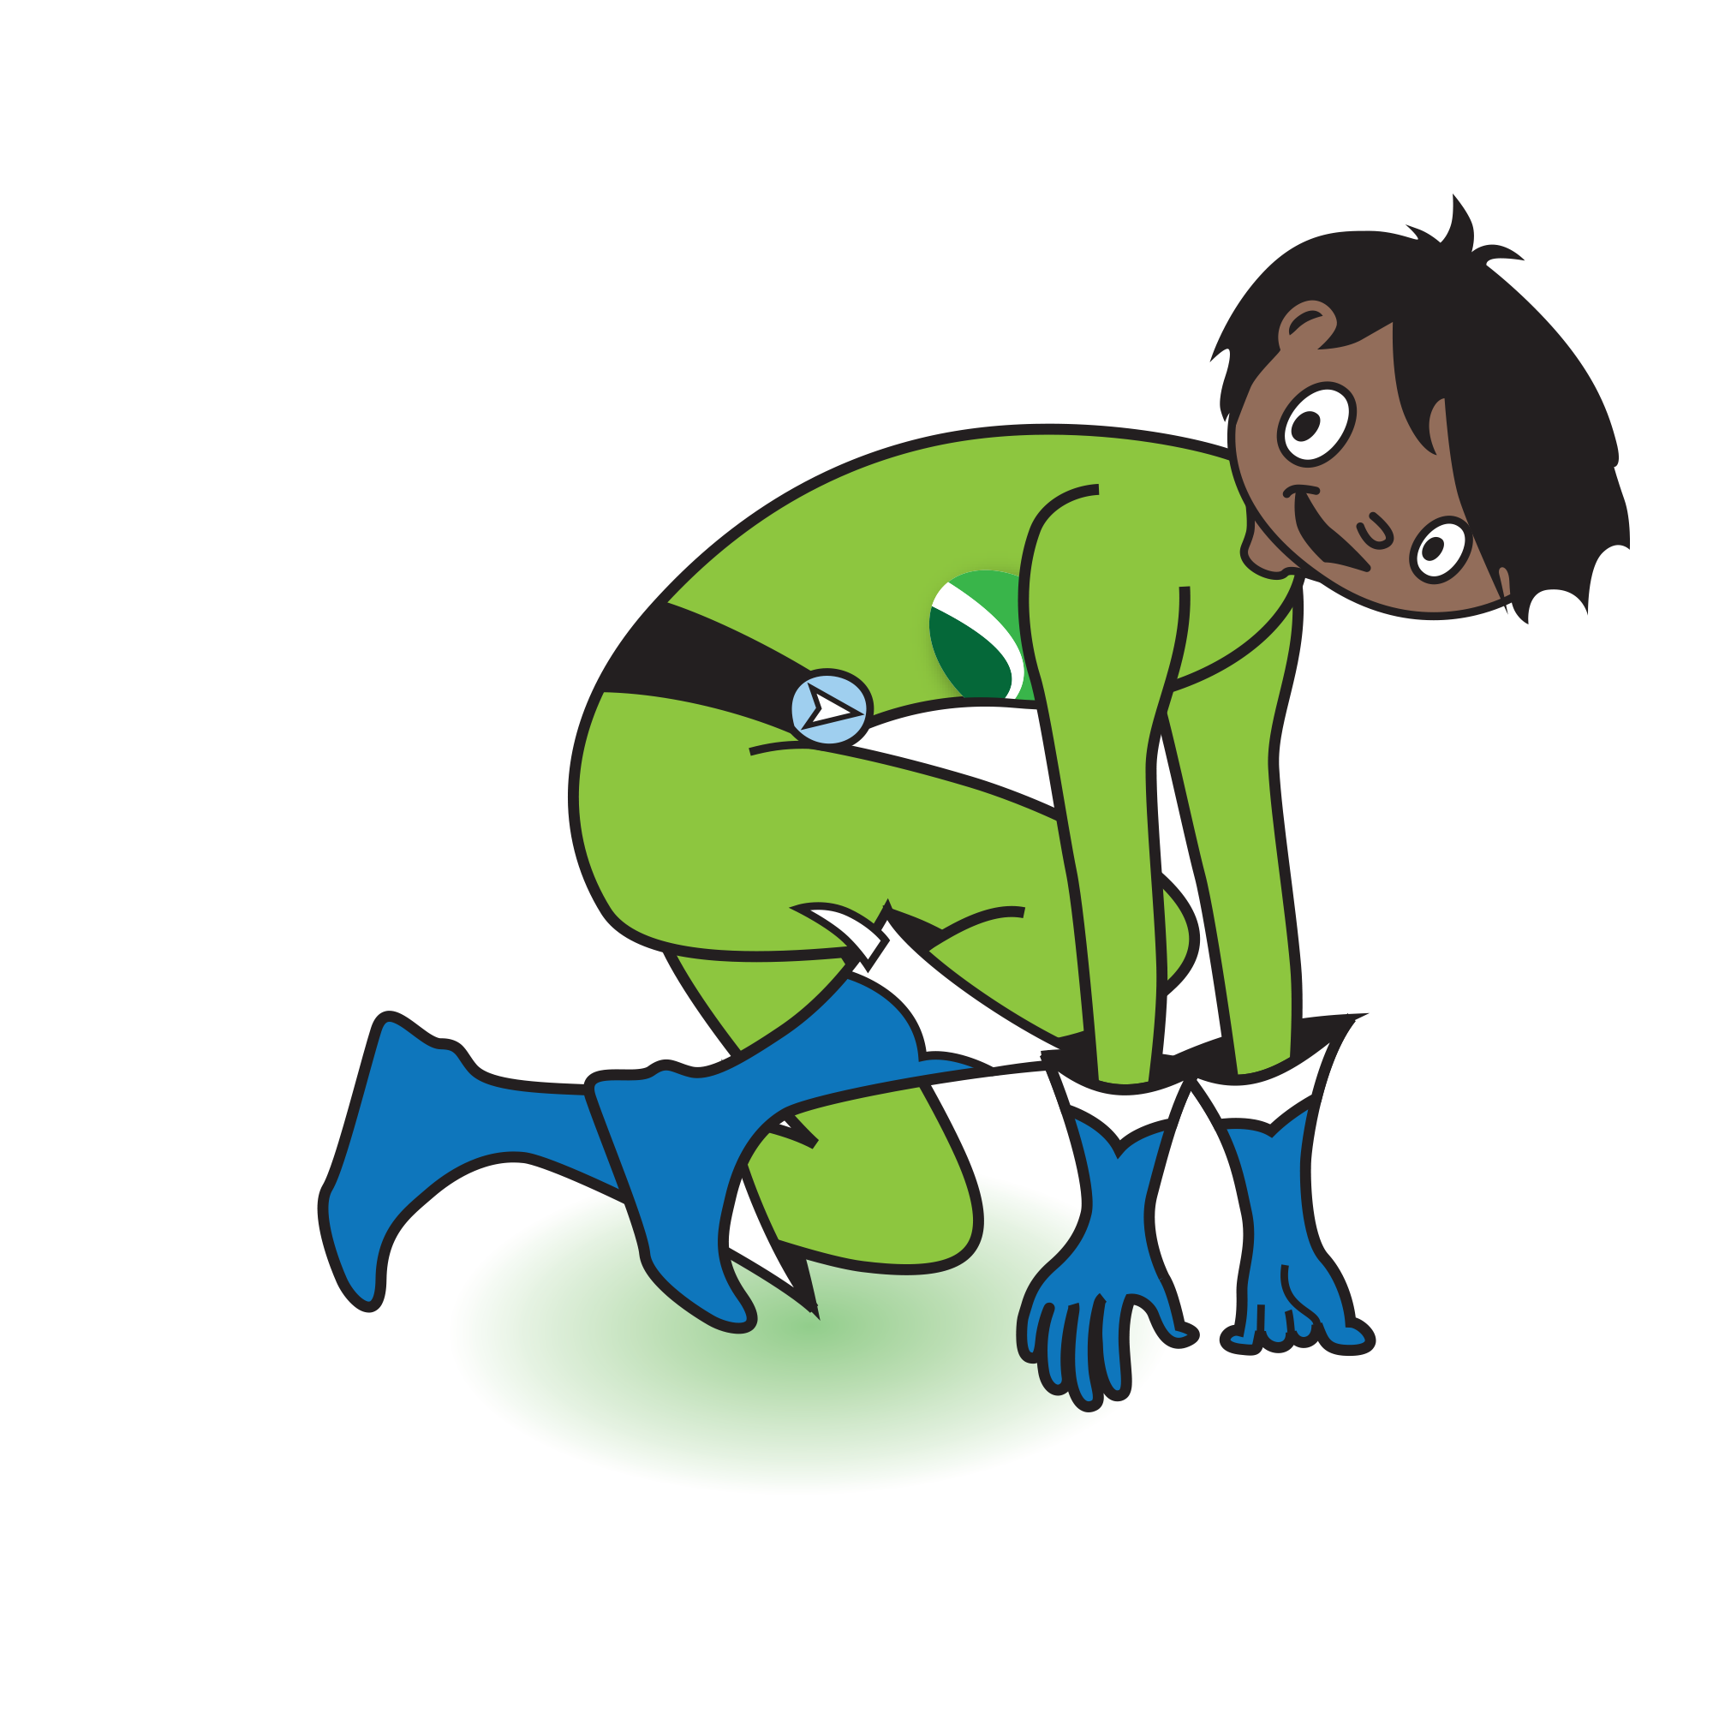  I know that being active regularly makes me healthy and happy. | To help children achieve this competence:  - explain to the children why physical activity is important for health, e.g. maintaining a healthy weight, building strong bones and muscles, improving balance, coordination and strength;  - encourage team activities to demonstrate how being active provides opportunities to develop social skills, make friends, improve confidence, self-esteem and sleep.  To measure if the competence has been achieved, children should be able to:  - talk about why being active regularly is important for health;  - be aware of how taking part in activities can improve confidence, self-esteem and social skills.
I know that I need to drink more fluid when I am active.  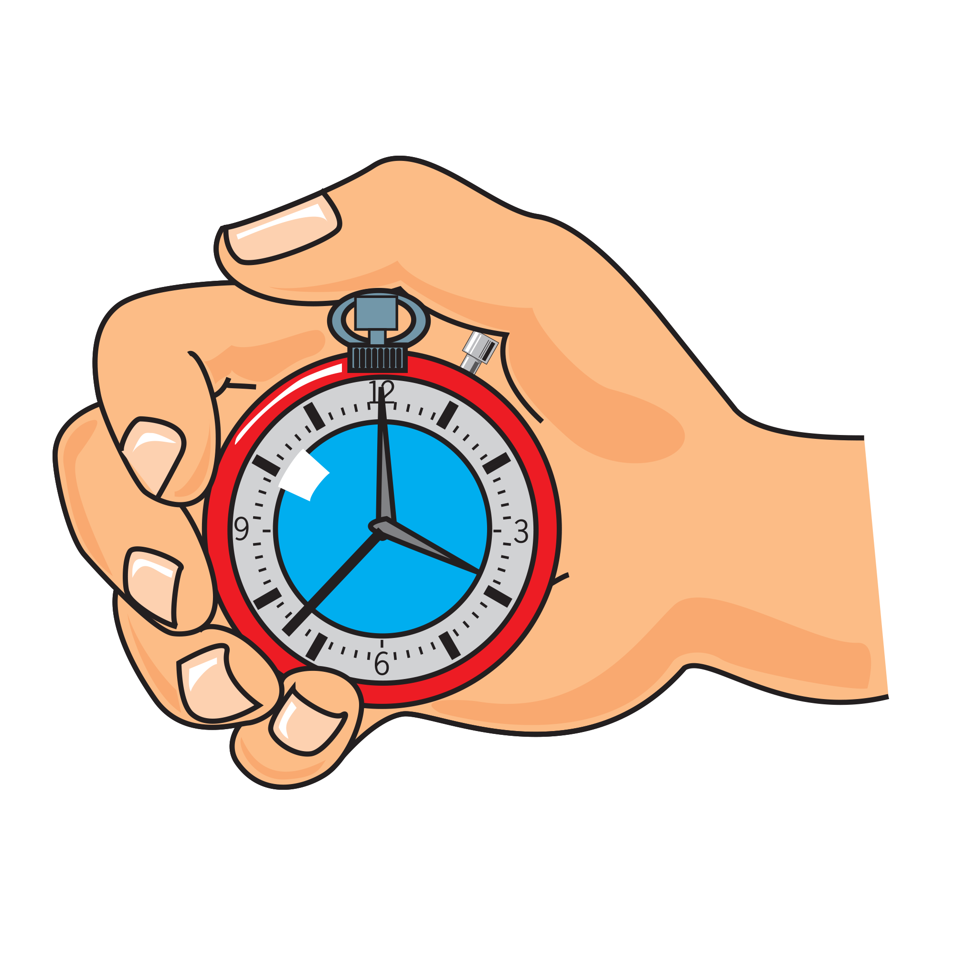 | To help children achieve this competence:  - explain why the body needs water to function correctly;  - explain what happens when you don’t drink enough, and how this affects you;  - encourage children to bring a water bottle with them when taking part in activities.  To measure if the competence has been achieved, children should be able to:  - explain the importance of water when they are active;  - talk about what happens when they become dehydrated.

How do the charts work?
The charts provide children with a number of targets or challenges with the five themes of the Core Competences. At home or at school, they can simply be used as target or record charts.

For each of the five themes, a series of age-appropriate competence statements is listed. Under each statement, there is the opportunity for the child to show that they have attained or experienced the competence on three separate occasions. This encourages repeat behaviour and reinforcement.
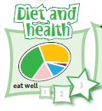
The two squares and final star could be coloured-in by the child or a sticky star could be awarded. If you wish to provide additional rewards, this is at your own discretion.
Colour-in on three occasions, or award sticky stars, to indicate that the competence has been achieved.

Worksheets also help to guide and support the child’s journey through the chart. The How to achieve guide provides additional support and guidance on how to help children attain the competences, as well as how to measure what they have done so far.

How can the charts be used?
The charts have been designed to be flexible, allowing them to be used in a variety of different settings, including home, school or out-of-school clubs and societies.

Complete chart
This chart provides all the competences for the five themes on one sheet, saving on paper. As the five themes often overlap, the chart provides the perfect opportunity for greater cross-curricular work and discussion. It also shows the child all the ‘targets’, so that they know where they are in their own personal food journey.

The chart could be used to:
- monitor the child’s food and activity journey and progression over time;
- help relate the five themes together in a coherent way;
- indicate areas for further development;
- celebrate achievement.

Individual charts
Rather than providing children with all the competences at once, the individual charts highlight each of the five competence themes. These can be used if you would rather concentrate on a particular theme in isolation, to help children concentrate, or if your curriculum dictates, e.g. healthy eating work.

These charts can be used to highlight and undertake the following activities:
 | By the age of 11-12…
Diet and health  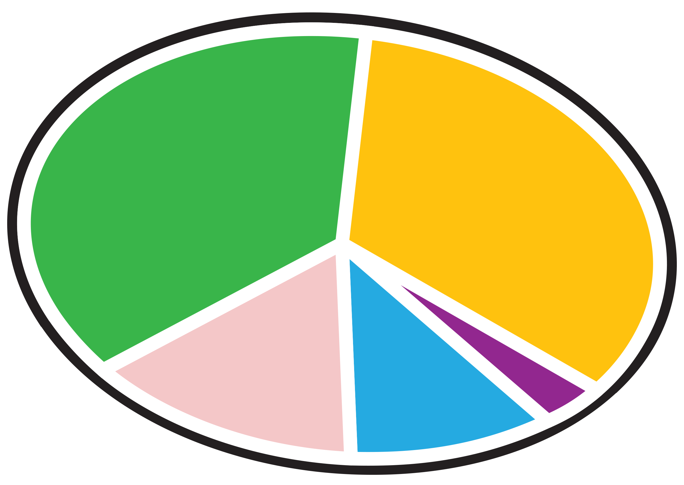 | - keep a food diary and relate to the eatwell guide;  - plan balanced meals according to the eatwell guide;  - investigate the roles of the key nutrients within the body and examples of where to find these nutrients;  - explore the needs of others throughout life;  - choose healthy drinks and know why it is important to stay hydrated.
Shopping  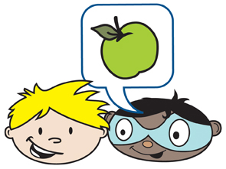 | - explore where and how food is made and sold;  - compare food prices;  - investigate advertising;  - understand why people choose different foods;  - read and compare food labels.
Cooking  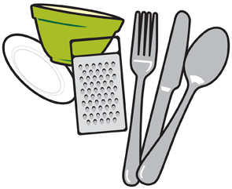 | - cook dishes from around the world;  - use a range of cooking equipment appropriately and safely;  - use a range of food skills;  - compost food and recycle food packaging;  - share food with friends and family.
Food safety  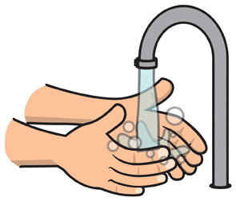 | - being hygienic when cooking;  - separate cooked and ready-to-eat foods from raw meat;  - understand and use food labels to store food;  - store and handle food which is safe to eat.
Active lifestyles  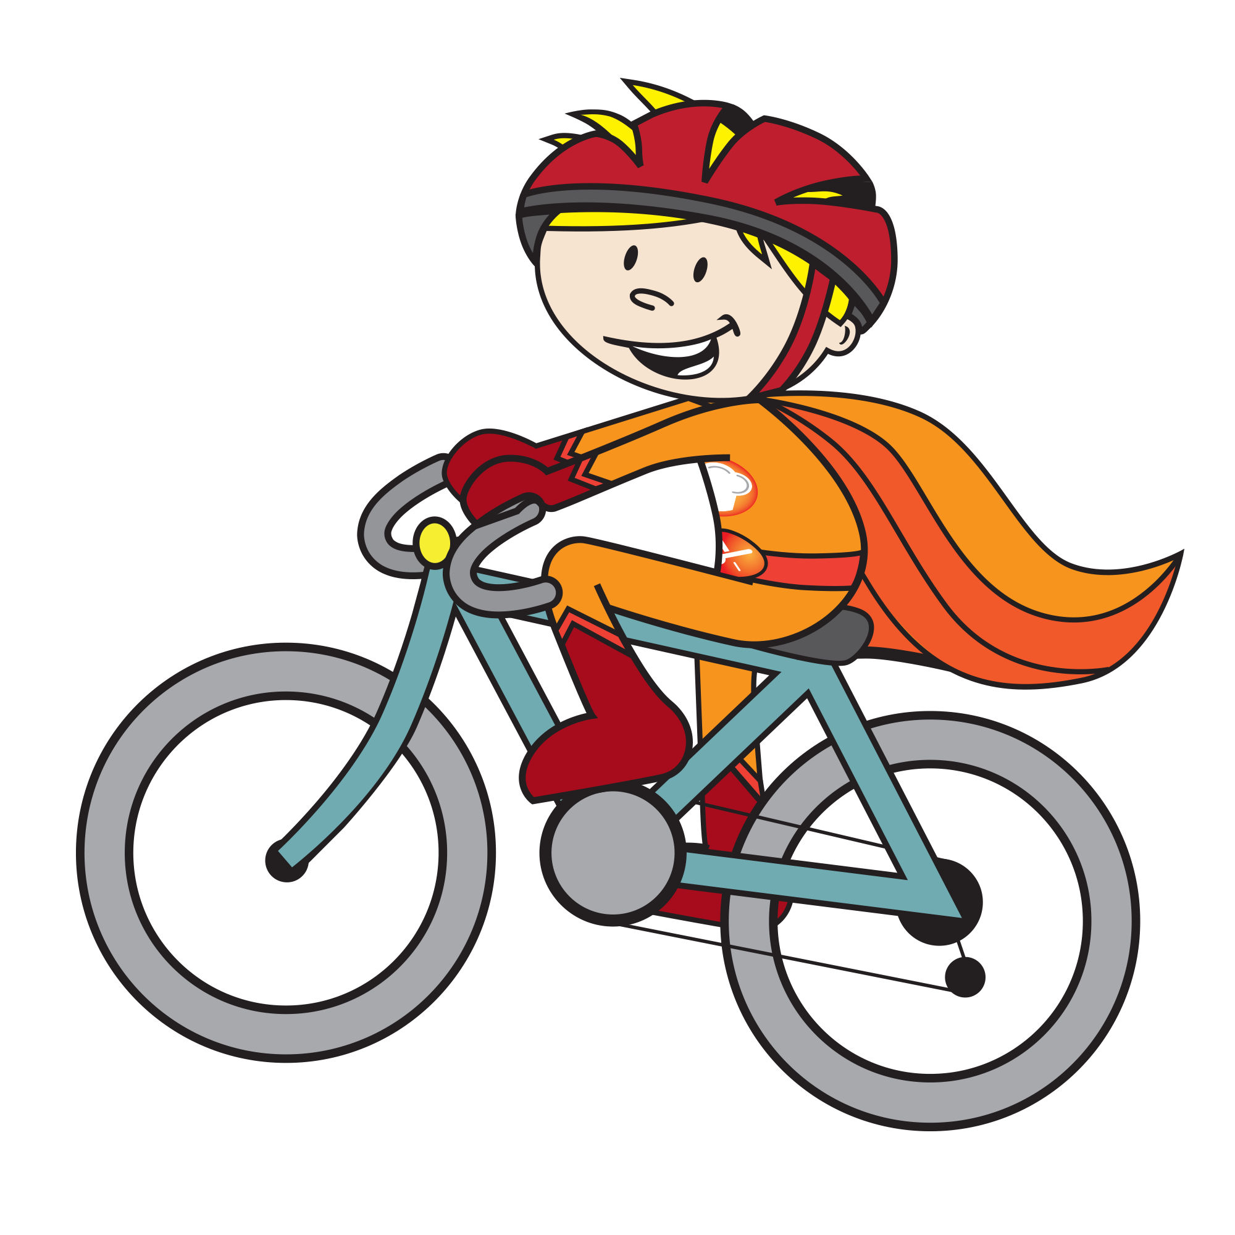 | - Suggest ways to be active for at least 60 minutes each day;  - Participate in team sports;  - Know how physical activity uses energy provided by food and drinks;  - Take part in activities which make them healthy and happy;  - Staying hydrated whilst being active.

Charts can be displayed on the classroom wall or kept by the children in their work books or drawers. If the charts are being used at home, they could be kept in the bedroom or on the fridge in the kitchen.

Curriculum links
The charts, along with the supporting worksheets, provide a strong platform for teaching children about diet and health, consumer awareness (shopping), cooking, food safety and active lifestyles. The location of these areas in the curriculum will depend on where you live in the UK. The charts can also provide support to those working in pre-school settings, particularly helping with group work around food.

England
It supports the Early Years Foundation Stage early learning goals, and Key stage 1 and Key stage 2 in Design and Technology (Cooking and nutrition), PSHE, Science and Physical Education. It can also be used in other areas such as Literacy (reading and writing recipes), Numeracy (weighing and measuring) and Religious Education (looking at, tasting and cooking different foods for special occasions).
https://www.gov.uk/government/collections/national-curriculum

Northern Ireland
It supports Foundation Stage, Key Stage 1 and Key Stage 2 in The World Around Us (Science and Technology, Geography) and Personal Development and Mutual Understanding and Physical Education. It can also be used in other areas such as Language and Literacy (reading and writing recipes), and Mathematics and Numeracy (weighing and measuring) and Religious Education (looking at, tasting and cooking different foods for special occasions).
http://www.nicurriculum.org.uk/

Scotland
It supports Pre-school to P7 in Technologies, Science, Social Studies and Health and wellbeing. It can also be used in other areas such as Languages (reading and writing recipes), Mathematics (weighing and measuring) and Religious and Moral Education (looking at, tasting and cooking different foods for special occasions).
http://www.educationscotland.gov.uk/

Wales
It supports Foundation Phase in Personal and Social Development, Well-Being, and Cultural Diversity; Knowledge and Understanding of the World, and Key Stage 2 in Design and Technology, PSE and Science. It can also be used in other areas such as English (reading and writing recipes), Mathematics (weighing and measuring) and Religious Education (looking at, tasting and cooking different foods for special occasions).
http://gov.wales/topics/educationandskills/schoolshome/curriculuminwales/arevisedcurriculumforwales/?lang=en

Acknowledgements

Food route: a journey through food was originally launched in 2009 by the Food Standards Agency (FSA) working in collaboration with the British Nutrition Foundation. Thank you to the following schools for their advice in the development of the original Food Route resources:
- England: Oak View Primary and Nursery School
- Northern Ireland: Gracehill Primary School
- Scotland: Stenhousemuir Primary School
- Wales: Waunarlwydd Primary School

The information is provided under the Open Government Licence. Terms can be found at:

http://www.nationalarchives.gov.uk/doc/open-government-licence

Published by Public Health England 2016 © Crown copyright 2016

Design by British Nutrition Foundation and ingenious

