

11-14 Years Users’ Guide

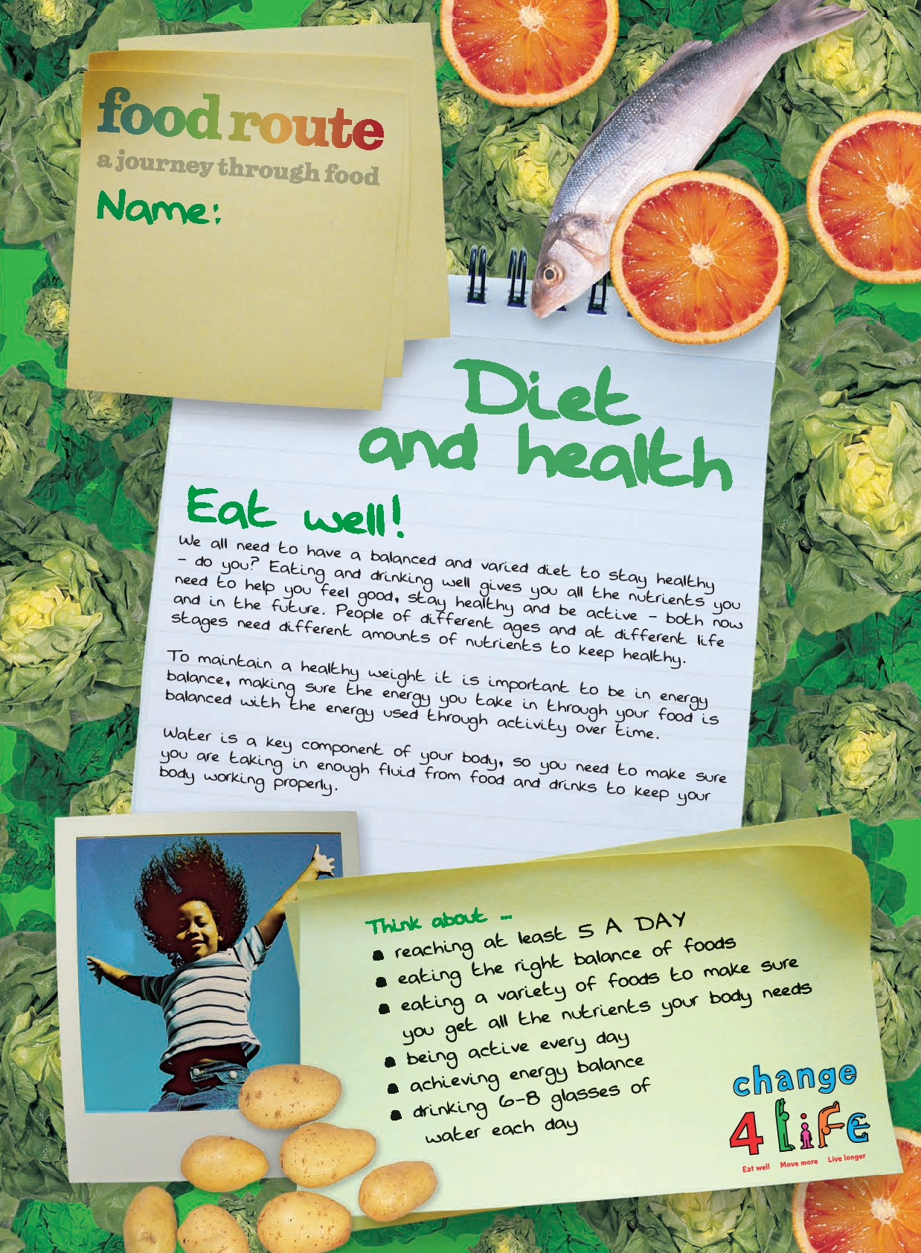


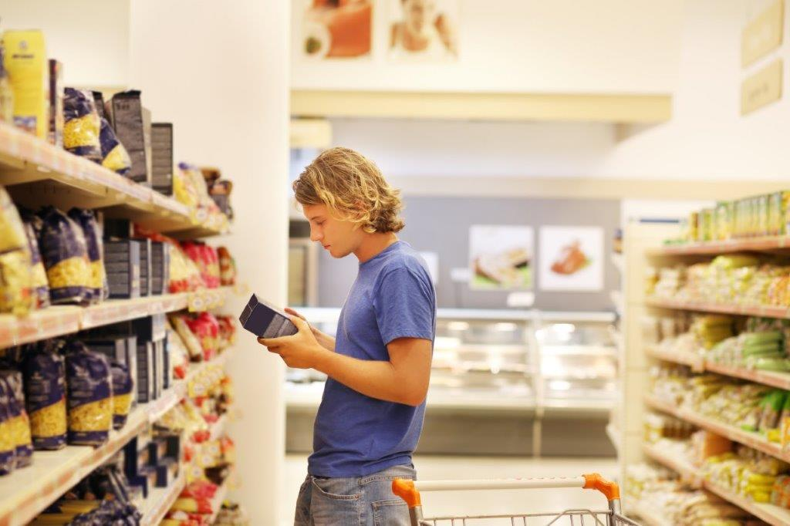

Welcome

Welcome
This guide is for teachers and others who wish to use the Food route: a journey through food resources at school or in other settings. The resources, developed by Public Health England and British Nutrition Foundation, have been devised to help young people engage with the Core Competences.

Background: Core Competences
The Core Competences were originally launched in December 2007 by the Food Standards Agency and the British Nutrition Foundation, and have since been reviewed and updated in 2014 by Public Health England, FSA Northern Ireland, FSA Scotland, the Welsh Government and the British Nutrition Foundation. An additional review was carried out in 2016 following the launch of the new UK Healthy Eating Model – the Eatwell Guide. They comprise a progressive series of food, nutrition and activity related competence statements for children and young people aged 5 to 16+ years. The competences are based around five themes: diet and health, consumer awareness, cooking, food safety and physical activity.

The Core Competences can help young people to choose, cook and eat safe, healthy food and lead an active lifestyle. They are set out as a framework of core skills and knowledge, providing essential building blocks so that parents/carers, schools and community-based organisations can provide young people with a consistent set of food skills and knowledge.

Because the competences are progressive and cumulative from one age stage to the next, they can help young people make healthier choices that benefit them now and in later life. Importantly, the competences apply to all learning experiences, both within and outside the school setting, and can be met at home or through other activities. For further information, go to: www.nutrition.org.uk/foodinschools/competences.

Food route – a journey through food
To help children and young people engage with the Core Competences, a series of focus groups and workshops were arranged throughout the UK. The original competences were rephrased in an age-appropriate way, and tested to ensure that young people understand what they meant and how they could achieve the different competences. The focus group sessions helped to gather feedback from young people about the language used, as well as the design.

What resources are available?
To engage young people aged 11-14 years with the Core Competences, a series of competence journals have been created. These act as journals of evidence, showing how young people engage with the competences in a meaningful way.

The journals set young people with a number of tasks in order for them to demonstrate their understanding and accomplishment of each competence. The Core Competences have been rewritten to be age-appropriate for young people.

Journals
Five journals have been devised. The journals are:
- Diet and health;
- Consumer awareness;
- Cooking;
- Food safety
- Active lifestyles.

Differentiation
Although the competences have been created for particular age phases, you may wish to use the different journals for young people at different ages or abilities. For example, you may wish to use the ’14-16 years’ journals to challenge more able students, or use the resources developed for primary aged children for those with special educational needs.

Certificates
A certificate is also provided. The certificate can be awarded after the young person has completed all the competences, or when they have successfully completed one competence area, e.g. cooking.
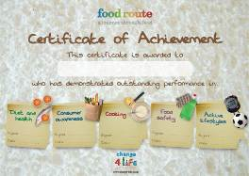
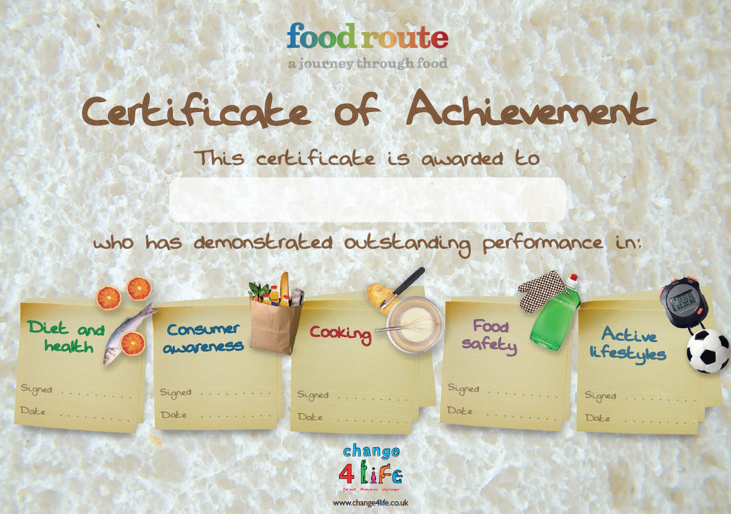
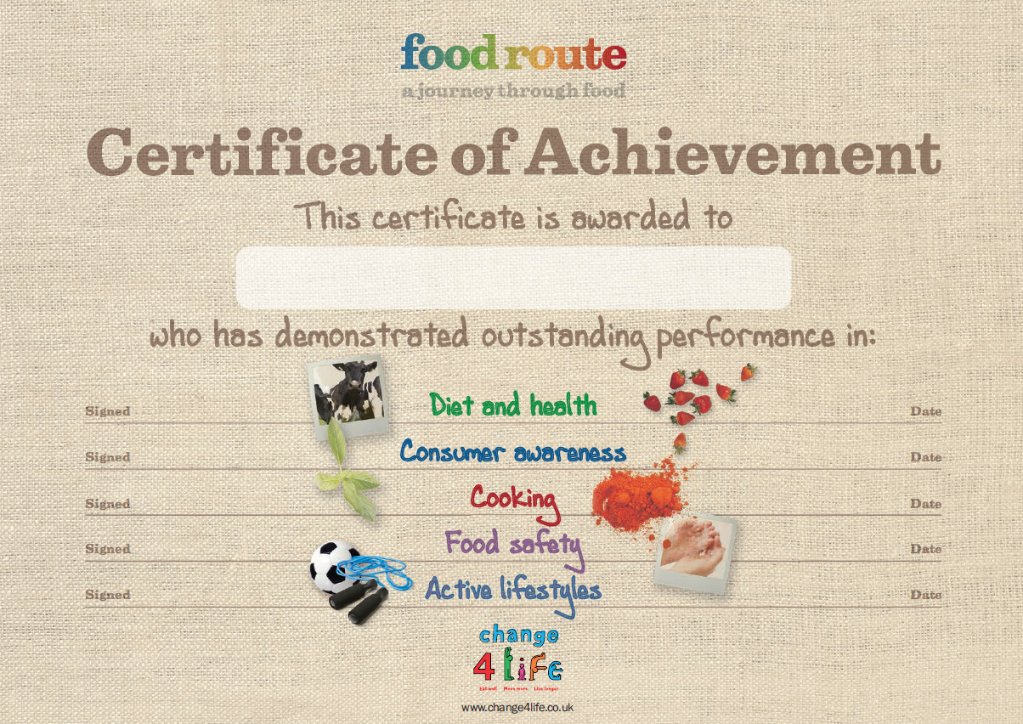

Layout of a journal
The journals provide young people with a number of challenges based around the four themes of the Core Competences . Although the two age phases have different designs, they share a similar layout.

Front page Back page
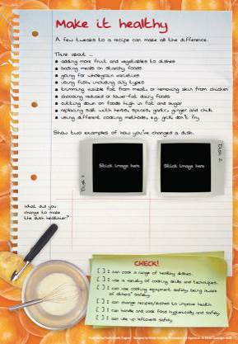
Information to support the completion of tasks.

Pupils personalise their own journal.

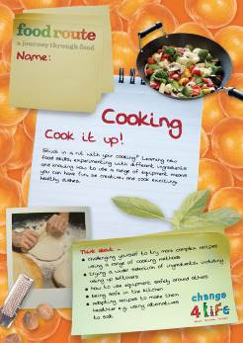

Journal name

Checklist of the competences covered.

Setting the scene.

Summary of the main issues in the journal.

Space for photographic evidence.

Inside pages

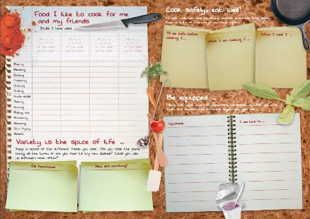
Tasks help pupils attain competences.

Checklist task.
Open-ended task.
How can the journals be used?
The journals have been designed to be flexible, allowing them to be used in a variety of different settings, including home, school or out-of-school clubs and societies.

It is suggested that each pupil should have their own journal in which they can complete the different tasks and challenges. It may be easier to provide one themed journal at a time, rather than giving students all five. However, the choice is yours as each of the journals are available individually for download. The journals could be a useful resource in supporting your own Scheme of Work in school.

The journals can be kept in pupil’s workbooks and completed as part of a lesson or other activities. For example, the journals could be used for:
- classroom activities, e.g. food technology, home economics, physical education or science lessons;
- homework tasks;
- cover lessons;
- healthy schools and activity weeks.

The journals can support work in …
 | By 14 years
Diet and health | - understanding and applying the eatwell guide;  - investigating nutrients and the needs of different people;  - exploring energy balance;  - understanding the importance of water in the diet.
Consumer awareness | - knowing where food comes from and factors affecting production;  - comparing the costs of food;  - investigating food choice;  - examining food advertising  - exploring food labels;  - determining portion sizes.
Cooking | - developing a range of food skills;  - investigating different equipment safely;  - adapting recipes for health  - ensuring food safety;  - avoiding waste and using up leftover foods safely.
Food safety | - keeping a kitchen clean, tidy and hygienic;  - being safe before, during and after cooking;  - following date mark and storage instructions on food labels;  - identifying foods which have a high risk of causing food poisoning.
Active lifestyles | - understanding the importance of being active every day;  - improving physical, social and mental health through physical activity;  - knowing what to eat before, during and after exercise;  - explaining why we require more water is required when exercising.
Curriculum links
The journals provide a strong platform for teaching young people about diet and health, consumer awareness, cooking, food safety and active lifestyles. The location of these areas in the curriculum will depend on where you live in the UK. The links below demonstrate how the journals support some aspects of food education in school.

England
Design and Technology: Cooking and Nutrition | - understand and apply the principles of nutrition and health  - cook a repertoire of predominantly savoury dishes so that they are able to feed themselves and others a healthy and varied diet  - become competent in a range of cooking techniques  - understand the source, seasonality and characteristics of a broad range of ingredients.
Science | - content of a healthy human diet: carbohydrates, lipids (fats and oils), proteins, vitamins, minerals, dietary fibre and water, and why each is needed  - calculations of energy requirements in a healthy daily diet  - the consequences of imbalances in the diet, including obesity, starvation and deficiency diseases
Personal wellbeing | - Healthy, active lifestyles.  - The benefits and risks of health and lifestyle choices.
The journals also support the aims of the Physical Education curriculum, notably the aim for pupils to lead healthy, active lives. https://www.gov.uk/government/collections/national-curriculum

Northern Ireland
Learning for life at work (Home Economics) | - Healthy eating - provides opportunities to develop understanding required in the choice, planning, storage, preparation, cooking and serving of food.  - Independent living - Investigate a range of factors that influence consumer choices and decisions.
Science and technology (Science) | - Organisms and health: healthy body and mind.  - Objective 1: developing pupils as individuals - explore physical, chemical and biological effects on personal health.  - Organisms and health: healthy body and mind.
Learning for life and work (Personal Development) | - Key concept: personal health (diet, hygiene).
Physical education | - Supporting the key Knowledge, Understanding and Skills – as well as aspects of the three Objectives
http://www.nicurriculum.org.uk/

Scotland
Technologies | - Food and textile contexts for developing technological skills and knowledge  - Preparation techniques and processes.  - Use of ingredients and equipment and can apply specialist skills in preparing food.
Health and wellbeing | - Planning for choices and changes.  - Food and health  - Nutrition.  - Safe and hygienic practices.  - Food and the consumer.  - Physical education, physical activity and sport
http://www.educationscotland.gov.uk/

Wales
Design and Technology: food | - Use a broad range of skills, techniques and equipment, as well as standard recipes, to cook meals and products.  - Plan and carry out a broad range of practical cooking tasks safely and hygienically.  - Apply current healthy eating messages in relation to the nutritional needs of different groups in society and consider issues of sustainability in order to make informed choices when planning, preparing and cooking meals or products.  - Classify food by commodity/group and understand the characteristics of a broad range of ingredients, including their nutritional, functional and sensory properties.
Science | - Components of a balanced diet are needed for good health.  - How food is used by the body as fuel.
Personal and social education | - Health and emotional wellbeing (the relationship between diet, exercise, and good health and well-being).
Physical education | - Learners should be given opportunities to promote their health and emotional well-being and moral and spiritual development; to become active citizens and promote sustainable development and global citizenship; and to prepare for lifelong learning.  - Physical education contributes to learners’ personal and social education by prioritising activities that contribute to health, fitness and well-being throughout life.
http://gov.wales/topics/educationandskills/schoolshome/curriculuminwales/arevisedcurriculumforwales/?lang=en

Acknowledgements

Food route: a journey through food was originally launched in 2009 by the Food Standards Agency (FSA) working in collaboration with the British Nutrition Foundation.

Thank you to the following schools for their advice in the development of the original Food Route resources:
- England: Maidstone Grammar School for Girls
- Northern Ireland: Cambridge House Grammar School
- Scotland: Larbert High School
- Wales: Bishop Gore School

The information is provided under the Open Government Licence. Terms can be found at:

http://www.nationalarchives.gov.uk/doc/open-government-licence

Published by Public Health England 2016 © Crown copyright 2016

Design by British Nutrition Foundation and ingenious

