How to grow wheat

Sprouting your seeds
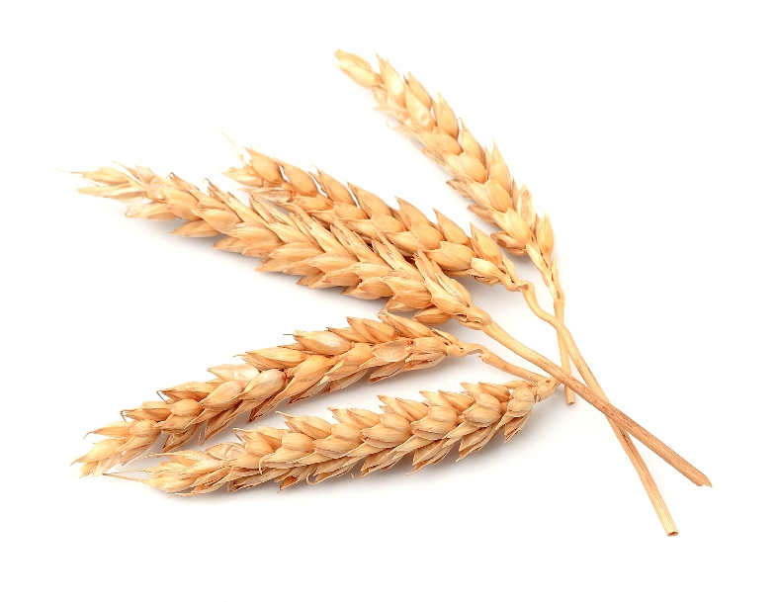
You will need:
- Paper towel (or a sheet of kitchen roll)
- Shallow plastic container
- Plastic jug of water
- Wheat seeds*

Method:
- Place the paper towel in the container.
- Water the paper towel so it is damp.
- Place some wheat seeds on the paper towel.
- Place the container on a window sill.
- Water your seeds every few days to keep the paper towel damp.

Planting your seeds

You will need:
- Plastic cup
- Ball of plastercine or tac
- Pen (biro)
- Compost
- Sprouting wheat grains
- Small trowel or old spoon (no longer used for eating)
- Tray (or bowl to catch drained water)
- Small jug (for watering)

Method:
- Stand the cup on the ball of plasticine or tac.
- Push the pen tip through the bottom of the cup three times to create small drainage holes.
- Place the cup on the tray.
- Fill the cup with compost until it is about 3cm from the top.
- Water the compost so it is damp
- Sprinkle a spoonful of the sprouting grains on top of the compost and spread them out so they are in a single layer (not on top of each other).
- Cover the seeds with compose and fill the cup until it is near the top.
- Water the newly added compose so it is damp.
- Place the cup (on the tray) on a window sill.
- Water the wheat every few days to keep the compost damp.

Notes: A wheat seed will grow successfully on a paper towel, initially. However, in order for its root system to fully develop (to support it properly), it is then best to plant it in soil. The soil also provides extra nutrients to help the wheat grow well.

The wheat seed contains its own food so it can start to grow in the dark. However, once its food supply runs out, it will then need light to be able to make its own food (photosynthesis).

