Wheat to bread

Wheat grain
Farmers plant seeds which grow into wheat. Wheat grains grow at the top of the plant. They are closely packed together in clusters called ears. Each ear of wheat is made up of 45-50 grains, however, this can vary depending on the type of wheat. It is these starchy grains that we eat. Here is what a grain of wheat looks like close up.

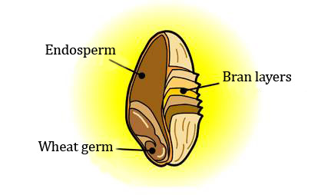
Each grain of wheat has three distinct parts. First there is the coarse outer bran layers. Inside the bran layer there are two parts. The smaller part is called the wheat germ – a new plant would grow from this part. The larger part is called the endosperm. This is the starchy store of food which the germ feeds on while it grows.

The endosperm is the white flour we use to make many products. After milling, the wheat germ and bran can be added back to white flour in different amounts to create either brown or wholemeal flour.

Growing wheat

Autumn/winter (September to November)
In autumn/winter, the field is ploughed to break up compacted soil. The seed is then planted. (The seed is grains of wheat produced previously.) The seeds need water, warmth and light to grow. Farmers also spray fertiliser on the plants. The fertiliser provides extra nutrients to help the plants grow well and produce a greater yield. The farmer will also use other sprays to protect the wheat from weeds, disease and pests.

Spring
In the spring, the wheat plants will grow more quickly and start producing ears of grain. The ears will be green in colour.

Summer
During the summer, the ears of grain ripen and turn golden yellow. In August, the wheat is harvested by the combine harvester. The combine cuts the wheat plant and separates the grain from the ‘chaff’. The chaff is the inedible parts of the plant – the stalk and the husks which cover the grain. In the past, before combine harvesters, people would ‘thrash’ the wheat by beating it on the ground to release the grain. Now, the combine cuts and thrashes the wheat. The grain is collected in the combine’s tank and the chaff is dropped back onto the field. The chaff will be gathered later by a baler and turned into bales of straw. The grain is dried and stored and then sent to a flour mills or other processors.

Milling
Wheat can be used to make many foods such as bread, cakes, biscuits, pancakes, soups, sauces, pasta, batter, fish finger crumb, chocolate, crumpets, muffins, stock cubes, breakfast cereal. However, before it is used to make different foods, it has to be milled.

Screening and cleaning
Firstly the wheat is cleaned and the things that cannot be eaten are removed. Powerful magnets, metal detectors and other machines extract metal objects, stones and other grains such as barley, oats and small seeds from the wheat grain. Throughout the cleaning process, air currents lift off dust and chaff.

Milling
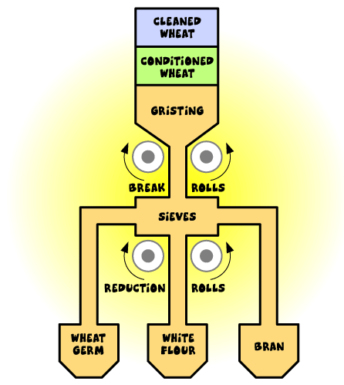
In the past, grain was milled by being crushed in one go between two big stones (in a windmill or watermill). Nowadays millers use a much more gradual approach and grind a bit and separate the different components then grind and separate a bit more. During the ‘first break’ the grain is milled through steel rollers with teeth that break the grains open. It is then repeatedly reduced and sifted to separate the wheat germ, bran and endosperm and achieve the desired colour and consistency of flour.

The whitest flours are produced from the early reduction rolls, with the flour getting less white on later rolls as the proportion of bran particles increases.

Bran
The bran is the skin of the grain. Bran is very high in fibre. It is used in cereal such as bran flakes and animal feed is also made from bran. Bran (and wheat germ) is put back into the white flour to make wholemeal flour - however, we only make a small amount of wholemeal flour so to avoid a lot of bran being wasted, it is used to make wheatfeed to feed animals, e.g. cattle, pigs, chickens.

Flour
In the past, when flour was ground between two stones, it was impossible to get such white, uniform, fine particles. Advances in the way the particles are separated and ground means that we have pure white silky smooth flour today; which goes on to make a huge array of products.

Brown flour is made by recombining the white flour with some of the wheat germ and bran that were separated out in the milling process.

Wholemeal flour is made by recombining the white flour with all the wheat germ and bran in the same proportions as they were in the original grain.

