Caribbean Islands cuisines –

a brief overview

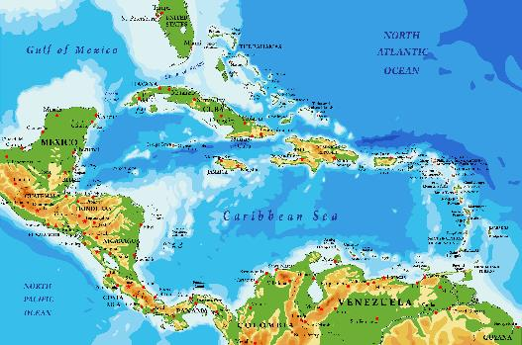
The Caribbean Islands is a large archipelago located in the Caribbean Sea, that can be subdivided into different regions: the Lucayan Archipelago, the Greater Antilles, the Lesser Antilles and the ABC Islands. There are 13 sovereign states and 17 dependent territories in the Caribbean, and the predominant languages are English, Spanish, French, Dutch and Antillean creole. The Caribbean covers more than 1.06 million square miles and is primarily located between North America and South America.

Modern Caribbean culture has been heavily influenced by the culture and traditions of Europe, along with aspects of African culture and others that have come to the islands through immigrant populations. These various waves of migration have formed a unique blend of cuisines, music, art, customs, and traditions in the region.

History
The Arawak, Carib, and Taino people were the first dwellers in the Caribbean Islands. Their daily diet consisted of vegetables and fruits such as papaya, yams, guavas, and cassava. The Taino began the process of preparing meat and fish in large clay pots; the Carib Indians introduced spices and lemon juice to their meat and fish recipes.
The Caribbean has seen migration from different continents for centuries. One of the greatest cultural impacts of this migration has been on the food. The islands in the Caribbean have been fought over and owned by various European countries in the past, mainly the British, French, and Spanish. All these cultures, as well as their respective culinary traditions, have played a role in forming the multi-national cuisine of the Caribbean.

When Columbus arrived in 1493, the Spaniards introduced other foods such as coconut, chickpeas, coriander, aubergine, onions, and garlic. European colonists, including the Portuguese, Dutch, Danish, British, French, and the Swedes came later to the islands with their culinary culture. Some of the foods introduced by them were oranges, limes, mangoes, rice, and coffee.

The key moment in the evolution of Caribbean cuisine was the Europeans bringing African enslaved people to the islands so that in effect, the Caribbean became the crossroads to the rest of the world. The enslaved people’s diet was mostly food that the owners did not want to eat, so the enslaved had to be inventive with what was available to them. They blended traditional African foods with staple foods found on the islands, introducing okra, callaloo, fish cakes, saltfish, ackee, pudding, and mangoes.
When slavery was abolished on the islands, slave owners had to look elsewhere for help. Bringing in help from India and China, different types of dishes using rice or curry were introduced and blended into mainstream Caribbean cuisine. This is how the Caribbean favourite curry goat was developed.

Caribbean cuisine therefore is a fusion of African, Amerindian, European, East Indian, Arab and Chinese cuisine, these global influences, combined with indigenous Caribbean ingredients and techniques have defined modern Caribbean cuisine.

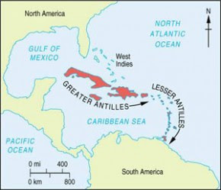
Islands and their cuisine
The Lucayan Archipelago also known as the Bahama Archipelago, is an island group comprising the Commonwealth of The Bahamas and the British Overseas Territory of the Turks and Caicos Islands.

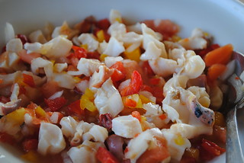
In the Bahamas only a very small amount of the land is arable, and soils are shallow. Nearly all the country’s food is imported, largely from the United States. However, the climate allows the cultivation of many fruits, including tomato, pineapple, banana, mango, guava, sapodilla (the fruit of a tropical evergreen tree), soursop, grapefruit, and sea grape. Some pigs, sheep, and cattle are raised.

The small fishing industry’s catch is dominated by spiny lobster, grouper, and conch.

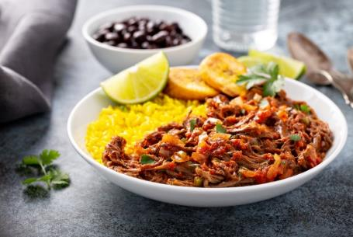
The Greater Antilles is a grouping of the larger islands in the Caribbean Sea, including Cuba, Hispaniola (Haiti and Dominican Republic), Puerto Rico, Jamaica, and the Cayman Islands. They make up nearly 90 percent of the total land area of the entire West Indies.

Hispanic and Latin American cultures heavily influence Cuba’s cuisine. Ropa Vieja is the national dish of Cuba, a hearty stew made with shredded beef, tomato sauce, onions, and peppers and is traditionally served with yellow rice.

It is believed that the Sephardic Jews from the Iberian Peninsula in Spain invented the dish because they could not cook on the Sabbath, so they prepared this hearty stew a day in advance.

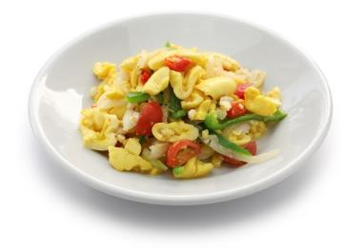

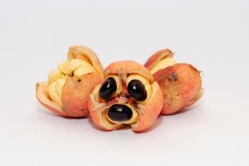
The national dish of Jamacia is ackee and saltfish and is often eaten for breakfast or brunch. Ackee is a pear sized fruit that originally came from West Africa in the 1770’s and when cooked looks like scrambled egg. Saltfish is fresh fish, usually cod, that is salt cured and dried and was originally imported to Jamaica during the 16th Century via Canada. The salt fish is boiled to remove most of the saltiness then fried with onions and green peppers.

The Lesser Antilles form long arc of small islands in the Caribbean Sea extending in a north-south direction from the Virgin Islands to Grenada. Several other islands such as Trinidad and Tobago and Margarita Island, off the northern coast of Venezuela are usually included in definitions of the Lesser Antilles. The north-south portion of the Lesser Antilles was divided into two groups by the French, Dutch, and British. The names of the groups, Windward and Leeward, reflect the importance to the region of the prevailing easterly trade winds. The Windward Islands are those ranging south from Dominica to Grenada, and the Leeward Islands are those that arc westerly from Guadeloupe to the Virgin Islands.

The food is varied across the islands - here are some favourites:
Cou-cou, also known as fungi/fungee, forms at least part of the national dish on many islands of the Caribbean, including Antigua and Barbuda, The Virgin Islands and Barbados. It describes a thick mash of yellow cornmeal and okra, with origins in Caribbean-African with inspiration and ingredients from both continents. In Barbados, the country’s national dish is flying fish and cou-cou, traditionally served on Fridays.
Doubles are a curry chickpea sandwich, popular as a street food in Trinidad and Tobago. The sandwich “breads”, called baras, are formed from a dough of flour, yeast, water, cumin and turmeric, giving them their bright yellow colour. The dough is then rolled flat and shallow fried and topped with various fillings and condiments.
The name “bara” is an alternative name for “vada”, which is used to described fried carbohydrate snacks in India. The filling of doubles is curry channa. Chana is an Indian term for chickpeas, and the filling is a variation of the chana masala, which are spiced, stewed, chickpeas. The curry channa is made by combining whole chickpeas with sautéed onion, garlic, Scotch bonnet chillies, cumin, curry powder, allspice, nutmeg and thyme. Water or stock is added to this mixture, and it is simmered until a thick stew is formed. This is then sandwiched between a pair of freshly fried baras, and various chutneys or sauces, such as green mango, green chillies, garlic, onion or tomato, are often provided at the street stall so that customers can add varieties and amounts to their taste.

The ABC Islands (Leeward Antillies) are the group of Aruba, Bonaire, and Curaçao, the three westernmost islands of the Leeward Antilles in the Caribbean Sea. All islands share a similar European heritage and because of this they share similar dishes. The local cuisines on the Leeward islands also have a lot in common with South American cuisine as most of their fresh vegetables and fruits are imported from Venezuela.
Most people eat their main meal at lunch time on these islands. The meal often consists of polenta or rice with steamed or fried meat.

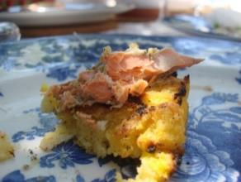
On special occasions dishes such as weddings, Keshi Yená, stobá and bolo pretu are served. Keshi Yená is a dish made from a hollowed out Edam cheese that is filled with a mixture of meat with raisins, plums, capers and olives. The stobá is a stew and can be made with meat, fish or vegetables. Well-known stobá’s are konkomber stobá (cucumber) and the kabritu stobá (goat stew). These stews are usually served with funchi. For desert pretu, which is a dark fruitcake with fruit that has been soaked in an alcoholic syrup is often served.

Ingredients
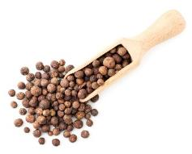
Pimento (Allspice)
Dried pimento berries look like large dark peppercorns and are used in jerk cooking. Pimento wood is often used to smoke jerked meat, the sticks are placed over the heat, the meat (usually chicken or pork) sits on top of the wood and is sealed by a metal lid, thus infusing the meat. The berries are also used to make jerk seasoning or rub.
Tamarind
Tamarind is common across the Caribbean where the season is usually around March. Tamarind is used to flavour sauces, and to make tamarind balls - a sticky sweet made of balls of tamarind flesh rolled in sugar.
Coconut milk
Coconut milk is a liquid that comes from the meat, or white flesh, of a coconut (not the slightly opaque liquid that flows from a freshly opened coconut). Coconut milk is sold in two main forms, one of which is canned. It is a thicker product and most often used in Asian or Indian cuisine. The other is a thinner, more processed commercial coconut drink that is typically kept in the refrigerated section with other plant milk alternatives.
Canned coconut milk is made by grating the inner white meat of a coconut and simmering it in water to make a creamy paste. The liquid is then strained, and the meat is removed. Canned coconut milk separates into a thicker coconut cream and thinner coconut water.
Commercial coconut milk is made by blending coconut milk with water and coconut cream to make a milder, thinner consumer drink.
Plantain
Plantains (plátanos in Spanish) look like large bananas. They are technically fruits, but they are eaten and cooked as if they were a vegetable. Harder to peel (especially when green) than bananas, plantains cannot be eaten raw. Peeled plantains may be baked, boiled, fried, grilled, or steamed.

A selection of national dishes of the Caribbean Islands

Antigua and Barbuda - Fungee and Pepperpot  Fungee is a bread ball like polenta, consisting of cornmeal mixed with okra.  Pepperpot is a one-pot stew that is originally from Guyana but has been adapted to the Caribbean islands.  The key ingredient in Pepperpot is cassareep - a thick, sticky liquid obtained from the roots of the cassava plant, which is extremely poisonous if it isn't cooked correctly. | 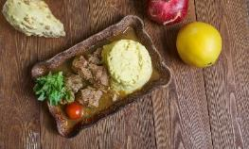
Dominican Republic – Callaloo soup  The soup is made with a combination of leafy vegetables such as dasheen or spinach, coconut milk, salted meat, yams, onions, peppers, green bananas, and dumplings consisting of flour and cornmeal. It is traditionally eaten during carnival season or at parties and special occasions.  It is a popular dish across the Caribbean with many variations. | 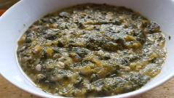
Martinique – Grilled snapper with creole sauce  The fish is topped with the tomato-based Creole sauce and is typically served over a bed of fungi, the classic Virgin Islands side dish of buttery cooked cornmeal with sliced, boiled okra. Creole sauce is made with tomatoes, onions, peppers, thyme, oregano, basil, paprika and Creole seasoning – a spice mix originally from New Orleans. | 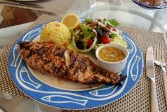
Monserrat – Goat water  Goat water is the national dish of Montserrat, a stew authentically made from the meat of the male (ram) goat with breadfruit, onions, tomatoes, and fresh herbs. It is similar to Irish stew and can be served with a variety of foods, such as bread, and rice. It reflects the islands African and Irish ancestry. | 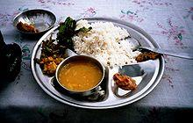
St Lucia – Green fig and saltfish (also known as green bananas and salted cod).  This dish consists of stewed fish, which is usually sold dried and salted, with boiled green bananas, locally referred to as green fig. It is often served with fresh cucumber salad, avocado slices, carrots, and cabbage. The saltfish is stewed with tomatoes and lots of fresh green herbs, peppers, garlic and onion. | 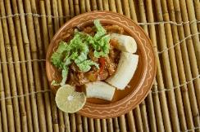
St Marteen – Conch and dumplings  The dish uses local conch (a large sea snail) which is seasoned with various herbs and spices and cooked in a pressure cooker until it is soft and succulent. The conch is accompanied by light and fluffy dumplings made with or without cornmeal, depending on the chef. | 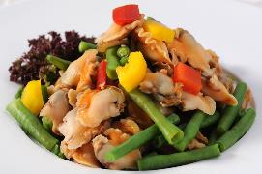
St Vincent and the Grenadines – Roasted breadfruit and fried jack fish  Traditionally, the whole breadfruit is roasted over an open fire until it is slightly charred from the outside, while its centre remains soft and tender.  The fish is usually marinated in lemon juice before it is dusted in flour and fried until crispy. The dish is typically accompanied by a sauce that incorporates onions, tomatoes, garlic, thyme, or other vegetables and herbs. | 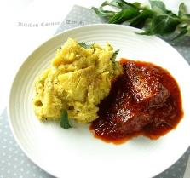
Trinidad and Tobago – Crab and Callaloo  The dish is traditionally enjoyed for Sunday lunch and is made by simmering pieces of crab in callaloo, a creamy mixture of dasheen leaves (taro or eddo leaves), onions, green onions, okra pods, pimento peppers, scotch bonnet peppers, butter, thyme, and fresh coconut milk. It is thought of as a side dish, and its consistency can range from thick and stew-like to thin and soupy. | 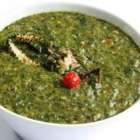

Did you know?
- The Arawaks were among the first to use barbecue techniques by building grills with green sticks. They called it barbacot. The Spanish word barbacoa is a variation of barbacot as is the English word barbecue. Many of these native techniques and foods are still prepared today.
- Enjoyed throughout the Caribbean under different names, cornmeal cou-cou is often eaten with stews of fish, meat, or poultry. The key for a successful cou-cou lies in the vigorous stirring in the later stages of cooking using a specially designed cou-cou stick - a long (about 30cm) flat rectangular wooden spoon that looks a bit like a spatula.
- Most citrus comes from the Pacific region, but the grapefruit originated in Barbados in the 18th century. It is a cross between a sweet orange and a bitter citrus fruit called a shaddock, brought from Polynesia by a Captain Shaddock.

