Middle Eastern style baked eggs

Ingredients
Complexity: medium

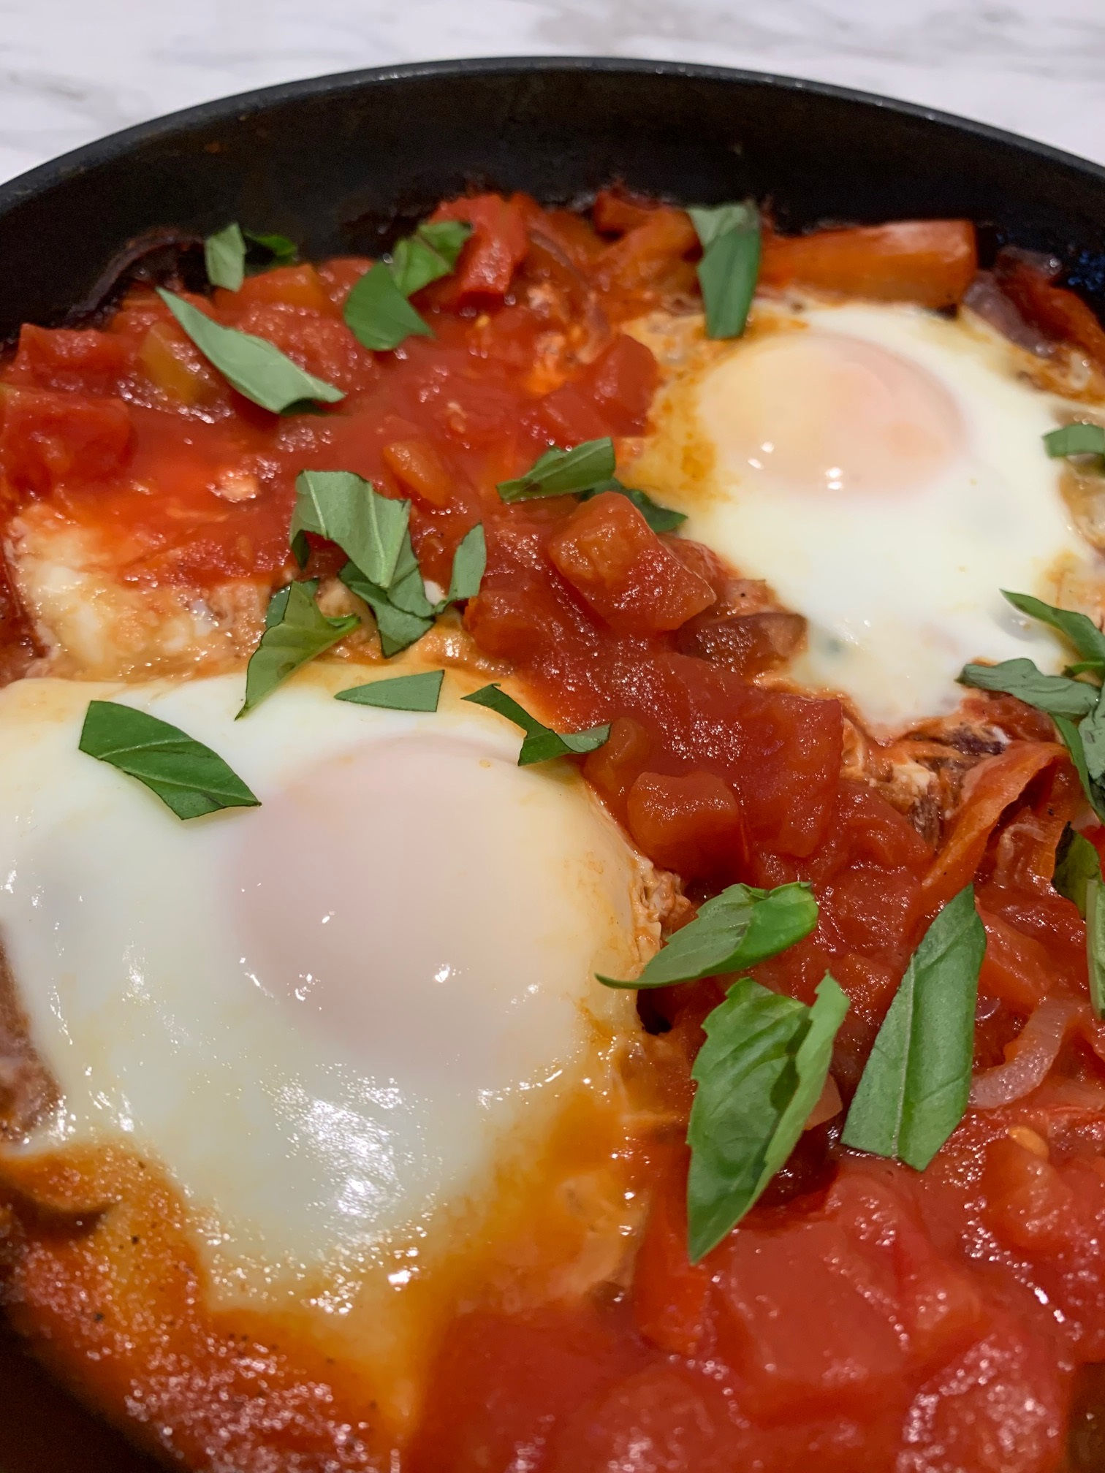
1 large red onion

1 red pepper

Spray oil

Fresh black pepper

200g canned chopped tomatoes

2 eggs

Optional

Small bunch fresh basil – garnish

Equipment

Chopping board, vegetable knife, large frying pan and lid/tin foil, mixing spoon.

Method
- Prepare the ingredients:
- peel and finely slice the onions;
- deseed and finely cut the peppers into 1cm slices;
- chop the fresh basil, if using.
- Spray the frying pan with oil. Add the onions and peppers.
- Gently fry for 10-12 minutes until softened and slightly caramelised. Season with black pepper.
- Add the chopped tomatoes and bring to a gentle simmer. Cook for 15-20 minutes adding a little water if necessary to avoid the sauce becoming too dry.
- When the peppers and onions are soft, make two small wells for the eggs. Crack the eggs into the wells and cook on a gentle heat for 6-8 minutes, until the eggs are cooked to your liking. If necessary, place a lid on the pan to help cook and set the eggs, or cover with tin foil.
- Garnish with the chopped basil, if using.

Top tips
- Choose canned tomatoes with added garlic, herbs or chilli for extra flavour.
- Try substituting the pepper with other vegetables such as courgettes, aubergine, or fennel. For a breakfast or brunch dish, baked beans work well!

Food skills
- Peel
- Slice
- Fry/sauté
- Simmer

Did you know?
This recipe is very similar to shakshuka, which is said to have originated in Ottoman in North Africa in the mid-16th Century after tomatoes were introduced to the region. The word Shakshuka is a Maghrebi Arabic term meaning ‘mixture’ or ‘mixed up’. There are many variations to the basic sauce with ingredients such as olives, harissa, spicy sausage or soft cheese all adding different flavour and texture. It is often served with crusty bread for dipping into the eggs!

In Jewish culture, a large batch of tomato stew is made for the Sabbath dinner and the leftovers used the following morning to make a breakfast shakshuka with eggs.

This recipe was adapted from a recipe for Middle Eastern style baked eggs, kindly donated by Marks and Spencer.

