The salt content of food

Introduction
Common salt is sodium chloride and these two constituents are tested for separately. If silver nitrate is added to solution containing chloride a white precipitate of silver chloride forms which will dissolve in dilute ammonium hydroxide.

If a substance contains sodium it will give a bright orange-yellow colour, when held in a flame.

You will need
Equipment
Test tubes
Test tube rack
Fine pipette or dropper
Spatula
Mechanical grinder or pestle & mortar
Bunsen burner
Tripod
Gauze
Mat
Lengths of chrome or iron wire or wire paper clips (uncoated)
Forceps
Beaker
Glass rod
Eye protection

Materials
Food samples
Distilled water
Silver nitrate solution
Ammonium hydroxide solution, dilute
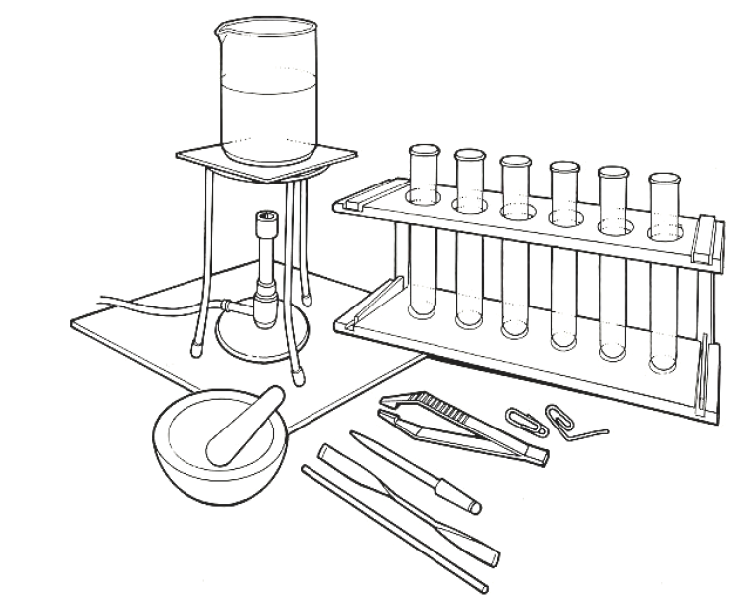

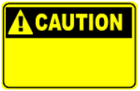



Some people are allergic or intolerant to a particular food or ingredient. Refer to the 14 allergens and check against student records before completing this experiment.

Do not consume food in a laboratory, or any food used for experiments, because it may contaminated.
Wear eye protection.
After heating, the wire should be dropped into water to prevent damage to the bench top etc.
Care should be taken with silver nitrate solution to avoid contact with skin as it will cause discoloration.

Method A
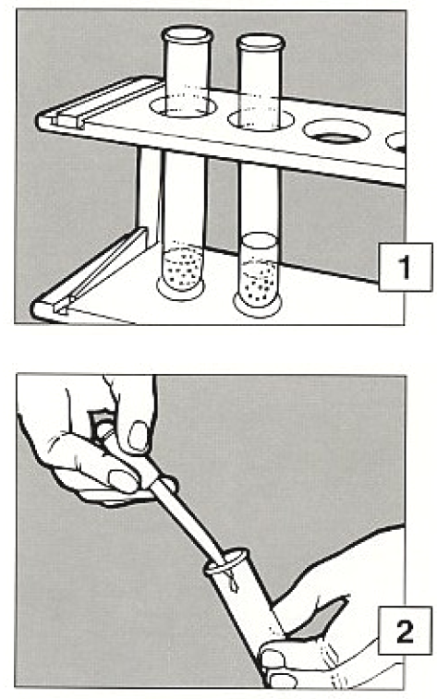
- Make an extract of solid food by grinding, crushing or chopping a small amount, putting it into a test tube to a depth of about 2cm and adding distilled water until the total depth is about 3cm. Stir the mixture with a glass rod and allow to stand for a few minutes.

- Transfer some of the clear liquid into a second test tube and add one drop of silver nitrate solution. Look for a change to a cloudy appearance.

- If a white precipitate forms add dilute ammonium hydroxide solution, drop by drop, to see if the precipitate indicates the presence of chloride.

Method B
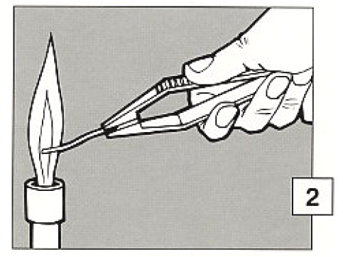
- Obtain a short piece of iron wire, e.g. by bending straight a wire paper clip. Holding one end with forceps put the other end in the bottom of a colourless Bunsen flame. If there is more than a slight yellow colour wash the end of the wire in distilled water and try again until there is only slight colouration of the flame.

- Moisten the end of the wire in distilled water and pick up on it one or two grains of table salt (sodium chloride). Insert the wire in the colourless Bunsen flame and observe the colour change. This is due to the presence of sodium.

- Dip the end of another, clean wire in the food prepared as in method A and insert it in the flame as before.

- Look to see if there is any colour change similar to that caused by the table salt, showing the presence of sodium.

Extension work
If the extract was prepared from food out of a packet look at its label to see if salt is mentioned amongst the list of ingredients.

