South American cuisines –

a brief overview

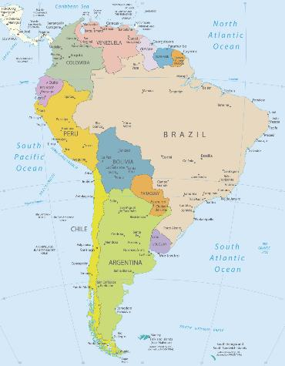
South American cuisine – an overview.
The countries of South America are: Argentina, Bolivia, Brazil, Chile, Colombia, Ecuador, French Guiana, Guyana, Paraguay, Peru, Suriname, Uruguay, Venezuela.

South America is the fourth-largest continent and is home to the world’s largest river (the Amazon) as well as the world’s driest place (the Atacama Desert). It can be divided into three physical regions - mountains and highlands, river basins and coastal plains – all of which have an influence on the food and diet of that area.

Food crops and farming
Corn (maize), a native of tropical America and now a staple in countries around the world, is the most widely cultivated crop throughout the continent. Wheat, along with other cereals, was introduced by the Spanish by the 1550s throughout Andean South America, where it is still grown. Beans are widely cultivated and form an important food item in most countries. The potato, which originated in the high Andes, is now a dietary staple of many European countries. Quinoa is a grain that was first cultivated in the Andes Mountains of South America.

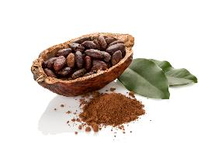
Cacao is native to the Amazon region and the source of cocoa, was prized by indigenous peoples and is still cultivated in many parts of South America, particularly in the state of Bahia, Brazil. Avocados also originated in the same region.

Europeans introduced a number of plants to the continent. Sugarcane has been cultivated in the humid tropics of South America since early colonial times, especially in northern Brazil, where it became the mainstay of the economy.

Since the early 1970s Ecuador has become one of the largest banana exporters in the world. Mangoes, oranges, lemons, and grapefruits are grown widely throughout tropical and subtropical environments in South America.
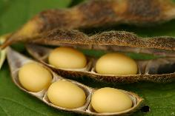
Soybeans were introduced in the 1950s in the Argentine Pampas and in the 1960s in southern Brazil. By the turn of the 21st century, Paraguay had also become one of Latin America’s top exporters of soybeans.

Grapes, apples, pears, and peaches are important exports for Argentina and Chile, and Brazil has been increasing its exports of cantaloupes and honeydew melons to Europe and North America.

Coffee was imported in the 1800s and grown in the highlands of Venezuela, Colombia, and Ecuador. It is exported all over the world and is known as some of the best quality coffee available.

The two commercially most important native South American spices, allspice and red, or chili, pepper are exported from Brazil.

Cattle have a cultural and economic importance and South America has a high percentage of the world’s total cattle population. They are bred and raised in the rich pasturelands of the Argentine Pampas and Uruguay, in eastern and southern Brazil, in the temperate zones of the Andes and in nearly all environmentally suitable areas of every country.
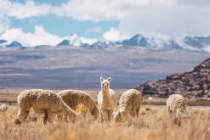
Llamas and alpacas, along with sheep and goats, are found in the higher Andes from Ecuador through northern Argentina and Chile. Pigs and smaller animals like chickens are present in almost all rural areas of the continent. Within the former Inca settlement area of the Andes guinea pigs are still raised as a food source.

Culinary influences from around the world
South American cuisine is a fusion of Indian-South Asian, Portuguese, Italian, Spanish, African, European and Native American characteristics.

The first evidence of humans occupying South America dates back to 9000 BC, which was the time that saw the beginning of beans, chili peppers, and squash cultivation across the Amazon basin. Europeans included some dishes from the indigenous peoples and brought European food and livestock to South America. These included goats, cows, chickens, pigs, almonds, wheat and citrus trees.

Europeans later learned to prepare their own Portuguese, Italian, and Spanish foods with available local ingredients. After adopting indigenous cooking methods, they modified them. New available European food was also mixed into recipes and culinary traditions of Africa and Asia were brought by immigrants. The cuisine in this region is a blend of all these cooking styles.
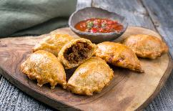
European cuisine has had a significant influence on South American cuisine. Dishes such as empanadas, tamales, and paella were brought over by European settlers.

African cuisine has also had a significant impact on South American cuisine. One example is yuca frita, a dish made with cassava root popular in Brazilian cuisine.

Asian cuisine has also played a role in shaping South American cuisine. One example is the use of soy sauce in Peruvian dishes.

Brazilian foods have native, African, and Portuguese influences. The Portuguese brought desserts like rice pudding and corn pudding, spicy meat stew, and dried salt cod, whereas rice and beans are common in Brazil.

Peruvian cuisine is known for its use of potatoes. Potatoes were introduced to Peru by the Spanish and have since become a staple in Peruvian cuisine.

The cuisine of Argentina is strongly influenced by Italian and Spanish cuisines and cooking techniques. Indigenous cooking from groups such as the Quechua, Mapuche, and Guarani have also played a role.

National dishes
Argentina – national dish is Asados. An asado usually consists of beef, pork, chicken, chorizo and morcilla which are cooked on a grill, called a parrilla, or an open fire. The meat is typically served with Chimichurri sauce.  Gauchos, travelling horsemen in the 18th and 19th centuries, are credited with this dish. Due to its lack of smoke, they would roast beef over wood from the quebracho tree, which gave the meat a very rich flavour. A skewered metal tool called an asador was used to cook the beef close to the slow-burning fire. | 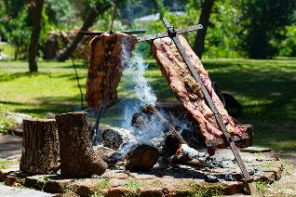
Bolivia – the national dish is Salteñas. Made with beef, pork or chicken, this type of baked empanada is typically filled with a sweet and spicy gravy, boiled eggs, peas, carrots and potatoes. There are also vegetarian versions.  Juana Manuela Gorriti is credited with creating the salteña. She came up with this recipe to support her family who were living in extreme poverty. | 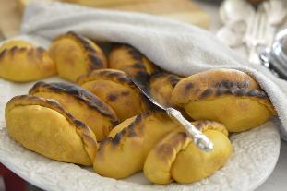
Brazil – the national dish is Feijoada, a stew made with beans, pork, beef or other meat. The meat is usually salted and smoked.  It’s said that Feijoada was created by enslaved persons in Brazil. The leftovers they were given for dinner were usually a mixture of some kind of beans and meat, thus creating the stew. | 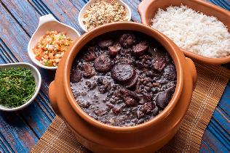
Chile – the national dish is Pastel de Choclo, a beef and corn casserole/pie. Ingredients include corn, basil, minced beef and various spices.  According to some anthropologists, this dish was created when tribal cooks were hired by Spanish conquerors to cook food that reminded them of home. The cooks made a corn dough to be similar to empanadas. | 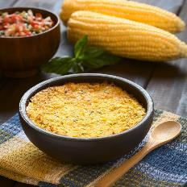
Columbia – Bandeja paisa is a typical meal popular in Colombian cuisine. The main characteristic of this dish is the generous amount and variety of food in a traditional bandeja paisa: red beans cooked with pork, white rice, minced meat, fried pork belly, fried egg, plantain, chorizo, arepa, hogao sauce, black pudding, avocado and lemon. It is served on a platter or a tray.  The origin of the bandeja paisa was influenced by different cultures including the indigenous peoples of Colombia, as well as colonial Spaniards and Africans. In the 19th century French and British colonialists also brought their cuisine with them. | 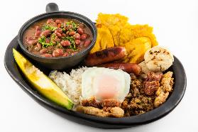
Ecuador - Ecuadorian Ceviche is soup-like and is served with fried plantain chips, as opposed to Peru’s ceviche which is drier and served with cooked potato slices.  Peru, Ecuador’s neighbour, is credited with the invention of ceviche. They would mix fresh seafood with fruity marinades. As more Spanish started to arrive in the region, they planted several citrus fruit plants. The dish started being made with citrus foods such as lime and lemon. | 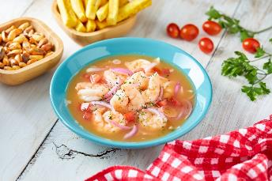
Guyana - Pepperpot is the national dish of Guyana and celebrates the contribution of the nation’s first people.  It is a slow-cooked meat stew using beef, but some versions use mutton, pork or chicken. The meat is cooked with peppers, cinnamon, spices, and cassareep (a sauce made from cassava root (yucca) and a handful of other ingredients). | 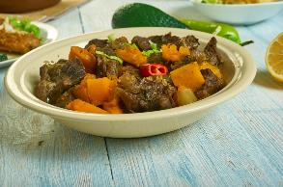
French Guiana – the national dish is bouillon d’awara (bouillon aoura), a tasty stew of smoked fish, crab, prawns, chicken, vegetables, and aoura fruit, which comes from savanna trees.  As in many South American countries, food staples include rice, yucca, and sweet potatoes. French influences are evident in the food, particularly in pastry. | 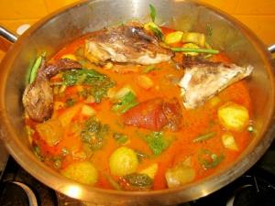
Paraguay - Sopa Paraguaya, like cornbread, the recipe consists of corn flour, cheese, milk and onions.  In the 19th century when the president of Paraguay was making a visit to a certain region of the country, a chef was making a white soup for him, but added too much corn flour. This caused it to become more of a batter, which he then decided to cook in a clay and adobe oven. Impressed by it, President Don Carlos Antonio Lopez named it sopa Paraguaya, translating to “Paraguayan soup.” | 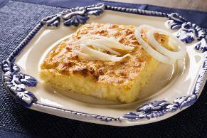
Peru - Peruvian Ceviche is typically made with raw fresh fish, prepared with lime juice, onions, yellow pepper, sweet potatoes, corn, garlic and coriander.  The Moche are responsible for creating ceviche. The Moche was a coastal civilisation that flourished in what is now northern Peru almost 2,000 years ago. | 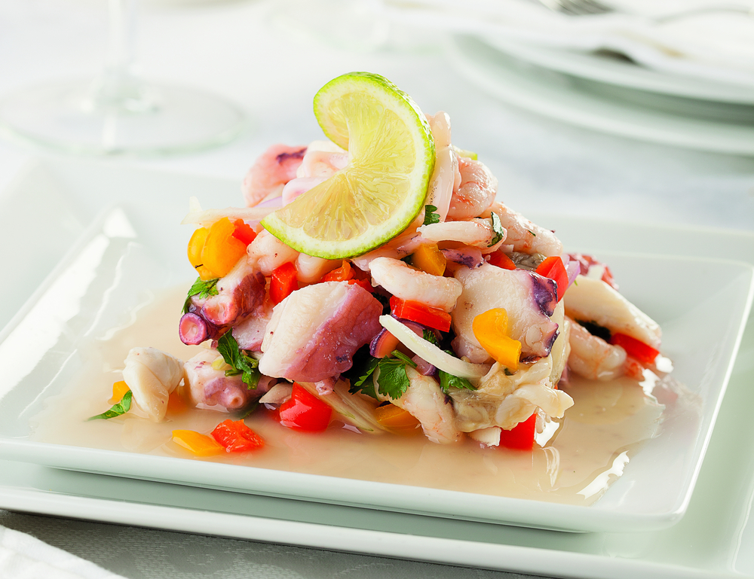
Suriname - Pom is the most popular meal in Suriname. It is a casserole made of meat and local root vegetables such as taro roots. Pom is traditionally prepared on Sundays and for festive occasions.  Pom (locally called pomtajer) was introduced by Portuguese-Jewish enslaved people and landowners as a potato casserole, but as potatoes needed to be imported, they were replaced with the shredded taro root (also called arrowleaf elephant ear). | 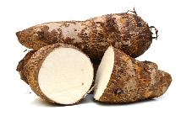  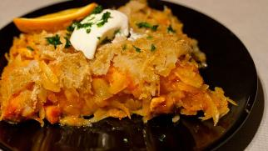  Taro root
Uruguay – the national Chivito sandwich in Uruguay contains thinly sliced steak, mozzarella cheese, tomatoes, mayonnaise, and olives in between a soft bun. Sometimes ham, bacon, or a hard-boiled or fried egg will be added.  An Argentinian tourist was visiting Uruguay and one day at a restaurant he asked for a sandwich with “chivo,” meaning goat meat. The restaurant didn’t serve that type of meat, but they didn’t want to lose a customer. The chef whipped up what the sandwich is today and told the tourist that it was meat from a “chivito,” little goat. | 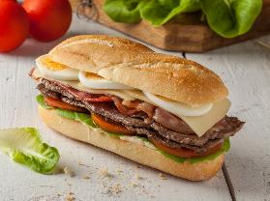
Venezuela - Pabellón Criollo dish is Venezuela’s version of rice and beans. It consists of white rice, shredded beef, fried plantains and stewed black beans.  It’s unclear when or how this traditional meal came about. It is said that that the colours mimic the Venezuelan flag, while others say that each ingredient represents different ethnic groups that settled in the area - indigenous people, Europeans and Africans. | 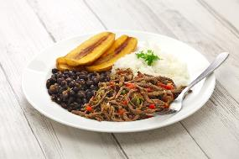

Ingredients
Queso fresco / queso blanco: This fresh cheese is a staple of South American cooking. Queso fresco is a lightly salted, unripened cow’s milk cheese that is added to sauces and crumbled in salads.

Yucca (manioc, cassava): The starchy edible root of the yucca plant is another very important food. It is especially popular in Brazil, where the root is ground, dried and roasted to make farofa. Farofa is a key ingredient in feijoada, a pork and black bean stew. Other regions use a sweet variety of yucca that can be mashed or fried. Cassava flour is often used in baking, such as the Brazilian cheese rolls pão de queijo.

Peppers (ajis): Peppers are the most important seasoning ingredient in South American cooking. There are both sweet and hot varieties, and they are used in many different ways, such as the colourful marinades for ceviche.

Corn (maiz, choclo): Corn has been cultivated in South America for more than 5,000 years and is the key ingredient of many staple dishes, such as arepas (cornbread), tamales, various pasteles (casseroles or savoury tarts) and chicha, an ancient (yet still popular) drink.

Did you know?
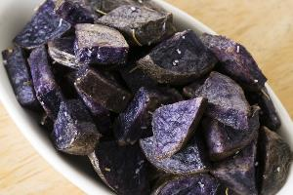
Hundreds of varieties of potatoes are cultivated in the Andes and are therefore used in many recipes. Potatoes are fried, mashed, freeze dried, baked, and combined with sauces into dishes. They rival corn as the oldest and most important South American crop.

Papa púrpura are Peruvian purple potatoes. The skin and flesh have a deep purple colour, and when cooked, the potatoes usually turn a bluish colour.

In the pre-Hispanic times, purple potatoes were usually reserved exclusively for the Inca Kings, and now some chefs call them Gems of the Andes.

