Polish potato cakes

Ingredients
Complexity: low-medium
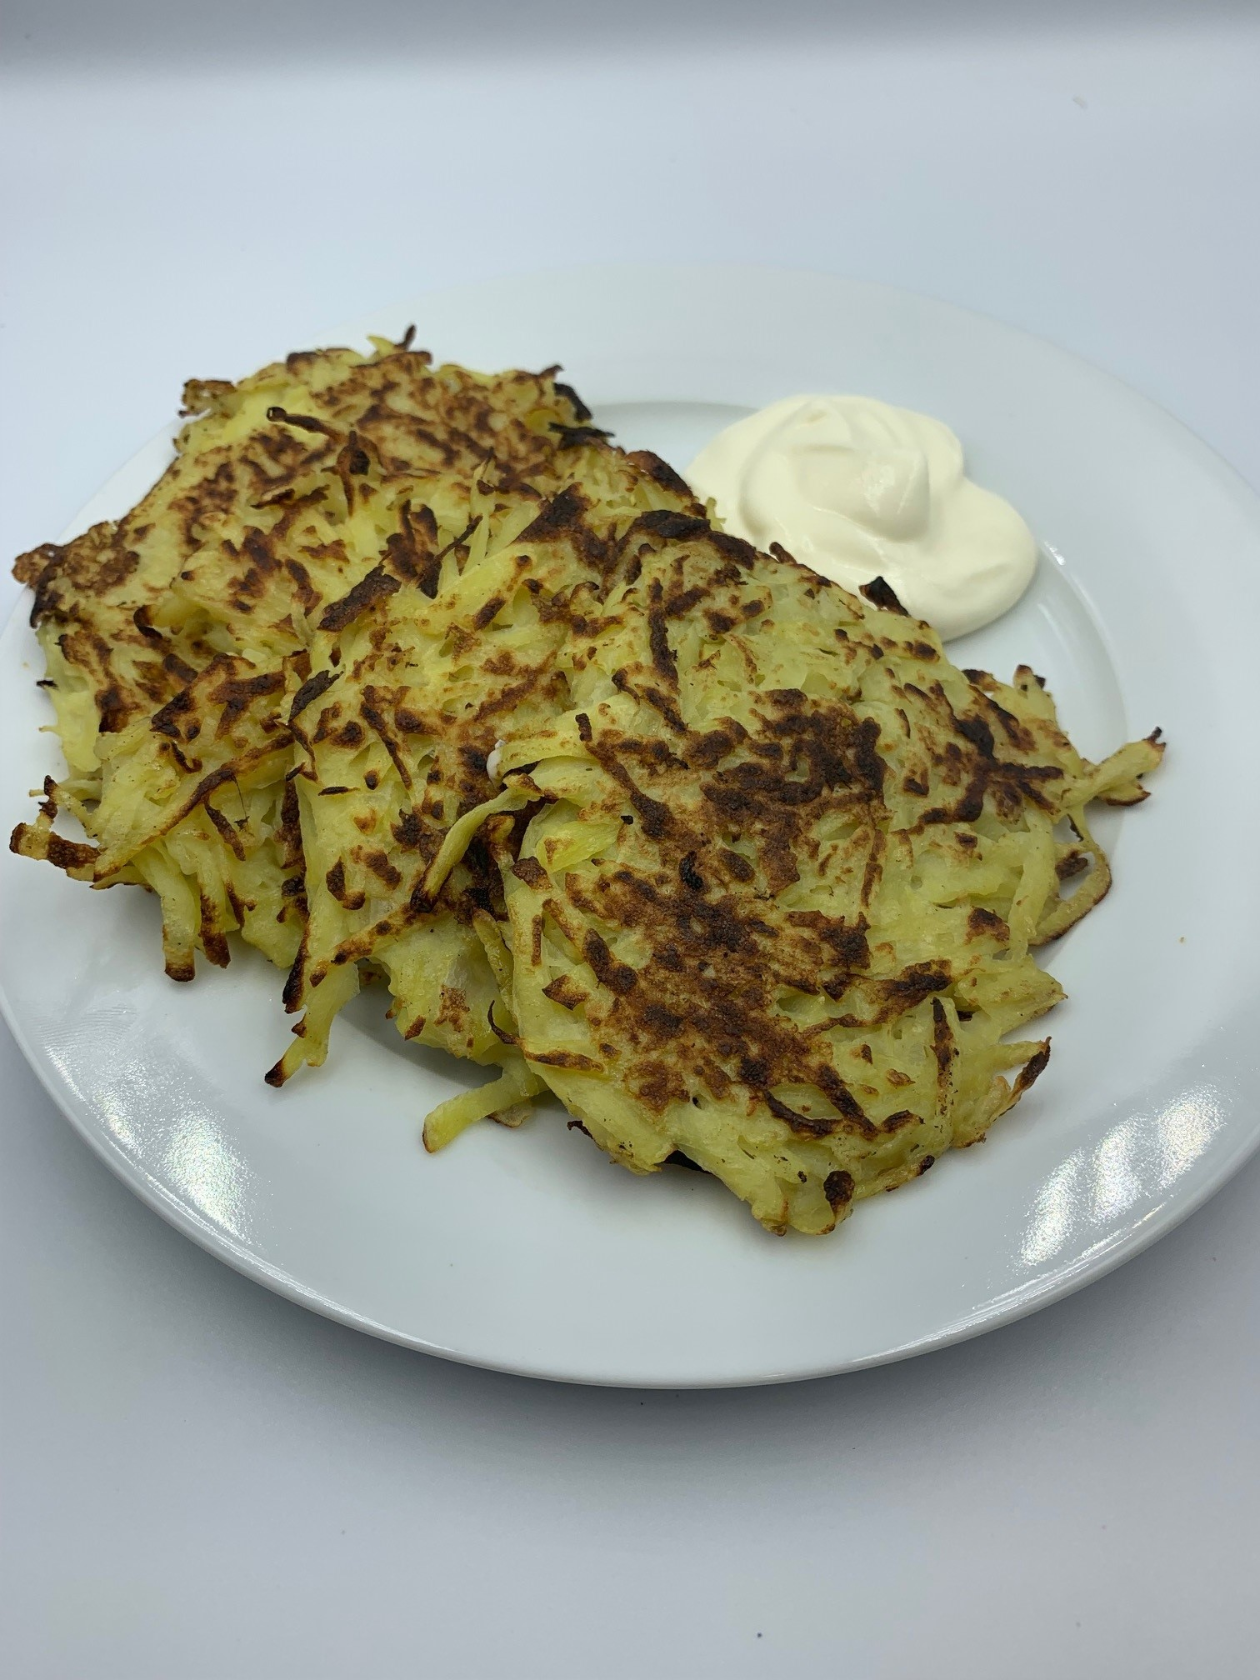
1 small onion (optional)
2 large potatoes (approx. 375g)
1 egg
1 x 15ml spoon plain flour
Black pepper
Spray oil

To serve
Reduced fat sour cream, crème fraiche or Greek yogurt

Equipment
Chopping board, grater, vegetable peeler, colander or sieve, small bowl, fork, large mixing bowl, mixing spoon, non-stick frying pan, spoon, fish slice.

Method
- Peel and finely grate the onion, if using.
- Peel and grate the potatoes. Press the grated potato in a colander or sieve, to drain any excess liquid.
- Crack the egg into a small bowl and beat with a fork.
- Place the potatoes in a mixing bowl and add the beaten egg, flour, onion.
- Season with pepper.
- Mix well.
- Spray a non-stick frying pan with oil and add heaped spoonfuls of the pancake mixture. Flatten with a fish slice or the back of a spoon and cook until golden brown (approximately 3-4 minutes on each side).
- Turn over to cook the other side.
- Serve with reduced fat sour cream, crème fraiche or Greek yogurt.
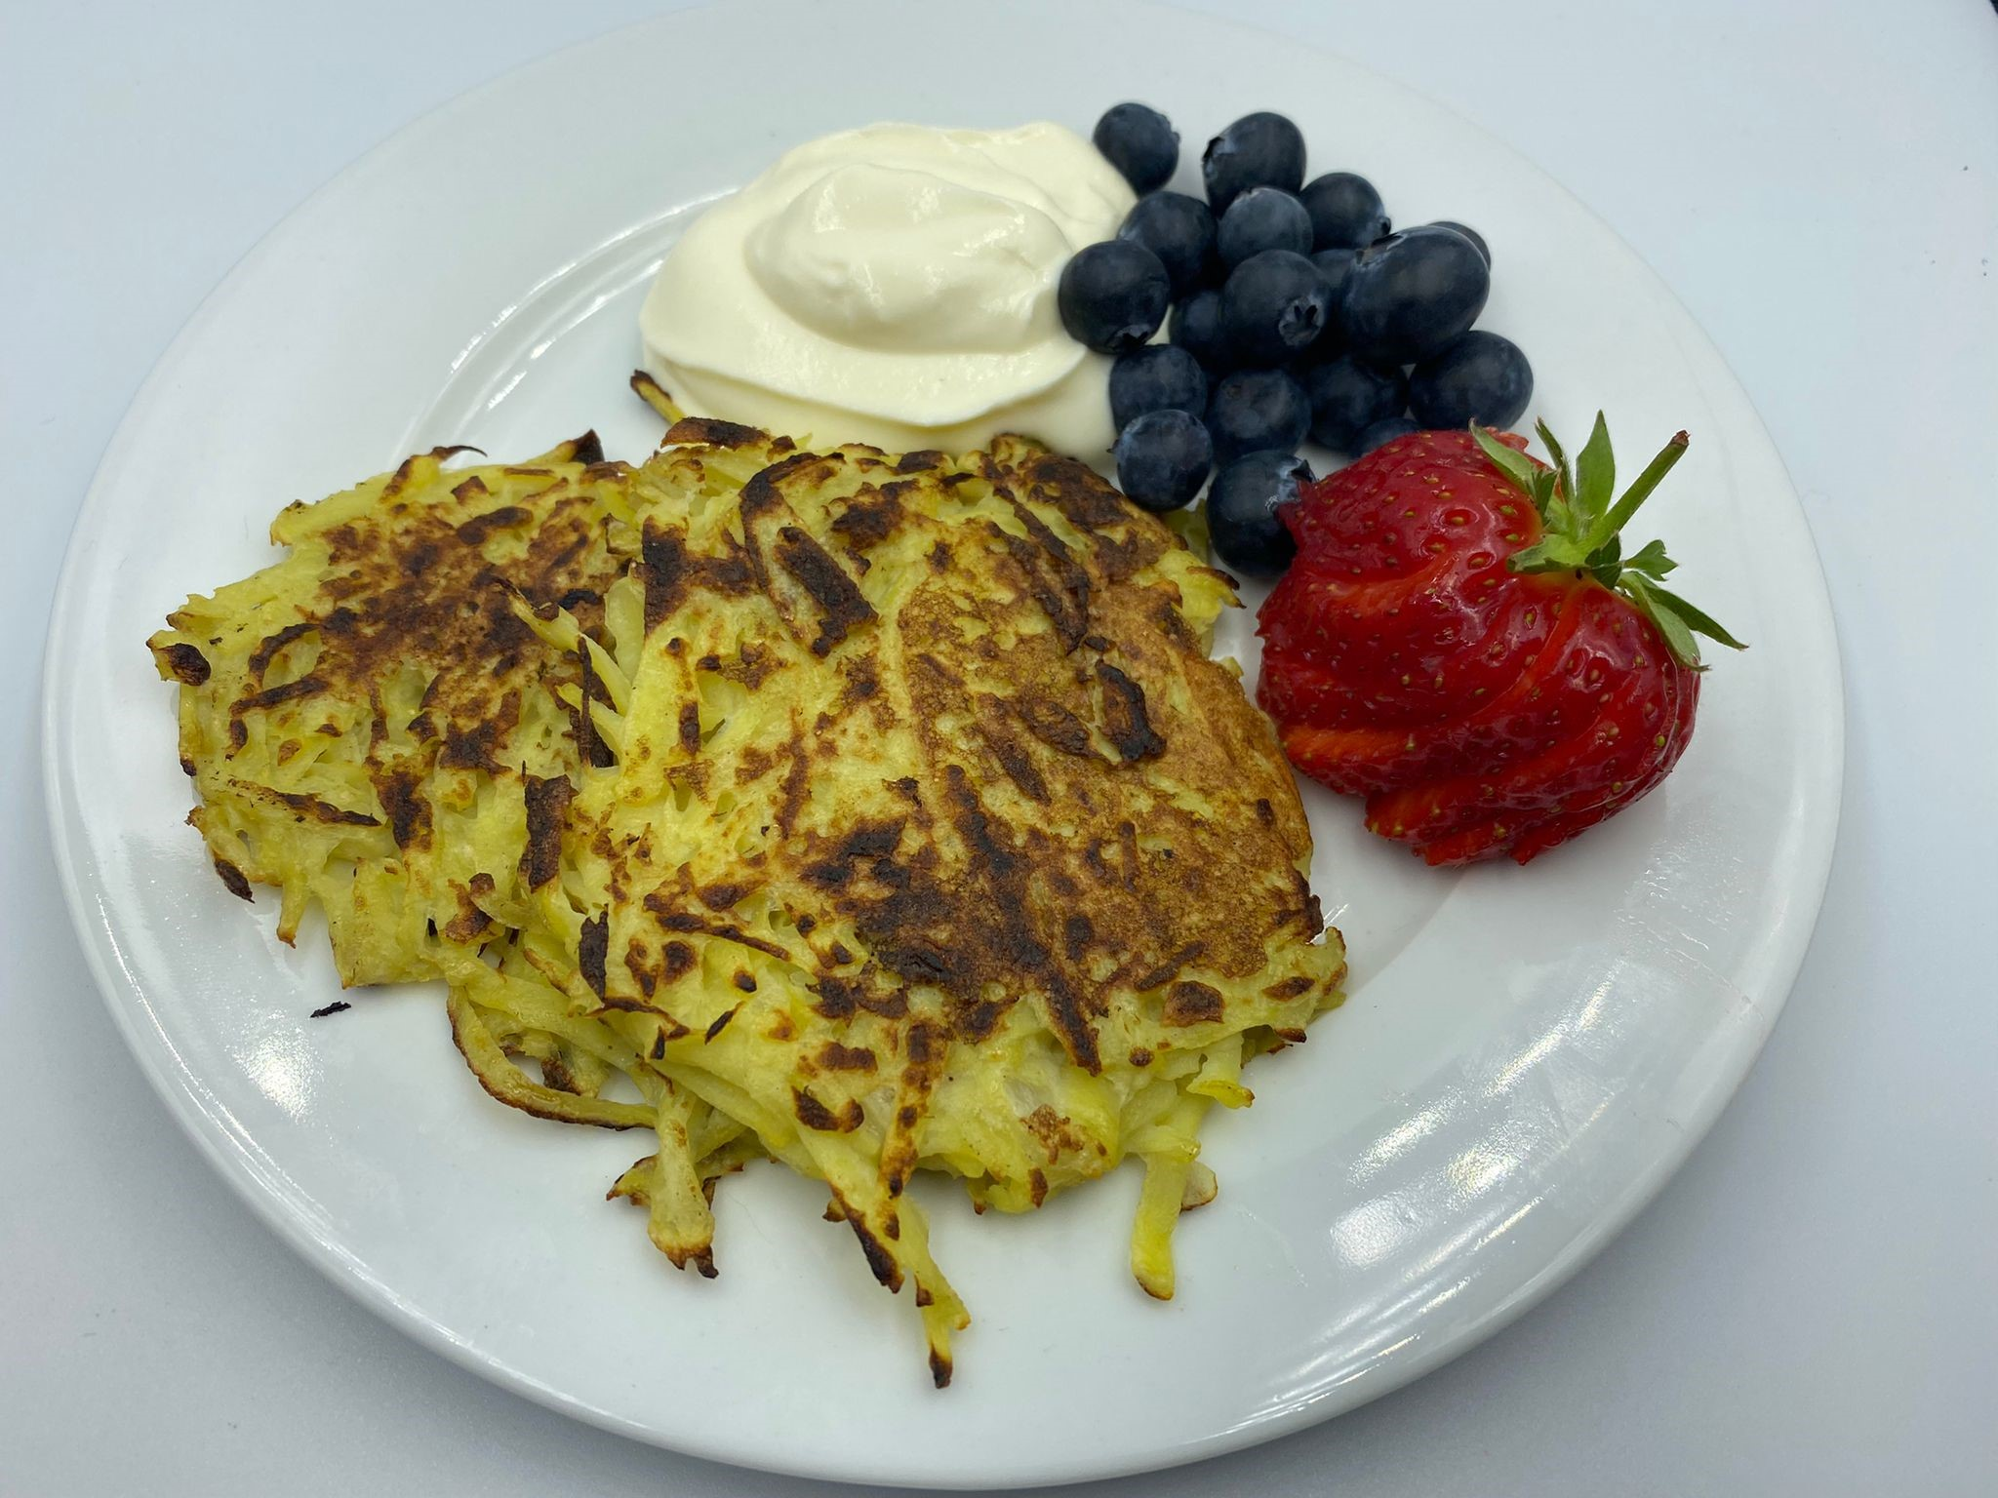
Top tips
- For sweet potato cakes, omit the onion and black pepper and serve with chopped fresh fruit or mixed berries.

Food skills
- Weigh
- Measure
- Peel
- Grate
- Beat
- Mix
- Fry

Did you know?
Memories from a Polish childhood: “I remember one dish which reminds me of my childhood. These are potato pancakes that my grandma used to do and she knew that dish from her mom. I am a captain’s daughter and my dad was on a cruise for half of the year. It was like beginning of the 90’s and each summer holidays together with my sister we spent with my mom and grandparents in our summer house in the forest, quite close to Poznań. It was a time in Poland where there was nothing much on TV, just one cartoon per day, that is why, when the weather wasn’t nice my mom let us to watch reruns of Dallas, you know, the soap opera from the 80’s. My grandma wasn’t a fan of that idea, as we were like 8/10 years old, so contents of series does not fit perfectly. That is why she always made those pancakes to distract our attention!”

This recipe is based on recipes kindly donated by Natalia Jarysz and Malgorzata Nizio.

