Session: Biscuit bonanza

Welcome
This session is about baking biscuits, both savoury and sweet. As with other sessions, students will revisit many skills and techniques, therefore making them more confident cooks. It also provides you with the opportunity to assess students' practical capability. You could use the practical observation sheet to help.
During this session, students will make either Cheese straws or ANZAC biscuits. These have been chosen as they improve essential knowledge of flour based products, act as a reminder for the safe use of the cooker and can be cooked by students easily at home for an occasional treat. If your students are intolerant to gluten, there is a range of gluten-free flours available for them to use.
There is lots of room for students to be creative, selecting different types of ingredients that could be combined into the dishes. You could get your students to use the Cheese straws or ANZAC biscuits recipe writing frames before cooking to develop their own ideas. The students’ own recipe creations could then be used in this session.
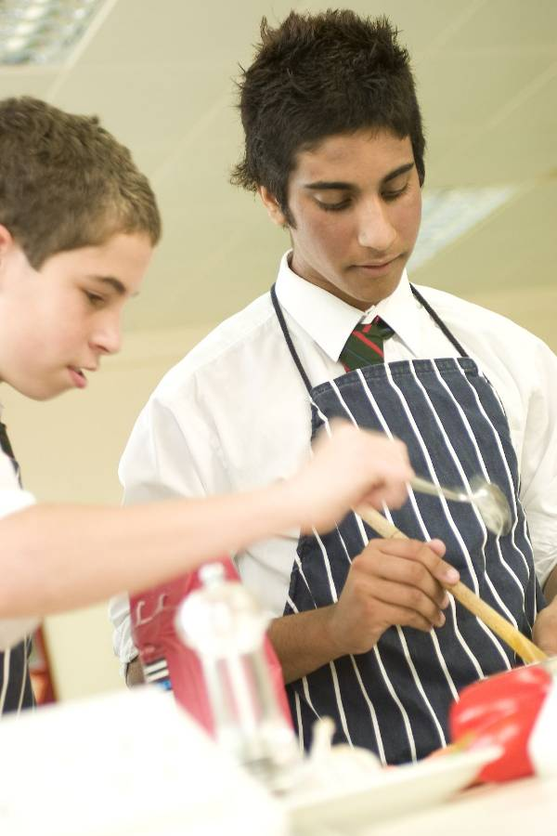
If you have an established lesson plan and/or recipe, which supports the aims and objectives of this session, feel free to use it instead. Look at the support materials provided within this session as they support this activity and may well be useful in your own lessons, e.g. worksheets, PowerPoint presentations.
This session can act as a stand-alone lesson, focusing on biscuit making. Alternatively, it could be integrated into a series of lessons, e.g. exploring mass food production; designing a biscuit; traditional and cultural variations in biscuits.
Aims and objectives
Aim
For students to:
- become more confident preparing and cooking a variety of biscuits.
Objectives
Students should be able to:
- demonstrate rubbing in or melting methods, and making a dough confidently;
- prepare a range of ingredients, e.g. sieving flour, grating cheese;
- use the oven safely to bake biscuits;
- make a batch of biscuits, e.g. Cheese straws or ANZAC biscuits.

Cooking session
Two cooking session plans, based on the Licence to Cook recipes are supplied within this session.

If you have your own tried and tested Cheese straws or ANZAC biscuit recipe, feel free to use it instead. In addition, you may wish to make other types of dishes, such as Viennese whirls.
Each plan refers to aspects of healthy eating, wise food shopping and food safety and hygiene which are themes which run through each session.
Before the cooking session
There are a number of factors that you need to consider before the cooking session. More detailed guidance is available in the Cooking session guide.

You will need to consider:
- Ingredients: who will be providing the ingredients and where will they be stored? Are there any students with allergies?
- Recipe: are students going to use a printed-out copy or follow instructions on an interactive whiteboard?
- Equipment: is all the equipment needed for the session available, clean and in good working order? Check that all the hobs and ovens are in good working order and clean. Students will require the use of a baking tray - check that there are enough. You may ask students to share a baking tray. Grease proof paper or Teflon sheets could be used as this saves time greasing the baking trays and washing up. Students could also share a kettle when using the ANZAC recipe.
- Aprons: do you have enough and are they clean?
- Hair: do you have ties/bands for long hair?
- Containers: will students be able to take away the biscuits they make? If so, in what?
- Waste: do you have adequate disposal facilities, including recycling or composting?
- Cooking area: is it clean and ready to use?

Differentiation and inclusion
Before this practical session, you will need to consider the age, ability, previous experience and any special requirements of your students. This will determine recipe selection, any advanced ingredient preparation and equipment used.
Do any of your students need:
- pre-prepared ingredients, such as grated cheese or ingredients pre-weighed?
- support using the oven?
- to follow different recipes? The Cheese straw recipe is slightly easier than the ANZAC biscuit recipe, and good for making in pairs.
- to be challenged, perhaps allowing them to prepare, cook and market their biscuits?
- gluten or dairy free alternatives?

Demonstration
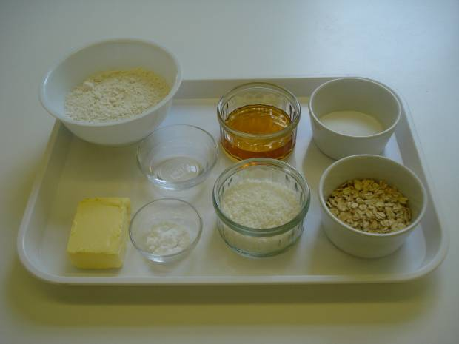
Although the two recipes suggested vary in the way in which the biscuit mixture is prepared, go through the main stages of the cooking and checking process with the students. You will probably not need to demonstrate any oven use again at this stage. However, do remind students to prepare ingredients and cook safely.

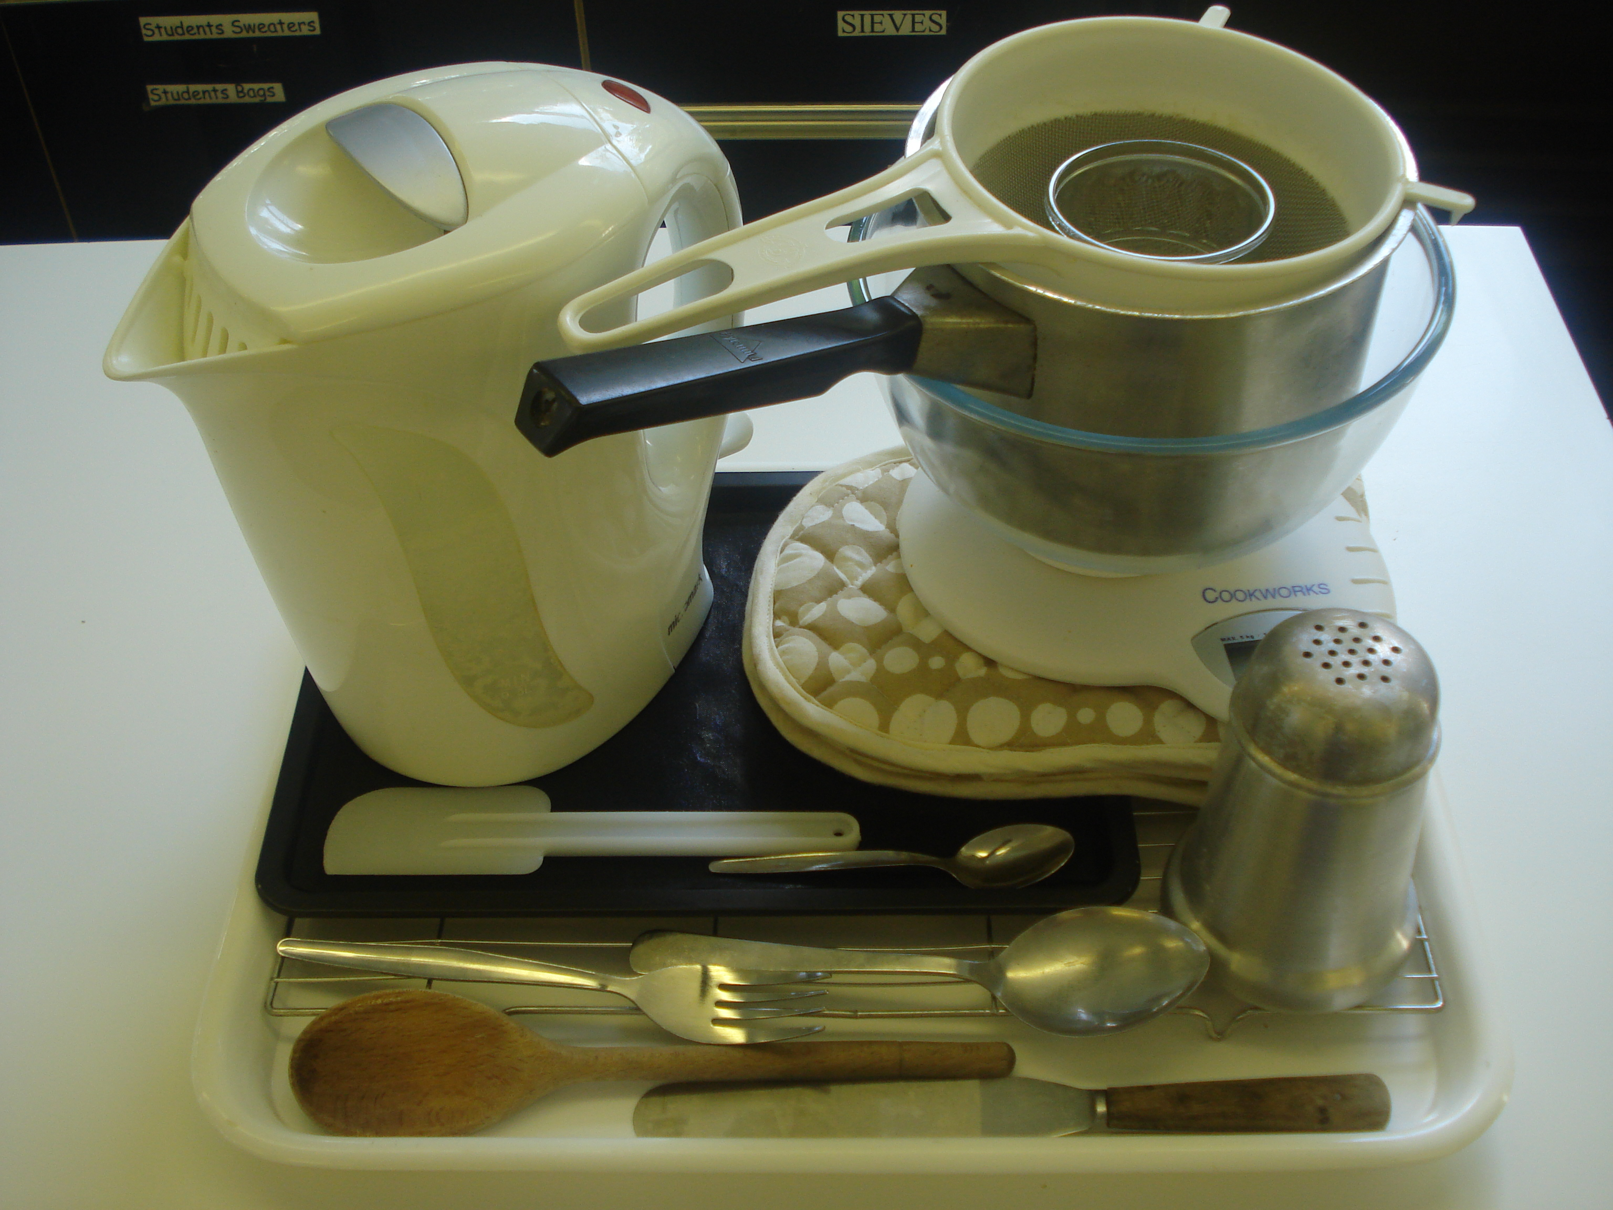
Ensure that you have all the ingredients and equipment you need before the session, perhaps on trays for ease, for your demonstration.

Think about:
- describing the ingredients and equipment used;
- highlighting the technique of rubbing-in, melting and mixing, forming and shaping a dough;
- showing how to turn on and set the oven temperature;
- ensuring that students have followed and understood the method.

More detailed guidance is available in the Demonstrating guide.

Risk assessment

The two cooking session plans and recipes highlight a number of different hygiene and safety issues which need to be considered before, during and after the cooking session.

Before the cooking session, you will need to assess these risks in relation to the number of students being taught, as well as their experience, and consider measures that can be put into place to manage the risk. Below are examples of potential risks, along with preventative measures.

Cheese straws
Potential risk | Measure | Likelihood
Dirty hands used for rubbing-in | Wash hands thoroughly and regularly during cooking | Med
Burn from placing and removing baking tray in oven | Demonstrate safe use of the oven, promote the use of oven gloves and monitor students’ use | Low/Med

ANZAC biscuits
Potential risk | Measure | Likelihood
Dirty hands used for shaping biscuits | Wash hands thoroughly and regularly during cooking | Med
Burn from placing and removing baking tray in oven | Demonstrate safe use of the oven, promote the use of oven gloves and monitor students’ use | Low/Med
Burn when using the hob or saucepan | Demonstrate safe use of the hob and monitor students’ use | Low/Med

Time
The session plans are based on a 60 minute session.

If you have less time available, you will need to modify the session plan to better suit your circumstances. For example, within this session you might:
- demonstrate the safe use of the hob and oven another time;
- demonstrate key aspects from the recipe, rather than every stage;
- have ingredients pre-measured;
- use ready lined baking trays, to save washing up and therefore time;
- allow students to work with a partner – sharing a batch of biscuits.

During the lesson
Time (mins) | Activity: Cheese straws | Equipment/ Resources
0 | Registration.  Explain to the students that they will be making cheese straws. Go through the aims and objectives for the lesson. | PowerPoint  Cheese straws  Recipe
5 | Gather the students around a demonstration area, with your tray of ingredients and equipment. Ensure that all students have their apron on, hair tied back and hands washed.  Briefly talk through the recipe – note your expectations, for example:  * preparing the ingredients carefully and accurately;  * rubbing the butter into the flour;  * grating cheese;  * cutting biscuits into straws using Bridge hold and Claw grip;  * using the and oven safely;  * being hygienic and safe when preparing food. | Aprons  Demonstration ingredient and equipment tray
10 | Demonstration  * Place out the sieve, mixing bowl, grater, chopping board, palette knife, wooden spoon, flour dredger, rolling pin, and baking tray.  * Demonstrate rubbing in. Explain that this technique is the basis of many other recipes, e.g. pastry. Sieve the flour (and mustard) into the bowl and add the cold butter (cut into small pieces). The butter is cold so that it does not easily melt into your fingers and helps to resemble breadcrumbs. Start to push the butter into the flour using your fingertips – thumb pressing down onto the fingers. Repeat this, moving your hands above the bowl. Shake the bowl, on the work surface, to bring any large pieces of butter to the surface. Rub-in until it looks like fine breadcrumbs. Clean your hands before you continue. Stir in the grated cheese.  * Explain that it is important to use a palette knife to mix a little water into the flour to create a stiff dough.  * Turn the mixture out onto a lightly floured surface. Use the rolling pin to roll it out to about 0.5cm thick.  * Use a palette knife to trim away the edges and cut the mixture into thin strips about 0.5cm by 7cm.  * Carefully transfer the straws across to the prepared baking tray using a palette knife so they do not break.  * Bake in the preheated oven for 10 minutes.
 | Ensure that students all wash their hands. Allow them to start making their Cheese straws.
 | During this time, circulate the room to ensure that students are preparing ingredients and using the oven safely. In this time, students should:  * sieve the flour and mustard powder;  * rub in the butter or margarine;  * grate the cheese and add to the mixture;  * add water to make a stiff dough;  * roll out biscuit dough on a lightly floured surface;  * cut out straws using a palette knife;  * place biscuits in the oven, using oven gloves. | Basic equipment  Ingredients
40 | All biscuits should be in the oven because they take 15 minutes to cook. Students should be washing up, cleaning work surfaces and putting away equipment.
50 | Give a 5 minute time warning.  Remind students that all washing up should be completed, work surfaces should be clean, and their Cheese straws should be placed in a container.  Circulate the room, ensuring that sinks are clean, and equipment is put away properly.
55 | Plenary  Pose the following questions to the students:  * What were the main skills demonstrated today?  * What herbs or spices could be added?  * What other types of savoury biscuits can be made?
60 | Finish

After the session
Check that the room is clean and tidy. Students should leave the room as they find it.

The Cheese straws may need to be stored after the lesson, because they will be hot, and may need to be kept until the end of the school day. If so, ensure that each container is loosely covered and clearly labelled with the student’s name and group.

If the same students are with you for another cooking session in the next few days or week, remind them of the ingredients and/or containers they need to bring, if appropriate. You may wish to provide students with recipes or writing frames.
During the lesson
Time (mins) | Activity: ANZAC biscuits | Equipment/ Resources
0 | Registration.  Explain to the students that they will be making ANZAC biscuits. Go through the aims and objectives for the lesson. | PowerPoint  ANZAC biscuits  Recipe
5 | Gather the students around a demonstration area, with your tray of ingredients and equipment. Ensure that all students have their apron on, hair tied back and hands washed.  Briefly talk through the recipe – note your expectations, for example:  * preparing the ingredients carefully and accurately;  * sieving flour and stirring in oats, sugar and coconut;  * melting butter and golden syrup on a low heat;  * adding the bicarbonate of soda and hot water;  * using the hob and oven safely;  * being hygienic and safe when preparing food. | Aprons  Demonstration ingredient and equipment tray
10 | Demonstration  * Place out the mixing bowl, saucepan, wooden spoon, cup or small jug, kettle and measuring spoons.  * Explain that you will be showing how to add bicarbonate soda. Melt the butter and golden syrup on a low heat in a small saucepan. Add the boiling water to the bicarbonate of soda in a cup or small jug. The bicarbonate of soda will start to fizz. This needs to be added immediately to the melted butter mixture. The butter mixture is then poured quickly into the dry flour mix.  * Stir the mixture thoroughly until all combined. Using a 15ml spoon to ensure the biscuits are equal amounts, roll the spoonful of mixture into balls in your lightly floured hands. Place them on the prepared baking tray.  * Use a fork lightly covered in flour to flatten the biscuits before placing them on the middle shelf of the oven. | Fire blanket
 | Ensure that students all wash their hands. Allow them to start making their ANZAC biscuits.
15 | During this time, circulate the room to ensure that students are preparing ingredients and using the hob safely. In this time, students should:  * sieve the flour and stir in oats, sugar and coconut;  * melt the butter and golden syrup on a low heat;  * add the bicarbonate of soda and hot water;  * add the foaming butter mixture to the dry ingredients and mix well;  * mould the biscuits and transfer them to the prepared baking tray; | Basic equipment  Ingredients
* press with a lightly floured fork;
* use oven gloves to place the biscuits on the middle shelf of the oven.
35 | All biscuits should be in the oven because they take 15-20 minutes to cook.  During the remaining time students should be washing up, cleaning work surfaces and putting away equipment.
50 | Give a 5 minute time warning.  Remind students that all washing-up should be completed, work surfaces should be clean, and their ANZAC biscuits should be placed in a container.  Circulate the room, ensuring that sinks are clean, and equipment is put away properly.
55 | Plenary  Pose the following questions to the students:  * What were the main skills demonstrated today?  * Recall the ingredients used to bind the biscuits mixture together.  * Which food groups from the Eatwell Guide did the ingredients come from?
60 | Finish

After the session
Check that the room is clean and tidy. Students should leave the room as they find it.

The ANZAC biscuits may need to be stored after the lesson and because they will be hot, may need to be kept until the end of the school day. If so, ensure that each container is loosely covered and clearly labelled with the student’s name and group.

If the same students are with you for another cooking session in the next few days or week, remind them of the ingredients and/or containers they need to bring, if appropriate. You may wish to provide students with recipes or writing frames.

Areas of learning
Healthy eating
- Use wholemeal flour, instead of white, for additional fibre.
- Experiment with different ingredients such as dried fruit and different cheeses.

Wise food shopping
- Buy economy brands to save money.
- Freeze the biscuits for another time.

Food safety and hygiene
- When getting ready to cook, always wear an apron, tie back long hair, roll up long sleeves, remove any jewellery and wash your hands.
- Check that the eggs are within their date-mark and that the shells are not damaged.

Extending this activity
This session provides a great opportunity to be integrated into existing lessons or be developed into a mini-scheme of work.
For example, students could:
- explore the range of biscuits available to buy in shops, noting their ingredients and sensory appeal;
- explore other methods of making biscuits such as creaming, or non-bake biscuits.
- Plan and create new recipe ideas for biscuits based on inspirations for a European country, e.g. Italy;
- evaluate their own, and class friend’s recipes, suggesting possible modifications in relation to healthy eating.

Appropriate aspects of ICT could also be integrated, including:
- recording the nutritional profile of a recipe;
- creating a recipe plan or flow-chart;
- modelling cost for economy or luxury versions of a recipe;
- exploring the internet for inspiration through travel websites.

Shopping list
Cheese straws

Ingredient | x 1 | x 10 | x 20
Plain flour | 75g | 750g | 1.5kg
Wholemeal flour | 25g | 250g | 500g
Mustard powder | 1/ 2 x 5ml spoon | 5 x 5ml spoon | 10 x 5ml spoon
Butter or margarine | 50g | 500g | 1kg
Cheddar cheese | 50g | 500g | 1kg
Cold water | Extra | Extra | Extra

ANZAC biscuits

Ingredient | x 1 | x 10 | x 20
Plain flour | 100g | 1kg | 2kg
Rolled oats | 25g | 250g | 500g
Caster sugar | 30g | 300g | 600g
Desiccated coconut | 25g | 250g | 500g
Golden syrup | 1 x 20ml spoon | 200ml | 400ml
Margarine | 50g | 500g | 1kg
Bicarbonate soda | 1 x 2.5ml spoon | 5 x 5ml spoon | 10 x 5ml spoon
Boiling hot water | 10ml | 100ml | 200ml

Equipment list

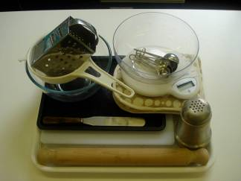
Cheese Straws

Baking tray, pastry brush, weighing scales, sieve, measuring spoons, mixing bowl, grater, palette knife, flour dredger, rolling pin, oven gloves and cooling rack.

ANZAC Biscuits

Baking tray, pastry brush, weighing scales, sieve, mixing bowl, measuring spoons, saucepan, wooden spoon, kettle, palette knife, oven gloves and cooling rack.

Containers

If students take their dishes, they will need to bring (or be provided with by the school) a suitable container, such as a plastic container with a lid.

