Thai green curry
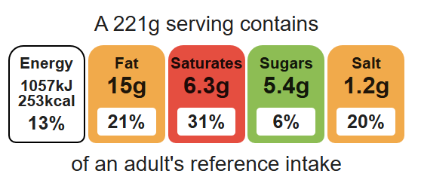
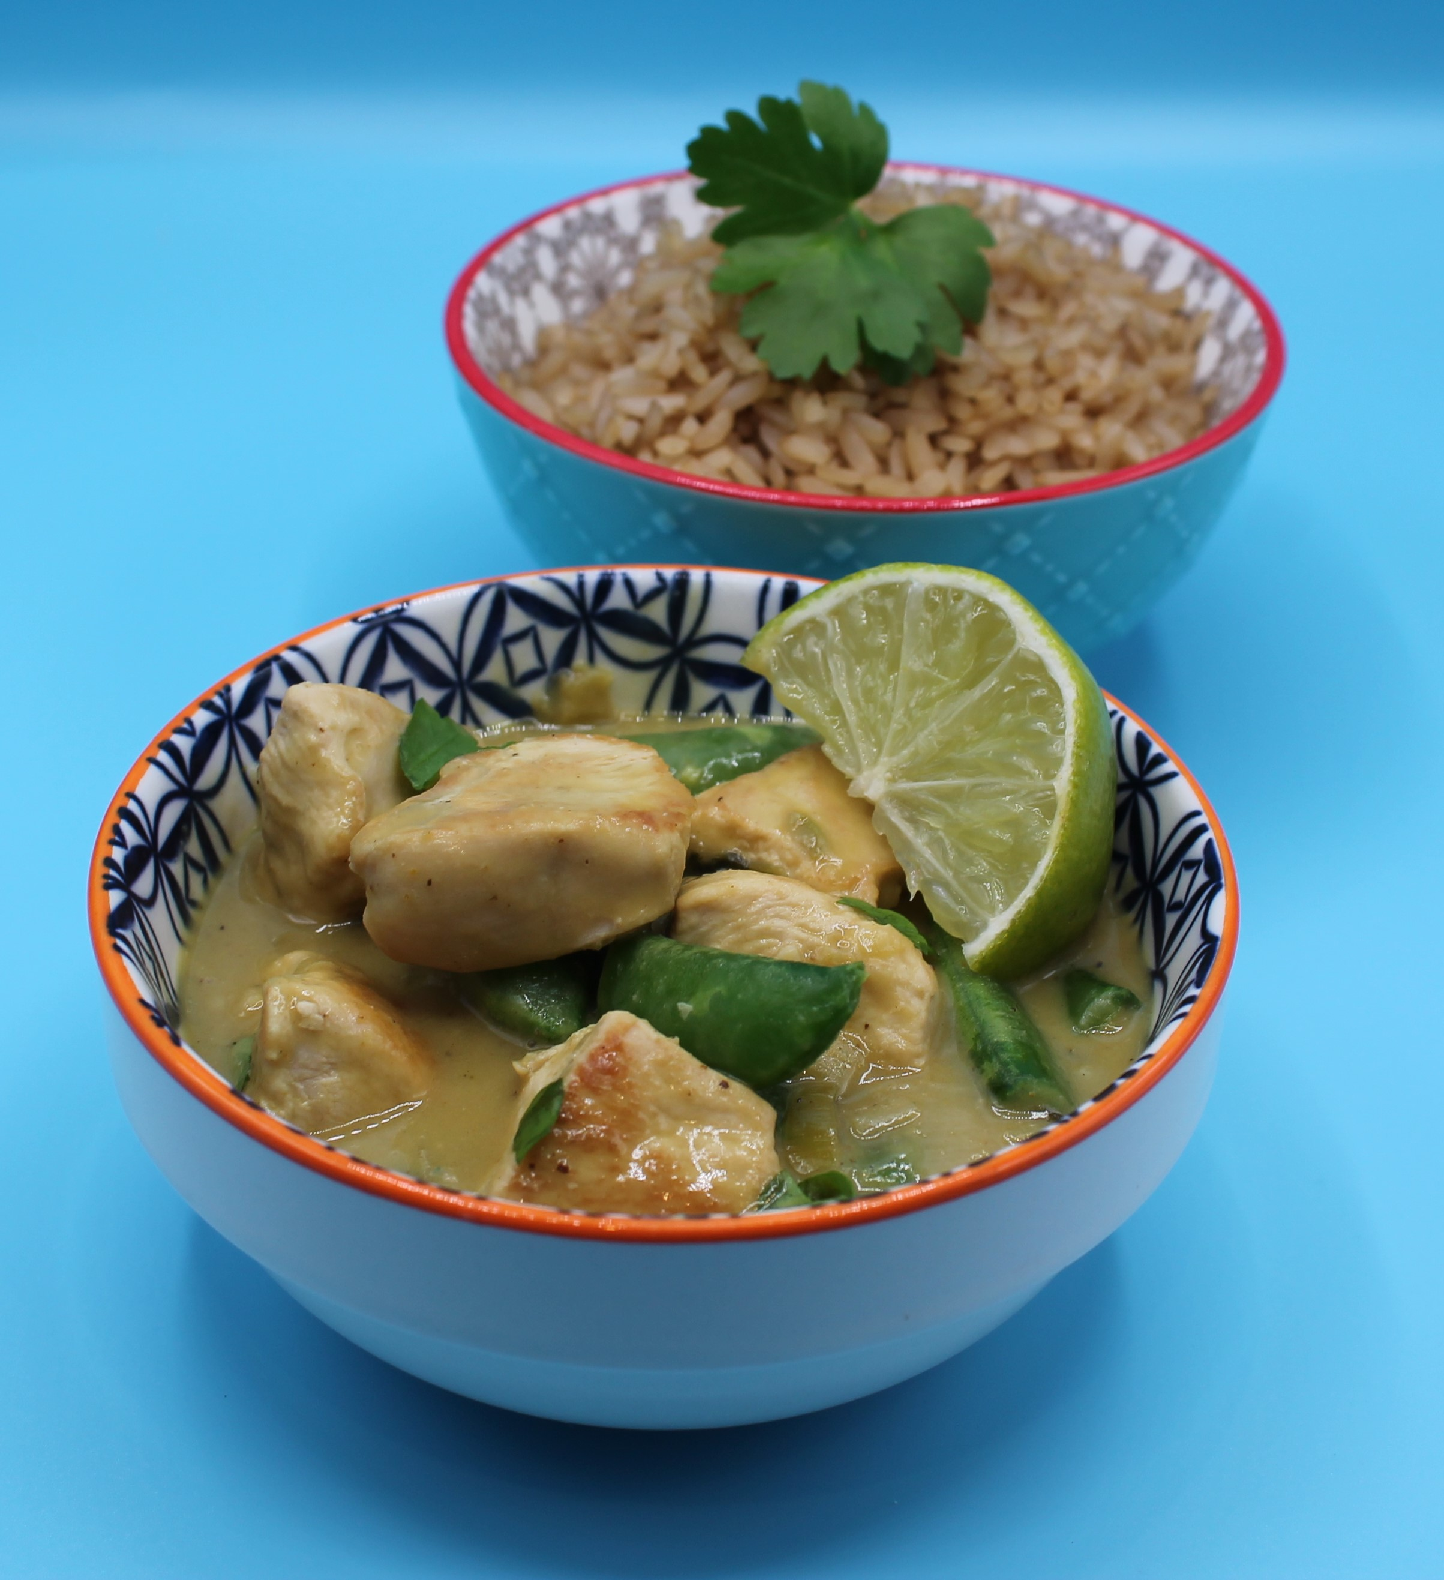
Complexity: medium

Equipment

2 chopping boards

Sharp knife

Garlic press

Frying pan

Measuring spoons

Weighing scales

Heat resistant spoon

Can opener

Juicer

Ingredients (serves 2)
1 x 10ml spoon oil or spray oil
3 spring onions
1 clove of garlic
80g sugar snap peas
1 chicken breast
2 x 15ml Thai green curry paste
200ml reduced-fat coconut milk
½ lime
1x 15ml reduced-salt soy sauce
Top tips
- Reduce food waste: Add leftover vegetables such as broccoli, spinach or baby corn.
- Vary your protein: Swap the chicken for chickpeas, tofu, paneer, prawns or thin strips of pork.
- Focus on fibre: Serve with wholegrain rice or noodles.

Small bunch of coriander
Black pepper

Method
- Prepare the vegetables:
- slice the spring onions into rings;
- cut the sugar snap peas in half;
- peel and crush the garlic;
- roughly chop the coriander.
- Using a red board, cut the chicken into small chunks. Thoroughly wash and dry your hands after touching the raw meat.
- Add the oil to the frying pan and allow to heat. Fry the chicken in the oil for 3-4 minutes. Add the spring onions and garlic to the pan.
- When the chicken has cooked and no pink meat remains, stir in the green curry paste.
- Pour in the coconut milk and simmer for 10 minutes.
- Juice the lime and add to the pan.
- Add the soy sauce and sugar snap peas and continue to cook for five minutes.
- Season with chopped fresh coriander and black pepper.

Food skills
Weigh, measure, cut, chop, slice, dice and trim, fry and sauté, mix, stir and combine, melt, simmer and boil, juice.

