Leftovers recipe challenge

Teacher instructions

Introduction:

Create a mystery box of ingredients for students. It can be one for the class, or students could be given a box in groups.

The box should contain a variety of ingredients, e.g. half a loaf of bread, overripe bananas, leftover rice, some wilted carrots.

Activity:

Challenge students to create a meal or dish using only the ingredients in their mystery box along with some kitchen basics, e.g. oil, spices, flour, should you wish to provide them.

The rules:

- They must use 80% of the ingredients in their mystery box.
- Where possible they must make use of every edible piece, e.g. stems or peels.
- They can add one or two ingredients of their choice, e.g. milk, eggs. But the focus is on minimising waste.
- They must cook and serve their meal or dish within the time provided.

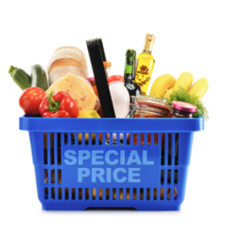

Practical task record sheet
Ingredients

Equipment

Method

Skills groups/techniques | ✔ | Comments
Knife skills – meat, fish and alternatives
Prepare fruit and vegetables
Prepare, combine and shape
Tenderise and marinate
Select and adjust cooking process
Weigh and measure
Preparation of ingredients and equipment
Use of equipment
Water based methods – hob
Dry heat and fat based methods – hob
Using the grill
Using the oven
Make sauces – blended, reduction, emulsion
Set a mixture – removal of heat (gelation)
Set a mixture – heating (coagulation)
Use of raising agents
Make a dough
Shaping and finishing a dough
Test for readiness
Judge and manipulate sensory properties

Add an image of your finished dish or meal here
List the steps necessary to ensure that the final dish is safe to eat:

List the steps necessary to ensure that the final dish is safe to eat:

