Borscht (Ukrainian)

Ingredients
Complexity: medium-high

1 small onion

1 clove garlic

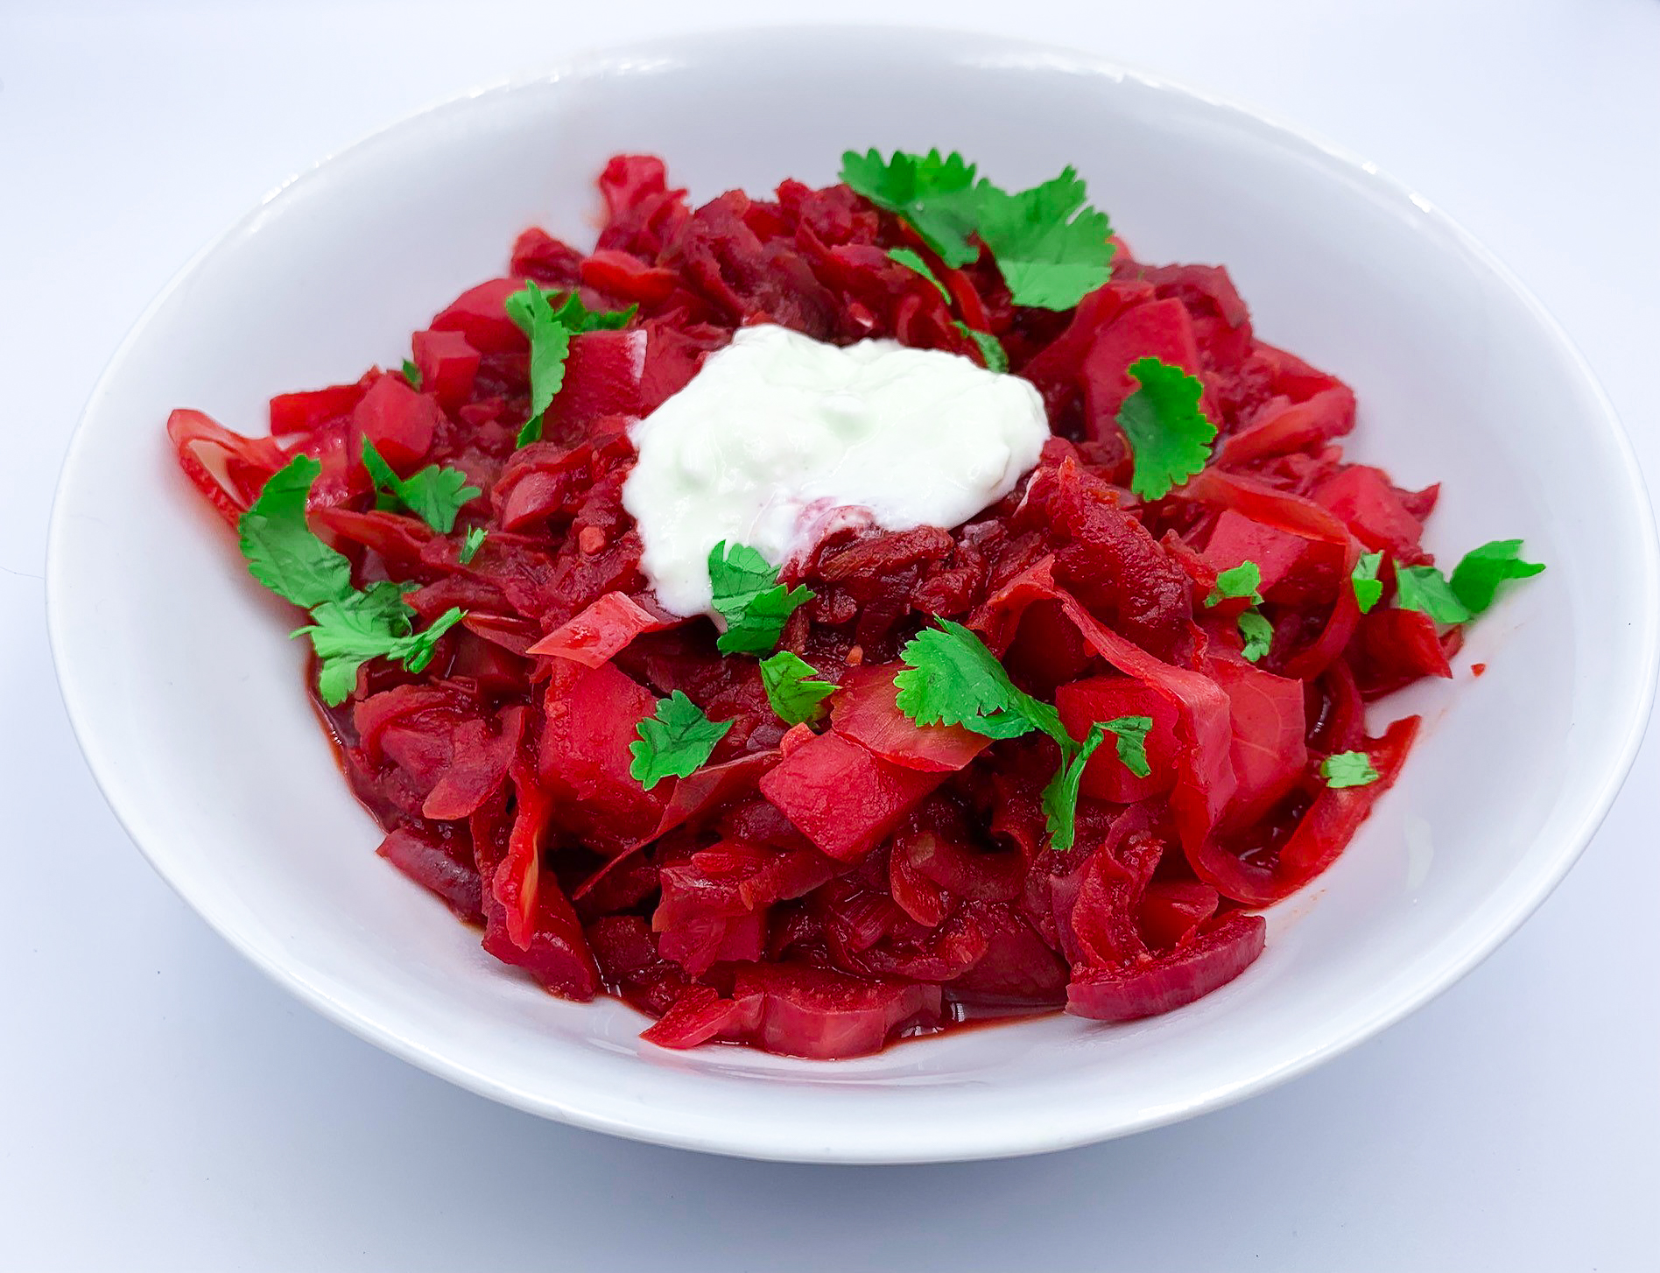
100g carrot

200g raw beetroot

150-200g potato

½ celery stick (about 30g)

100g cabbage

Spray oil

Black pepper

200g chopped tomatoes

1 stock vegetable cube

1 x 5ml spoon dill

2 x 5ml spoon coriander

4 x 15ml spoons reduced fat sour cream or crème fraiche (optional)

Equipment

Chopping board, vegetable knife, garlic press, vegetable peeler, grater, large saucepan with lid, mixing spoon, measuring jug, measuring spoons.

Method
- Prepare the ingredients:
  - peel and finely slice the onion;
  - peel and crush the garlic;
  - peel and grate the carrot;
  - wash and grate the beetroot;
  - peel and dice the potatoes into 2cm cubes;
  - thinly slice the celery;
  - cut and thinly slice the cabbage;
  - chop the dill and coriander.
- Spray a large saucepan with oil and heat gently, add the onion and cook until lightly browned.
- Add the crushed garlic and grated carrot and cook gently until softened.
- Add the potatoes, beetroot, celery and cabbage. Mix well.
- Add the chopped tomatoes and black pepper to season. Mix well.
- Add enough hot water to cover the vegetables and bring to the boil.
- Crumble in the stock cube and mix well.
- Turn down the heat and simmer for 40 minutes until all the vegetables are cooked. Add more water if need be.
- Add the chopped herbs and simmer for a further 5 minutes.
- Optional - serve with a spoon of sour cream on top.

Top tips
- Dried dill could be used if fresh is unavailable. Use ½ x 5ml spoon of dried dill. Fresh dill (and many other herbs) can be frozen to help prevent food waste.
- Use pre-cooked beetroot (not pickled in vinegar) to speed up the cooking of the borscht. The beet can be grated or chopped.
- This version of borscht is more stew-like than a soup. Add more water to make a soup.

Food skills
- Weigh
- Measure
- Peel
- Cut
- Slice
- Chop
- Dice
- Grate
- Crush
- Fry
- Stir
- Boil
- Simmer

Did you know?
The word borscht comes from the Slavic “borschevik,” which means “hogweed.” In early Slavic cuisine, hogweed stems, leaves and flowers were often cooked into a soup or fermented, producing something similar to sauerkraut. Cultivated beets eventually replaced the wild cow parsnip as the basis of the soup.

It is popular across the region but originated in Ukraine. There are many different versions of borscht but the one from Ukraine contains a range of different vegetables and is more of a stew than a soup.

The soup can be served hot or cold - the summer version called Green borscht, is made with sorrel.

