Dippy divers
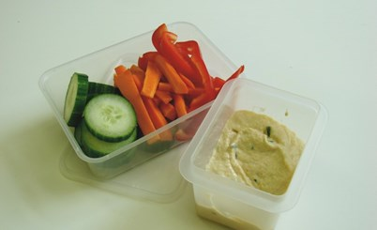
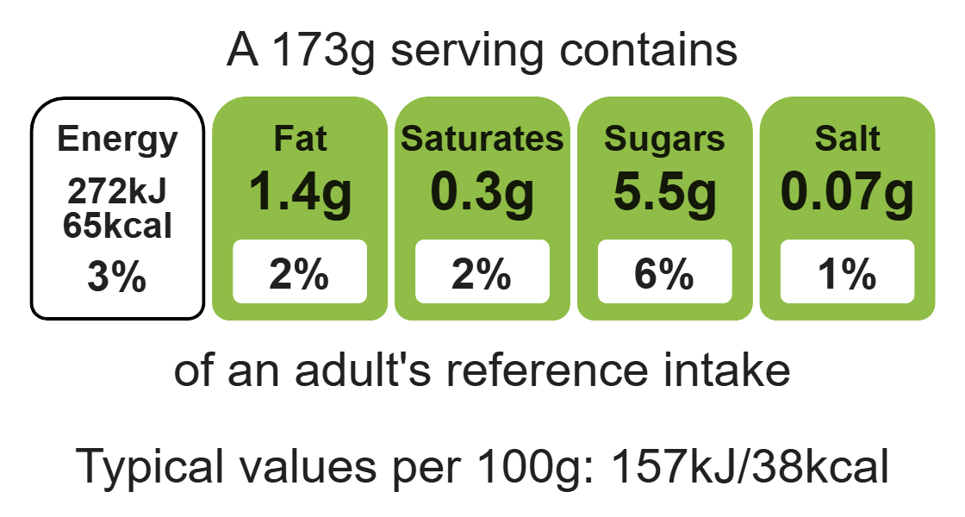

Ingredients (serves 2)
1 carrot
Complexity: low - medium
½ pepper
¼ cucumber

Equipment

Sharp knife

Chopping board

Vegetable peeler

Measuring spoons

Small bowl

Kitchen scissors

Spatula

4 x 15ml spoons hummus
1 x 15 ml spoon plain reduced-fat yogurt
Handful of fresh chives

Method
- Top and tail the carrot, then peel.
- Slice the carrot into sticks.
- Remove the seeds from the pepper, and slice into strips.
- Cut the cucumber into thick slices.
- Place the hummus and yogurt together in the small bowl.
- Snip the chives into the bowl.
- Stir everything together.
- Serve the dip, surrounded by the vegetables.

Top tips
- Turn up the flavour: Try different herbs such as chopped parsley, coriander or mint. Add spices to the hummus mixture such as ½ x 5ml spoon mild curry powder, mild chilli powder or ground cumin.
- Reduce food waste: Use up leftover vegetables such as courgettes or tomatoes.

Food skills
Weigh, measure, cut, chop, slice, dice and trim, snip, mix, stir and combine.

