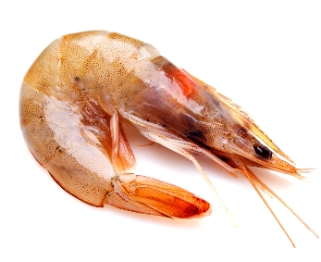
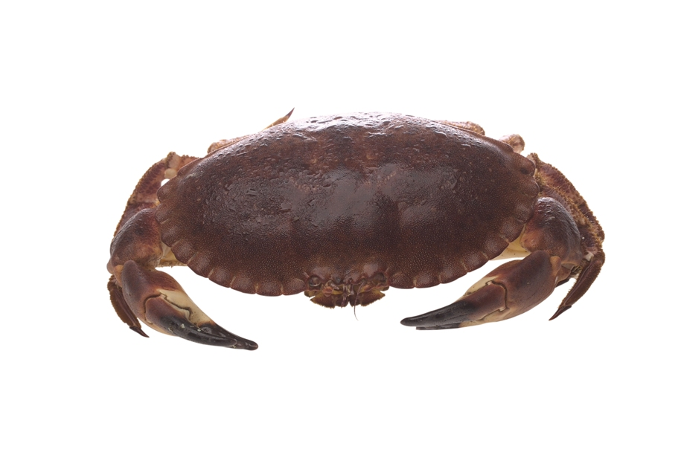
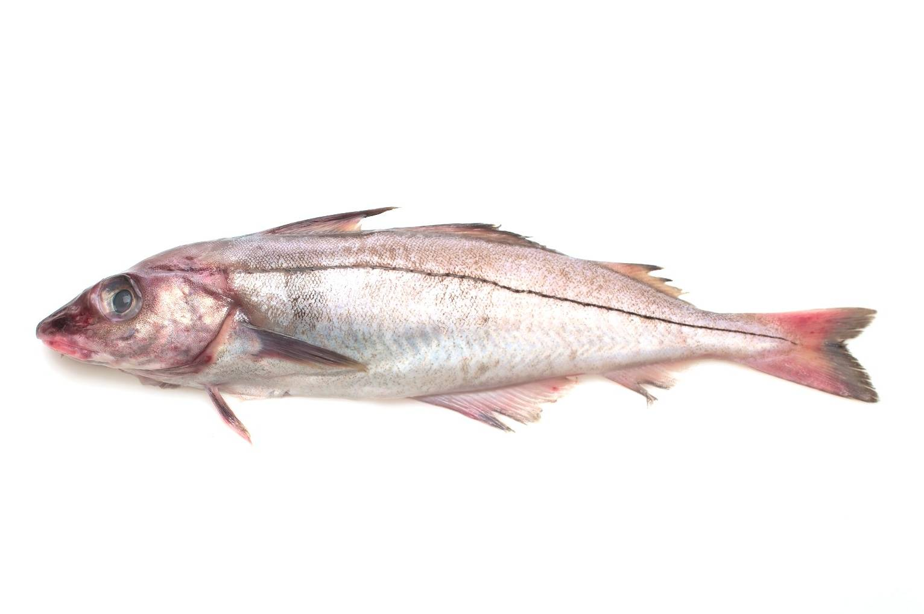
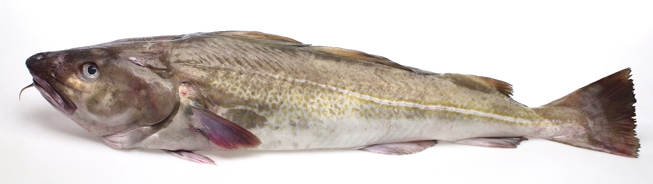
Prawn
Prawn
Crab
Crab
Haddock
Haddock
Cod
Cod

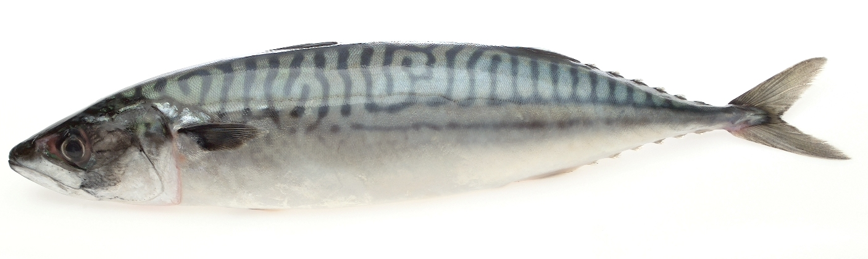
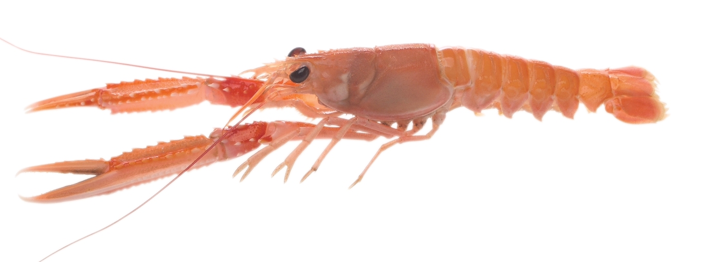
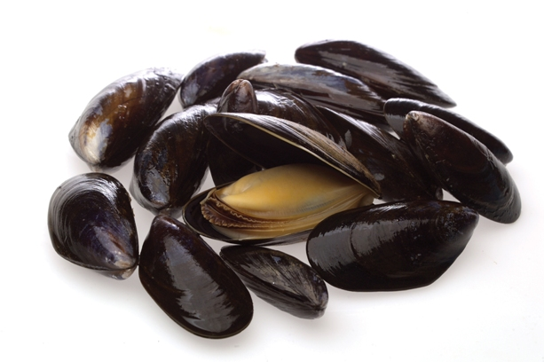
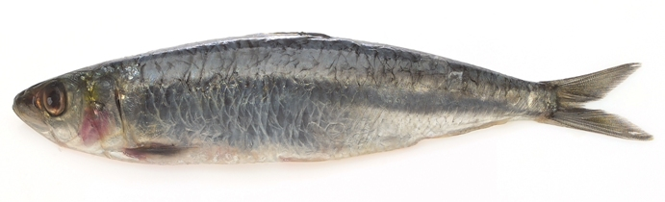
Langoustine
Langoustine
Mussels
Mussels
Sardine
Sardine
Mackerel
Mackerel
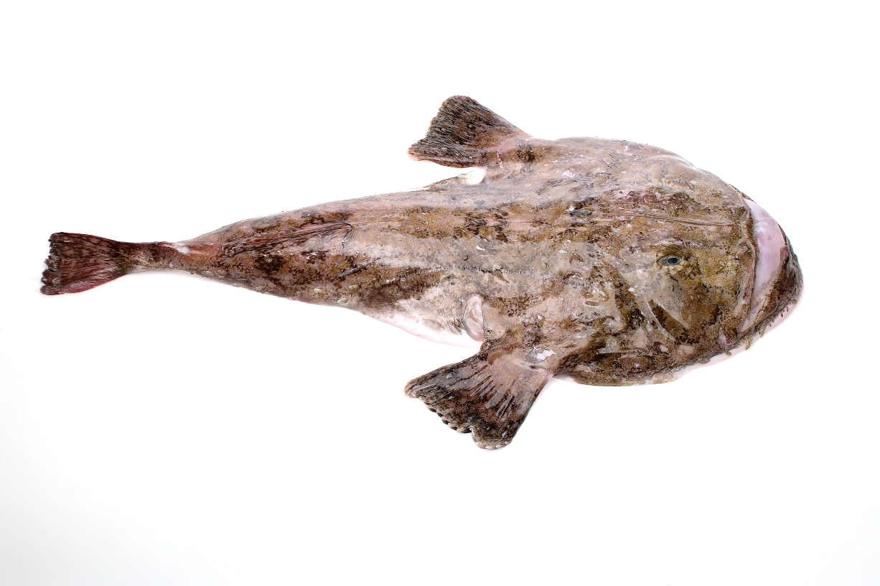
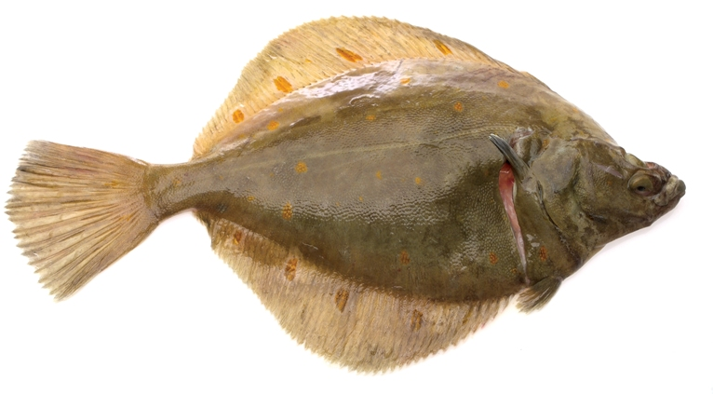
Mussels
Crab
Mackerel
Cod
Plaice
Monkfish
Monkfish
Plaice
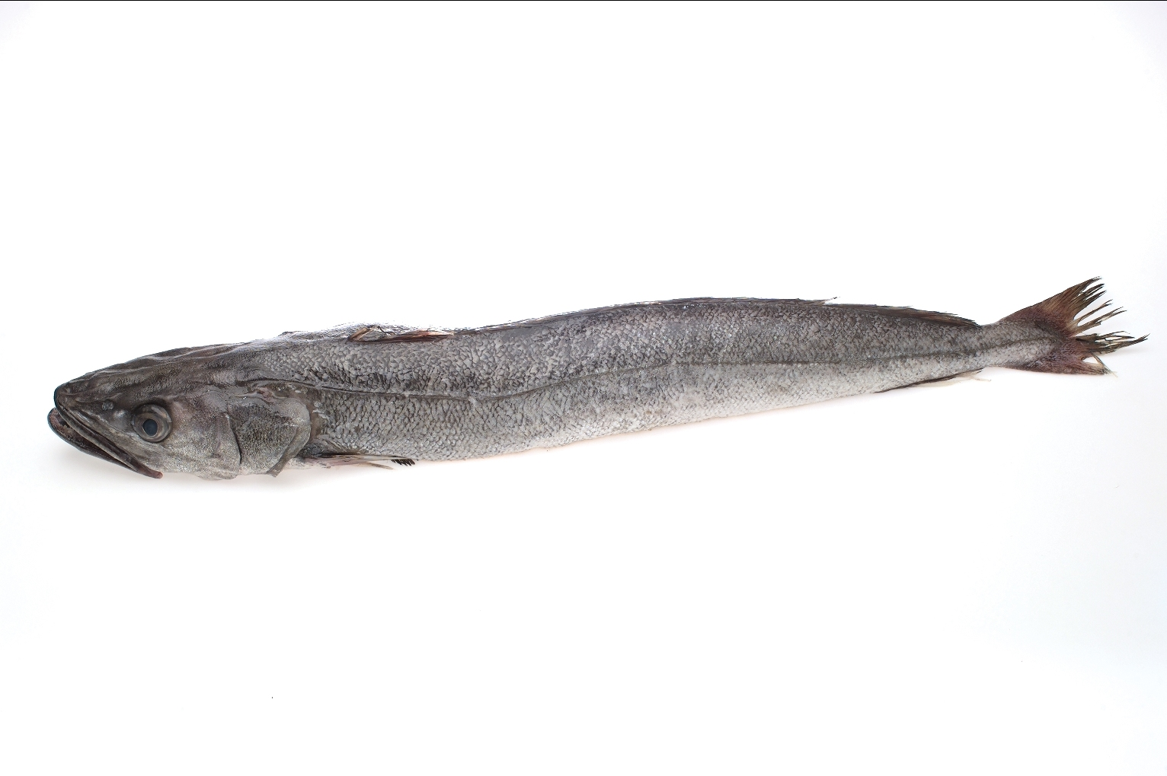
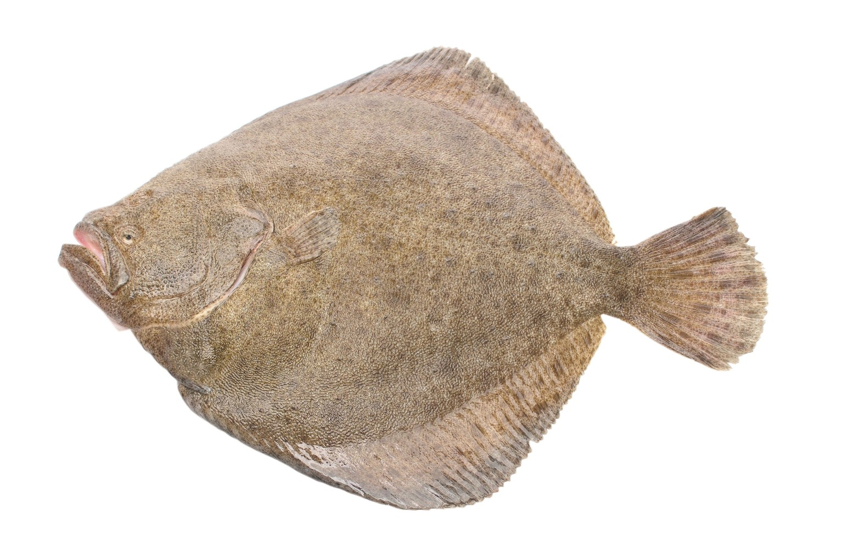
Langoustine
Prawn
Sardine
Haddock
Turbot
Hake
Turbot
Hake
Turbot
Plaice
Hake
Monkfish

