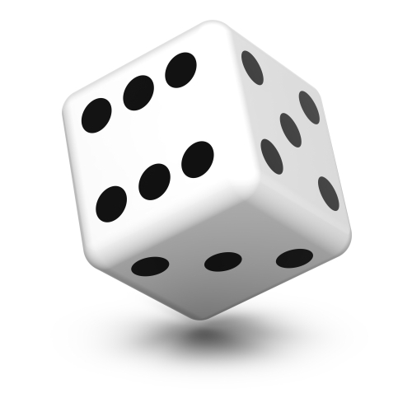
Potato meal generator
Roll a dice four times to create a potato-based meal!

 | Roll 1 | Roll 2 | Roll 3 | Roll 4
1 | Mashed potato | Fish fingers | Peas | Water
2 | Jacket potato | Chicken | Carrots | Orange juice (150ml)
3 | New potatoes | Beef burger | Sweetcorn | Milk
4 | Potato wedges | Salmon | Broccoli | Smoothie (150ml)
5 | Roast potatoes | Nut roast | Baked beans | Water with ice
6 | Potato croquettes | Omelette | Spinach | Infused cucumber water

Repeat three times to create three meal options and record them here.

1

2

3

