Types of potato
Name the type (fluffy, salad or smooth) and variety of potato for the following:
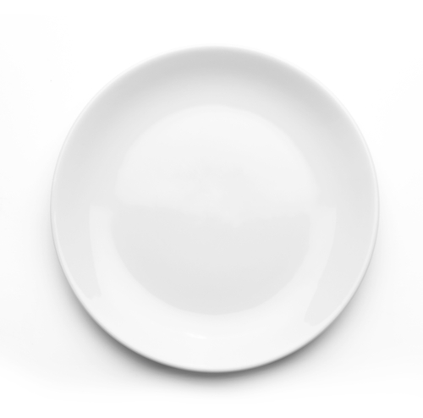

Jacket potato

Type:

Variety:
Potato salad

Type:

Variety:

Chips

Type:

Variety:
Mash potato

Type:

Variety:

