Growing potatoes

Potatoes
- Need light, water, food, space, air – and the correct temperature to grow really well.
- Read the following top tips to help grow the biggest weight of potatoes.

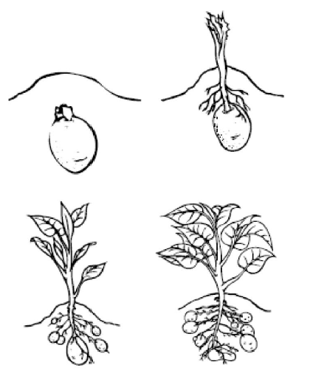
Space
- The more room the plants have to grow, the better, so remember this when selecting a container.

Light
- Plants need light to grow, so make sure that containers are placed somewhere in the light.

Water
- Potatoes need water to grow, make sure you do not over water or the plants will go mouldy.
- Ensure that the soil is moist.
- Water every 3 – 4 days.

Food
- Potatoes need food to grow. This comes from nutrients in the soil.
- Compost should contain everything your potato needs.
- You might want to add some extra plant food, if you do read the instructions carefully.

Temperature
- The ideal temperature for growing potatoes is 10-15°C.

