Growing tips
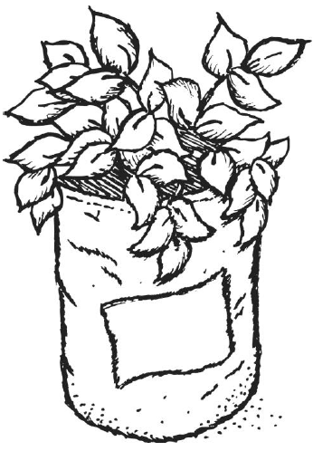
Growing your plants
- Your plants will go through a number of growing stages.
- The leaves of the plant may start to die off before it is time to harvest – don’t worry, this is normal.
- If the plant appears to be going mouldy, it is normally due to overwatering.

Growing potatoes in a greenhouse
- If it is frosty outside, make sure all of the greenhouse windows are closed.
- If it is very sunny, make sure the greenhouse is well ventilated so that the plant does not overheat.
- The ideal temperature for growing potatoes is 10-15°C.
Where can I plant potatoes?
- You can grow potatoes inside, outside, in a greenhouse or even start off inside and move containers outside when the weather is warmer.

Growing potatoes inside
- Put the container somewhere as light as possible, ideally south facing.
- Make sure it is away from radiators or heaters.
- Keep turning the plant round so it grows upright.
- Keep the plant moist, but do not over water.

Growing potatoes outside
- Watch the weather forecast and bring containers inside if it is likely to be frosty.
- Alternatively you can use bubble wrap or a blanket to protect the plants.
- Plants can be grown in full or partial sunlight.

What varieties can I grow?
- When choosing another variety you need to check that it will be able to grow in the time you have for the school term.
- Some varieties that should produce a reasonable yield in the time are: Premier, Swift, Estima, Marfona, Maris Bard and Desiree.

