Planting potatoes
Equipment
• Seed potatoes and grow bags.
• A tray or an egg box for the chitting process
• Compost or soil
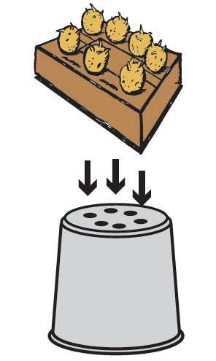
• Paper of plastic sheet to go under the container

Instructions
Step 1 - Chitting
Put your seed potatoes on to the tray or into an open egg box with the sprouts facing up.
Place on a windowsill for two weeks to allow the sprout to harden.

Step 2 – Choosing a container
Use a black plastic growing bag or a suitable container. If using a metal bucket,
get an adult to make drainage holes in the bottom using a hammer and nail.
If you are using a plastic bucket, then it may be advisable to use a drill for the task.

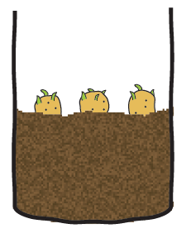
Step 3 – Fill your container
Once chitting is complete, half fill the containers to be used with compost or soil.
If you are planting in raised beds, make a suitable size hole for each seed potato to approximately 1.5 times its own depth, place the seed potatoes in the holes and
cover with soil.

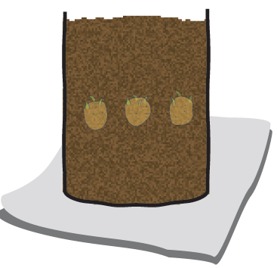
Step 4 – Placing the seed potatoes
Place three seed potatoes in each container at equal spacing with the sprouts facing up.

Step 5 – Fill up the container
Fill the container nearly to the top with compost or soil and gently pat down. Water lightly if the compost or soil is dry.

Step 6 – Position the container in the best place
Place the container somewhere reasonably light and not too cold or warm. The ideal temperature is around 10-15º C.
Make sure that you place containers on some newspapers, a tray or some plastic sheet to prevent any water or soil leaking on to the floor.
If positioned outside, bring in containers if there is likely to be a frost.

Top tips
- Make sure that gloves are worn when handling potatoes and soil or compost.
- Wash hands thoroughly after completing the tasks.
- Keep the container in a sunny and airy position.
- Keep the soil moist (but not waterlogged) and away from any likely frost.

