Case study 3

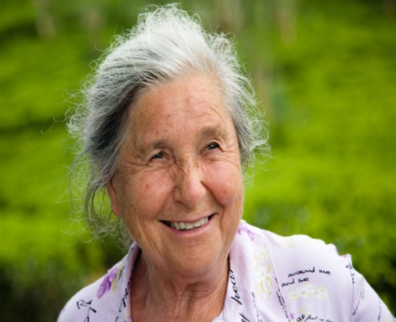
Name: Maureen

Age: 76

Further information:
At 76 years old, Maureen would be classed as an ‘older adult’ meaning that her energy and nutrient requirements would differ from the general population.

Below is Maureen’s diet diary. She was asked to record everything she ate and drank over a day.
Time of day | Food/drink consumed | Amount consumed (g)
7.30 | 1 small bowl of porridge made with milk and water  Cup of tea made with whole milk and 2 tsp sugar
10.00
11.30 | 2 chocolate digestives  Cup of tea made with whole milk and 2 tsp sugar
13.00 | A medium portion of oven chips and baked beans  1 glass of water
15.30 | 1 small packet of crisps  Medium glass of orange juice
18.00 | 2 medium slices of wholegrain toast with 1 egg  1 banana and 1 apple
20.00 | Cup of tea made with whole milk and 2 tsp sugar
21.00 | Glass of water

- Using the Portion sizes guide, complete the diet diary in the table above.

- Go to Explore Food http://explorefood.foodafactoflife.org.uk/

- Select ‘Calculate a diet’ and enter in the details of this person’s diet diary.

- Print out the results of their analysis. Attach the print-out to this worksheet.

- Compare their diet to the Dietary Reference Values (DRVs) for their age and gender.
Print out the results of this comparison.

- Look at the comparison of energy and macronutrients to the DRVs.
Are there any nutrients where too much is being consumed? Are there any nutrients where too little is being consumed? What are the consequences of this, if any?

- Look at the comparison of minerals and vitamins to the DRVs.
Are there any micronutrients where too much is being consumed? Are there any micronutrients where too little is being consumed? What are the consequences of this, if any?

- How much salt was consumed on this day?
(Convert mg of sodium to g of sodium and then multiply by 2.5 to calculate salt).

- Does this diet follow healthy eating messages (e.g. The Eatwell Guide, 5 A DAY, 8 tips for healthy eating, fluid recommendations)? Explain your answer.

- How could you modify the diet to make it healthier (with regard to the DRVs and healthy eating messages)?

- Carry out your suggested changes using Explore food.
Compare the results of and evaluate whether your changes were successful.

