Case study 9
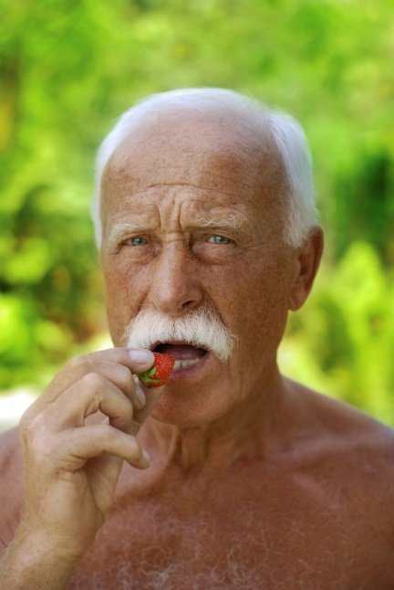
Name: Rodrigo

Age: 62

Further information:
Rodrigo has type 2 diabetes.

Below is a blank food diary for Rodrigo. Design a day’s diet for Rodrigo and complete the questions below.
Time of day | Food/drink consumed | Amount consumed (g)

- Using the Portion sizes guide, design a day’s diet for Rodrigo and complete the table above.

- Go to Explore Food http://explorefood.foodafactoflife.org.uk/

- Select ‘Calculate a diet’ and enter in the details of this person’s diet diary.

- Print out the results of their analysis. Attach the print-out to this worksheet.

- Compare their diet to the Dietary Reference Values (DRVs) for their age and gender.
Print out the results of this comparison.

- Look at the comparison of energy and macronutrients to the DRVs.
Are there any nutrients where too much is being consumed? Are there any nutrients where too little is being consumed? What are the consequences of this, if any?

- Look at the comparison of minerals and vitamins to the DRVs.
Are there any micronutrients where too much is being consumed? Are there any micronutrients where too little is being consumed? What are the consequences of this, if any?

- How much salt was consumed on this day?
(Convert mg of sodium to g of sodium and then multiply by 2.5 to calculate salt).

- Does this diet follow healthy eating messages (e.g. The Eatwell Guide, 5 A DAY, 8 tips for healthy eating, fluid recommendations)? Explain your answer.

- How could you modify the diet to make it healthier (with regard to the DRVs and healthy eating messages)?

- Carry out your suggested changes using Explore food.
Compare the results of and evaluate whether your changes were successful.

