Allergen labelling
There are rules that determine the way allergen information appears on labels and on food that is pre-packed, sold loose or served in a restaurant, café or take-away.

Fourteen major allergens will be highlighted on the label within the ingredients list.

The allergens are:

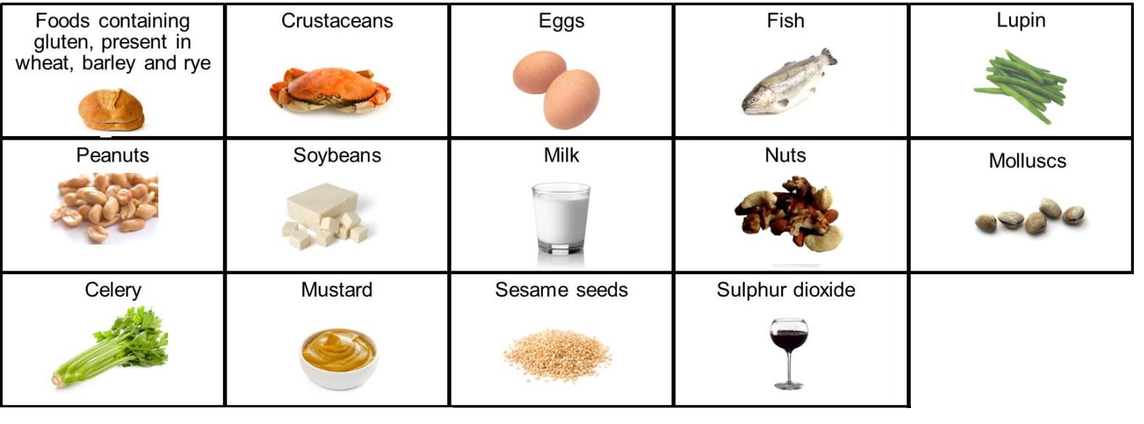

The allergen could be identified in bold, highlighted, underlined or in italics.

The example below is for a basic Victoria sponge:

Eggs, wheat flour, butter, sugar, vanilla essence, baking powder

- Identify the allergens in the following recipes and produce an ingredients list that could be included on a label. Remember that ingredients should appear in descending order of weight.
Scone based pizza

150g self-raising flour
40g hard fat or butter
a pinch of salt
100ml milk
2 x 5ml spoons tomato puree
150g grated cheese or Mozzarella cheese
50g chopped green, yellow or red pepper

50g canned tuna (in brine)

Vegetable quiche

150g plain flour
75g hard baking fat or butter
125ml semi-skimmed milk
2 large eggs (approx. 60g each)
50g grated Cheddar cheese
50g sliced mushrooms
50g cherry tomatoes
50g frozen sweetcorn or peas

Macaroni cheese

100g macaroni
100g Cheddar cheese
1 tomato (approx. 50g)
300ml semi-skimmed milk
25g butter
25g plain flour
1 x 5ml spoon English mustard

- Collect five examples of ingredient lists/food labels that highlight allergens.

