Creating a label
Follow the stages in the example below to create a label on Explore food http://explorefood.foodafactoflife.org.uk/.

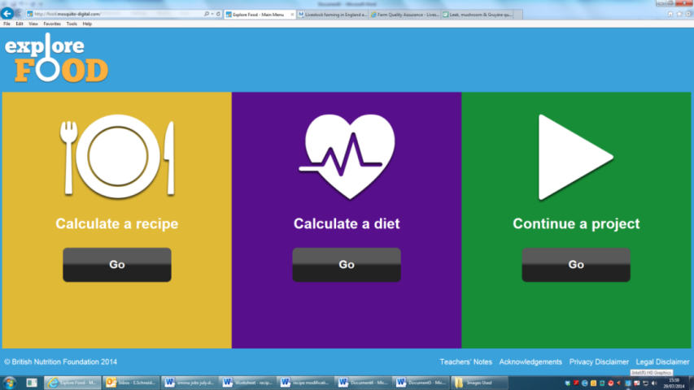
- Open Explore food. Click ‘Go’ under ‘Calculate a recipe’.
Click here

Click here
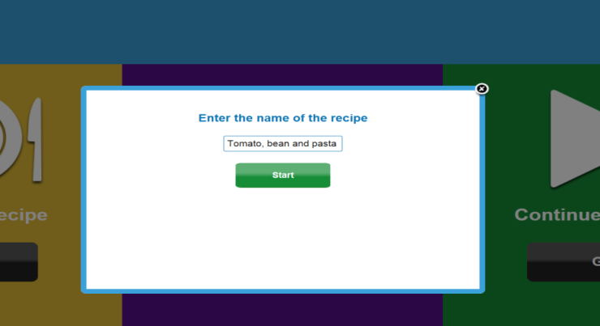
- Enter the name ‘Tomato, bean and pasta soup’. Click ‘Start’.

- Enter the following ingredients and quantities: 150g onion, 60g celery, 5g garlic clove, 11g olive oil, 800g chopped tomatoes, 190g butter beans, 50g macaroni.

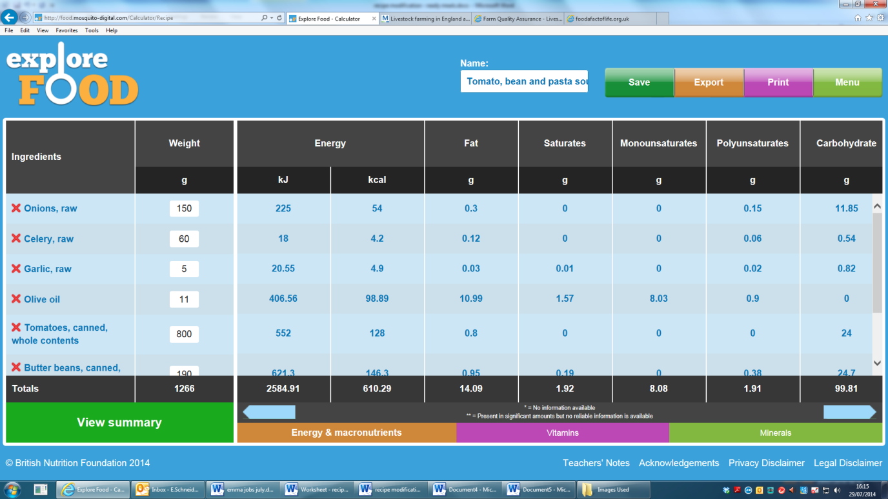
- Click ‘View summary’.
Click here

- Change the number of portions from 1 (default) to 4. Click ‘Calculate’ to recalculate the nutritional information based on the number of portions. Then click ‘Create label’ to create a front and back of pack nutrition label.

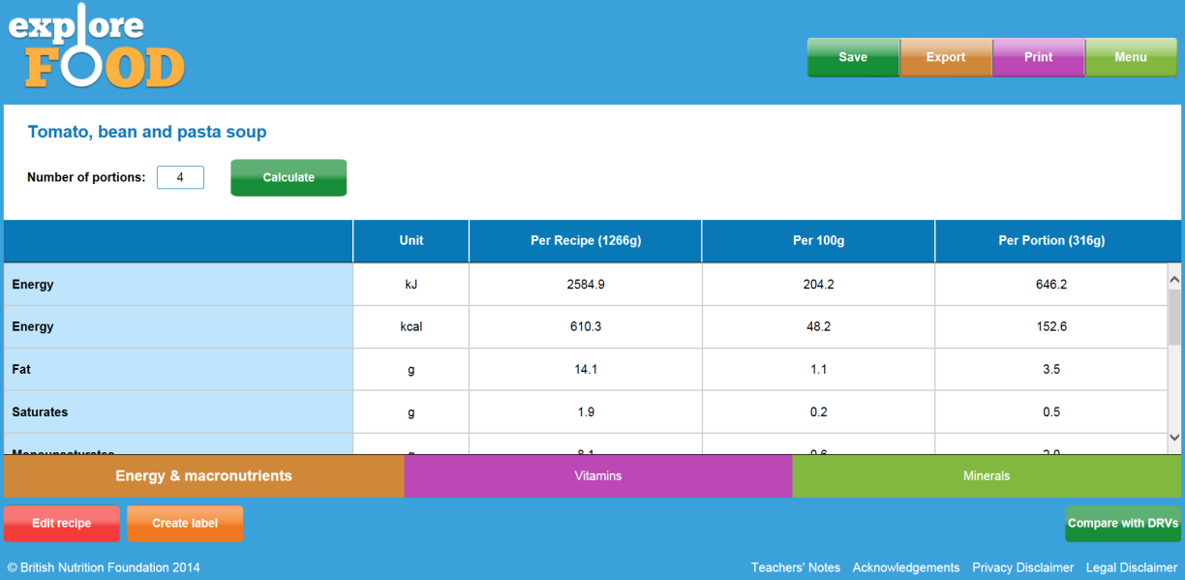
Change number of portions here

Portion size reflects number of portions

- Enter a title for the front of pack label. This should state the portion size that the nutrition information relates to. Enter the title ‘1/4 carton of soup contains’. Choose whether the recipe is for a food or drink. Click ‘Create label’.
Click here

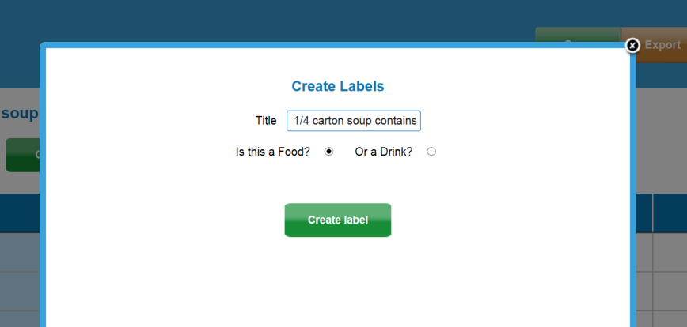
Enter title here
Click here

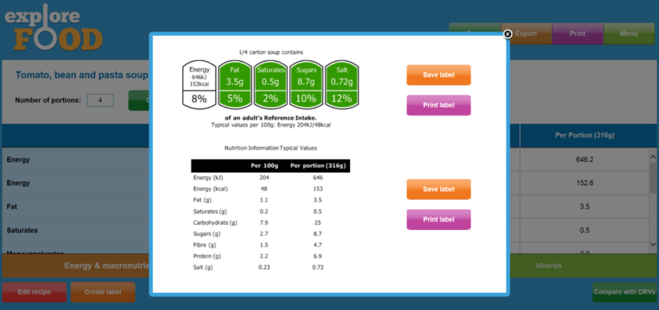
- Your food label should now appear on screen. From here you can save and print the labels. To go back to the main summary screen, press the cross icon (top, right hand side).

- Print out and attach your labels to the worksheet. Now you have followed the example, why not enter one of your recipes into Explore food to create a label?
Click here

