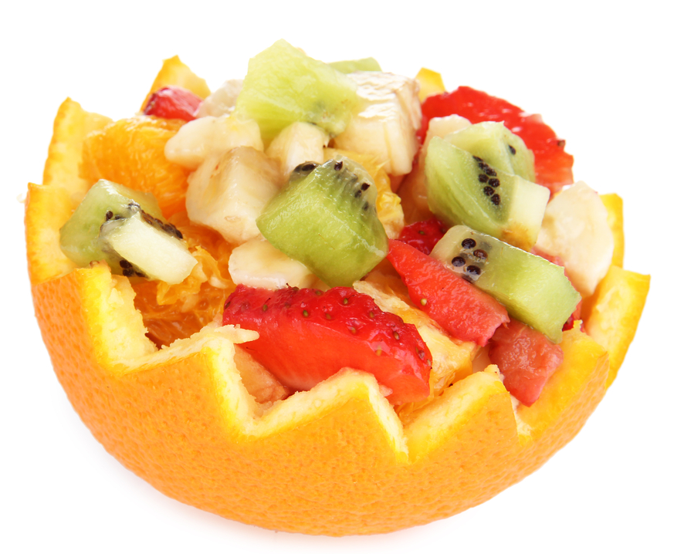
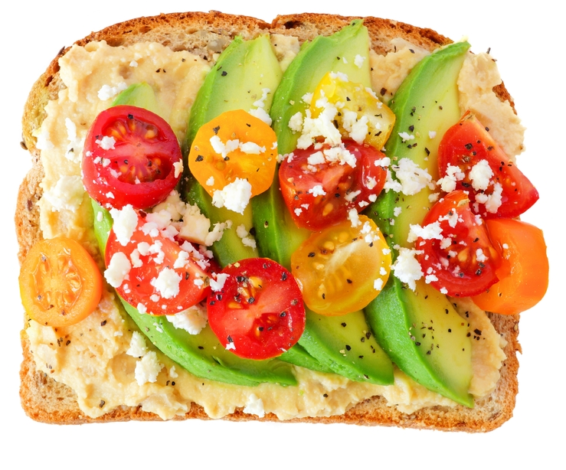
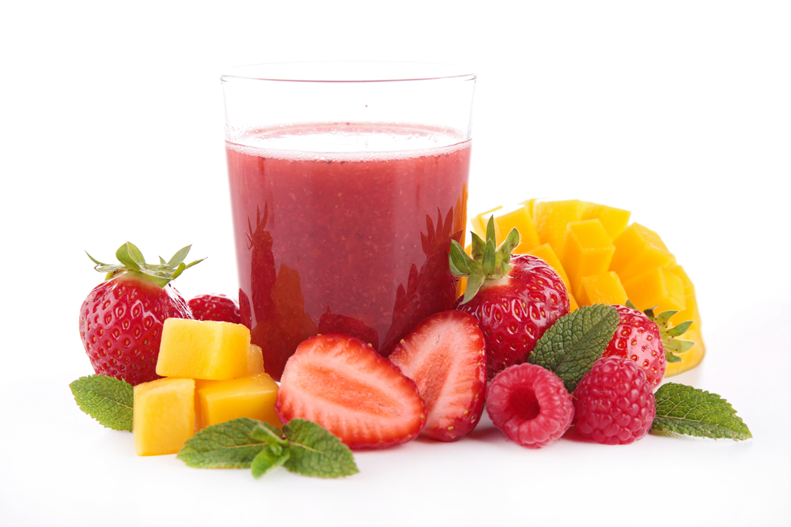
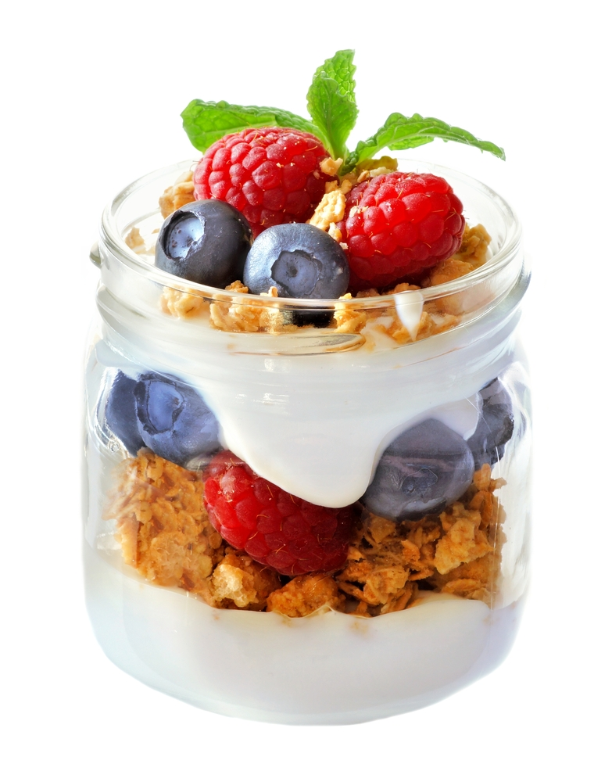
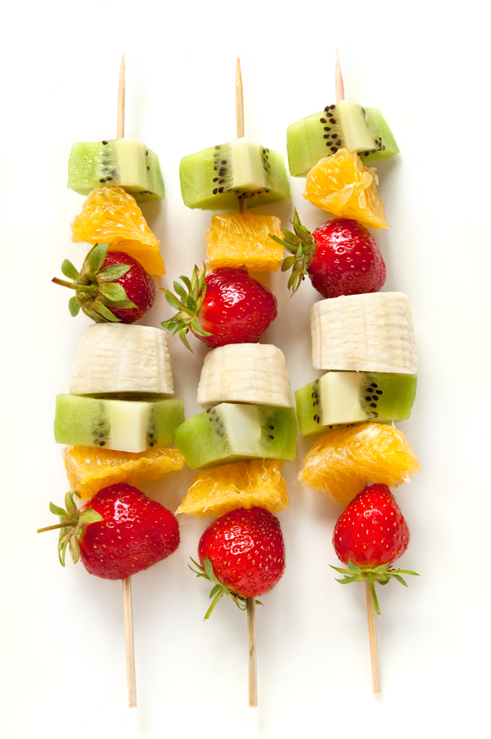
© Food – a fact of life 2023
www.foodafactoflife.org.uk
© Food – a fact of life 2018

[Dyddiad]
Am gwblhau’r her Codi a Deffro
[Enw]

