UK Wheat production

Look at the map showing where wheat is produced in the UK, and the wheat production table.
Using the information in the table, colour in the map.
Choose three shades of one colour – dark, medium and light. Colour the map to show how much wheat is grown in each region. Remember to colour in the key as well.
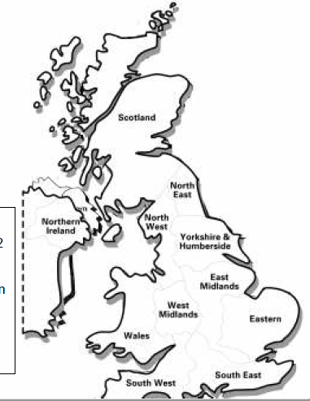

Key

More than 2 million tonnes (Dark colour)

Between 1 and 2 million tonnes (Medium colour)

Under 1 million tonnes
(Light colour)

Regions of the UK | Tonnes of wheat grown each year
North East | 576,000
North West | 240,000
Yorkshire and Humberside | 2,257,000
East Midlands | 3,070,000
West Midlands | 1,328,000
East | 4,170,000
South East | 1,934,000
South West | 1,285,000
Wales | 170,000
Scotland | 1,059,000

UK wheat production questions

- How much wheat did the region where you live produce?

- Is your region one of the top five highest producers?

- What position is your region if the biggest producer is number one?

- Which region grows the most wheat?

- Which region grows the least?

