Session 2: Top toastie
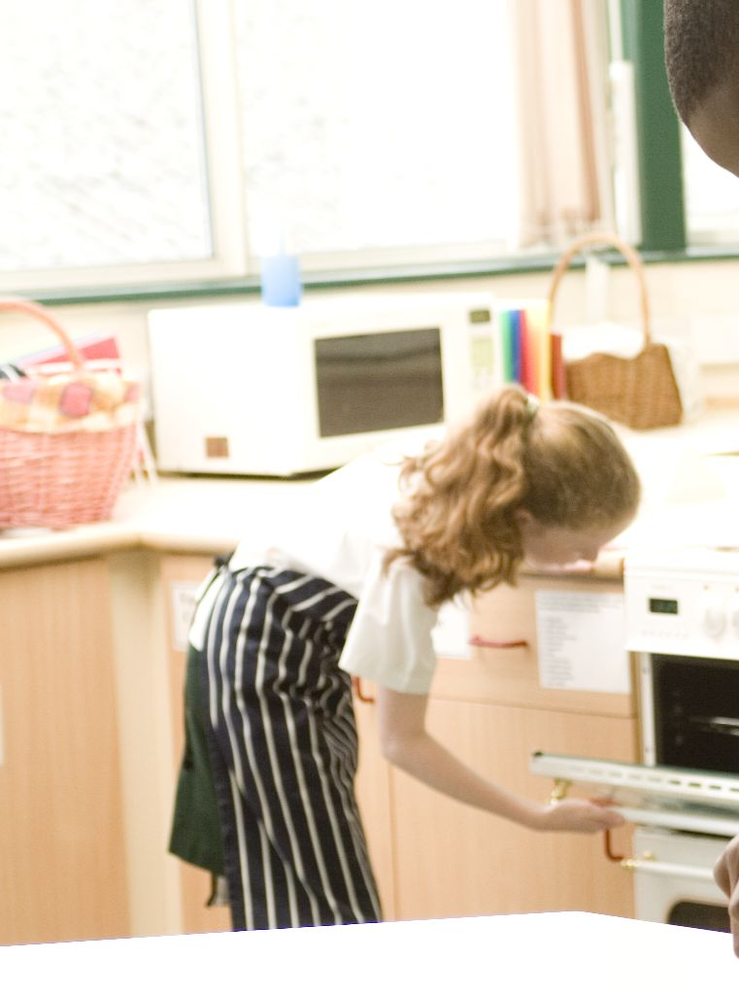
Welcome
This session is about pupils using the grill safely, as well as handling and preparing a range of ingredients. This session allows all pupils to build their confidence in the cooking area, learning where equipment is stored and how to work safely. It also provides you with another opportunity to assess their practical capability, e.g. safe use of equipment. You could use the practical observation sheet to help.

During this session, pupils will make either a croque-monsieur or pizza toast, something which they would enjoy making at home. These have been selected as they can be cooked under a grill and use a range of ingredients. If you have pupils who do not eat meat, or more specifically pork, the ham in the croque-monsieur can be replaced with an alternative or with vegetables. These recipes help to consolidate the safe use of a knife, as well as allowing pupils to use other basic pieces of equipment, e.g. a grater.

There is lots of room for pupils to be creative, selecting different types of bread, fillings and toppings. You could get your pupils to use the croque-monsieur or pizza toast recipe writing frames before cooking to develop their own ideas. The pupils’ own recipe creations could then be used in this session. You may wish to structure the activity so that pupils eat their toastie as part of the session, as they do not re-heat well.

If you have an established lesson plan and/or recipe, which supports the aims and objectives of this session, feel free to use it instead. Look at the support materials provided within this session as they support this activity and may well be useful in your own lessons, e.g. worksheets, presentations.

This session can act as a stand-alone lesson, focusing on the safe use of the grill. Alternatively, it could be integrated into a series of lessons, e.g. exploring a range of breads and fillings for toasties; creating grilled dishes for different occasions or developing interest in local produce, e.g. cheeses, breads.

Aims and objectives

Aim
For pupils to:
- develop confidence handling food and using a cooker (grill) safely.

Objectives
Pupils should be able to:
- use a range of basic equipment, e.g. chopping board, knife, grater;
- handle and prepare a range of ingredients, e.g. slicing bread, grating cheese;
- cut ingredients using the bridge hold and claw grip;
- use a grill safely;
- make a toasted bread dish, e.g. a croque-monsieur or pizza toast.

Cooking session
Two cooking session plans, based on the Licence to Cook recipes are supplied within this session.

If you have your own tried and tested croque-monsieur or pizza toast recipe, feel free to use it instead. In addition, you may wish to make quesadillas, Welsh rarebit or bruschetta.

Each plan refers to aspects of healthy eating, wise food shopping and food safety and hygiene which are themes which run through each session.

Before cooking session
There are a number of factors that you need to consider before the cooking session. More detailed guidance is available in the Cooking session guide.

You will need to consider:
- Ingredients: who will be providing the ingredients and where will they be stored? In the pizza toast recipe, 2x15ml spoons tomato sauce (ragu) is used. It may be easier for the school to provide a carton/jar of sauce for pupils to share.
- Recipe: are pupils going to use a printed-out copy or follow instructions on an interactive whiteboard?
- Equipment: is all the equipment needed for the session available, clean and in good working order? Check that all the grill pans are in the grills, along with handles (you may need oven gloves). If time and resource permits, you may wish to have some of the equipment out for each pupil, to build their confidence. In subsequent sessions, you may wish the pupils to locate their own equipment from cupboards and drawers.
- Aprons: do you have enough and are they clean?
- Hair: do you have ties/bands for long hair?
- Containers: will pupils be able to take away the food they cook? If so, in what?
- Waste: do you have adequate disposal facilities, including recycling or composting?
- Cooking area: is it clean and ready to use?

Differentiation and inclusion
Before the cooking session, you will need to consider the age, ability, previous experience and any special requirements of your pupils. This will determine recipe selection, any advanced ingredient preparation and equipment used.

Do any of your pupils need:
- ingredients partly pre-prepared, e.g. grated cheese?
- assistance with their practical work, e.g. using the grill?
- less ingredients in their recipe to make it manageable in the time?
- an extended range of ingredients to challenge their preparation skills?
- alternative ingredients to ham?

Demonstration
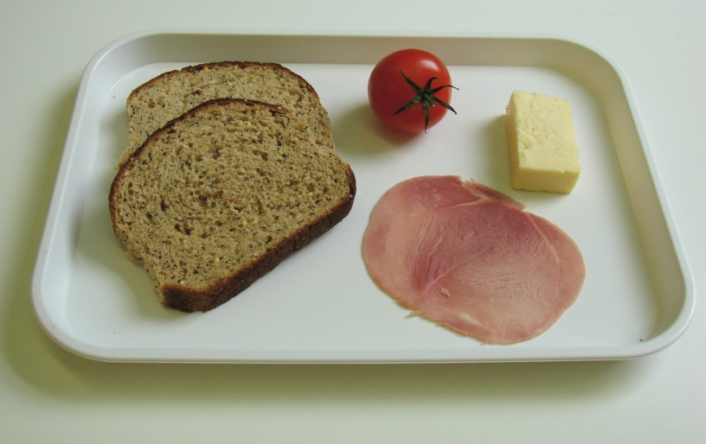
During the session you will be demonstrating the safe use of a knife and the grater, as well as the use of the grill.

Ensure that you have all the ingredients and equipment you need before the session, perhaps on trays ready for ease, for your demonstration.

Think about:
- describing the ingredients and equipment used;
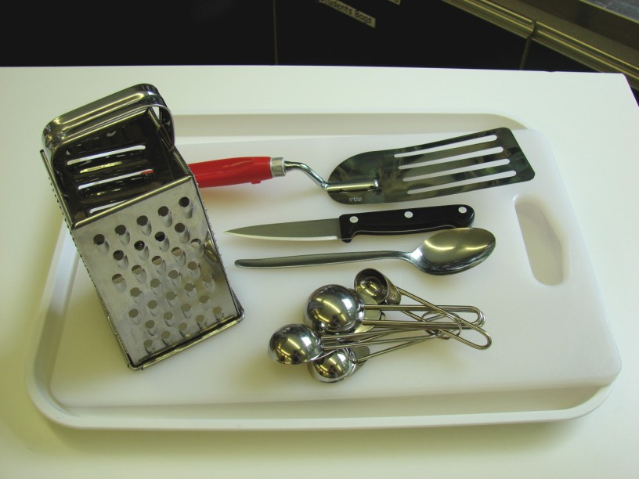
- highlighting key skills, such as slicing and grating safely;
- showing how to turn on the grill and handling the grill pan safely;
- ensuring that pupils have followed and understood the method.

Risk assessment

The two cooking session plans and recipes highlight a number of different hygiene and safety issues which need to be considered before, during and after the cooking session.

Before the cooking session, you will need to assess these risks in relation to the number of pupils being taught, as well as their experience, and consider measures that can be put into place to manage the risk. Below are examples of potential risks, along with preventative measures.

Croque-monsieur
Potential risk | Measure | Likelihood
Cheese and ham stored incorrectly, allowing harmful bacteria to multiply | Ensure cheese and ham are stored in the refrigerator between 0-5ºC | Low/Med
Cuts from using a knife unsafely | Demonstrate safe use of knives and monitor pupils’ use | Med
Cut and bruised knuckles from using the grater | Demonstrate safe use of the grater and monitor pupils’ use | Med
Burn to hand or arm from the grill or grill pan | Demonstrate safe use of the grill, promote the use of oven gloves when handling the grill pan and monitor pupils’ use | Low/Med

Pizza toast
Potential risk | Measure | Likelihood
Perishable foods are not stored correctly, leading to contamination
Dirt or food poisoning bacteria present on raw food, causing cross contamination | Wash vegetables | Low/Med
Out of date bread | Check date mark before purchase and use | Low
Cuts from using the knife unsafely | Demonstrate safe use of knives and monitor pupils’ use | Med
Peelings on floor causing accidents | Container on work surface for peelings and other waste | Low

Time
The session plans are based on a 60 minute session

If you have less time available, you will need to modify the session plan to better suit your circumstances. For example, within this session you might:
- demonstrate the safe use of the grill, leaving more time for cooking;
- demonstrate key aspects from the recipe, rather than every stage;
- use pre-grated cheese, to reduce preparation time;
- have ingredients pre-measured;
- allow pupils to work with a partner.
During the lesson
Time (mins) | Activity: croque-monsieur | Equipment/ Resources
0 | Registration.  Explain to the pupils that they will be making a Croque-monsieur. Go through the aims and objectives for the lesson. Recap what pupils learnt last time. | PowerPoint Croque-monsieur recipe
5 | Gather the pupils around a demonstration area, with your tray of ingredients and equipment. Get pupils to put on their aprons, tie back long hair and wash their hands.  Briefly talk through the recipe – note your expectations, for example:  * pre-heating the grill;  * using a knife safely to slice the tomato on a clean chopping board;  * grating the cheese on a chopping board or plate;  * assembling the ingredients together;  * placing and removing food from under the grill safely;  * being hygienic and safe when preparing food. | Aprons  Demonstration ingredient and equipment tray
 | Demonstration  * Show pupils how to pre-heat a gas and electric grill. Often electric grills take longer to pre-heat. Show them the grill pan, along with any handles, if not already attached.  * Place out the chopping board, knife and grater.  * Explain that you will be showing how to slice the tomato, using the claw grip technique. Show the technique, highlighting how the finger nails act as a guide for the knife.  * Grate the cheese on the chopping board or a plate, highlighting the use of the full length of the grater – talk about the pressure applied. Ensure that pupils do not grate their knuckles.  * When toasting their bread, remind pupils to position it in the middle of the grill pan. They could use a fish slice or tongs to position, turn over or remove hot items. Pupils need to watch their bread toasting – checking it regularly. Emphasise the use of oven gloves when handling grill pan handles, as these may become hot. | Aprons  Demonstration ingredient and equipment tray
20 | Ensure that all pupils wash their hands. Allow them to start making their croque-monsieur.  During this time, circulate the room to ensure that pupils are preparing ingredients and using the grill safely. In this time, pupils should:  * grate the cheese carefully;  * slice the tomato, using the claw grip technique;  * use the grill carefully, keeping their eye on it while cooking. | Basic equipment  Oven gloves  Ingredients

50 | Give a 5 minute time warning.  Remind pupils that all washing-up should be completed and work surfaces should be clean.  Either allow pupils to eat their croque-monsieur or place it into a labelled container.  Circulate the room, ensuring that sinks are clean and equipment is put away properly.
55 | Plenary  Pose the following questions to the pupils:  * What were the main skills demonstrated today?  * How could the croque-monsieur be healthier? (Reduced fat cheese, low-salt ham, added vegetables, wholegrain bread)  * What alternative fillings could be used?
60 | Finish

After the session
Check that the room is clean and tidy. Pupils should leave the room as they find it.

The croque-monsieur may need to be refrigerated until the end of the school day, if so, ensure that each container is covered and clearly labelled with the pupil’s name and group. The refrigerator should be between 0-5ºC. It may be better that it is consumed during, or shortly after, the session, as the croque-monsieur will be at its best.

If the same pupils are with you for another cooking session in the next few days or week, remind them of the ingredients and/or containers they need to bring, if appropriate. You may wish to provide pupil’s with recipes or writing frames.
During the lesson
Time (mins) | Activity: pizza toast | Equipment/ Resources
0 | Registration.  Explain to the pupils that they will be making pizza toast. Go through the aims and objectives for the lesson. Recap what pupils learnt last time. | PowerPoint Pizza toast recipe
5 | Gather the pupils around a demonstration area, with your tray of ingredients and equipment. Get pupils to put on their aprons, tie back long hair and wash their hands.  Briefly talk through the recipe – note your expectations, for example:  * pre-heating the grill;  * using a knife safely to prepare the vegetables on a clean chopping board;  * grating the cheese on a chopping board or plate;  * placing and removing food from under the grill safely;  * being hygienic and safe when preparing food. | Aprons  Demonstration ingredient and equipment tray  Recipe
 | Demonstration  * Show pupils how to pre-heat a gas and electric grill. Often electric grills take longer to pre-heat. Show them the grill pan, along with any handles, if not already attached.  * Place out the chopping board, knife and grater.  * Explain that you will be showing how to prepare the vegetables, using the claw grip technique. Show the technique, highlighting how the finger nails act as a guide for the knife while slicing the yellow pepper and mushroom.  * Grate the cheese on the chopping board or a plate, highlighting the use of the full length of the grater – talk about the pressure applied. Ensure that pupils do not grate their knuckles.  * When toasting their bread, remind pupils to position it in the middle of the grill pan. They could use a fish slice or tongs to position, turn over or remove hot items. Pupils need to watch their bread toasting – checking it regularly. Emphasise the use of oven gloves when handling grill pan handles, as these may become hot.  * If you have time, you may wish to show how to assemble the pizza toast or use PowerPoint.Pizza toast recipe | Aprons  Demonstration ingredient and equipment tray  Recipe
20 | Ensure that pupils all wash their hands. Allow them to start making their pizza toast.  During this time, circulate the room to ensure that pupils are preparing ingredients and using the grill safely. In this time, pupils should:  * grate cheese;  * slice the vegetables safely using the claw grip;  * toast one side of the bread;  * spread the tomato pizza sauce over the bread;  * arrange toppings on their bread;  * use the grill carefully – keeping their eye on it while cooking. | Basic equipment  Ingredients  Oven gloves
50 | Give a 5 minute time warning.  Remind pupils that all washing-up should be completed, and work surfaces should be clean.  Either allow pupils to eat their pizza toast or place it into a labelled container.  Circulate the room, ensuring that sinks are clean, and equipment is put away properly.
55 | Plenary  Pose the following questions to the pupils:  * What were the main skills demonstrated today?  * How could the pizza toast be healthier? (Reduced fat cheese, low-salt ham, added vegetables, wholegrain bread)  * What alternative toppings could be used?
60 | Finish

After the session
Check that the room is clean and tidy. Pupils should leave the room as they find it.

The pizza toast may need to be refrigerated until the end of the school day, if so, ensure that each container is covered and clearly labelled with the pupil’s name and group. The refrigerator should be between 0-5ºC. It may be better that it is consumed during, or shortly after, the session, as the pizza toast will be at its best.

If the same pupils are with you for another cooking session in the next few days or week, remind them of the ingredients and/or containers they need to bring, if appropriate. You may wish to provide pupils with recipes or writing frames.
Extending this activity
This session provides a great opportunity to be integrated into existing lessons or be developed into a mini-scheme of work.

For example, pupils could:
- explore different varieties of toasted sandwiches that are available, e.g. quesadillas, paninis;
- plan, and create new recipe ideas for toasties, perhaps using different types of bread and fillings to suit different people, e.g. young children;
- evaluate their own recipes, focusing on the use of ingredients and equipment used.

Appropriate aspects of ICT could also be integrated, including:
- recording cooking and the final dish with a camera;
- creating a recipe plan;
- modelling sensory evaluation data;
- exploring the internet for recipe inspiration.

Shopping list

Croque-monsieur

Ingredient | x 1 | x 10 | x 20
Hard cheese | 30g | 300g | 600g
Tomato | 1 | 10 | 20
Bread (slices) | 2 | 20 | 40
Ham (slices) | 1 | 10 | 20

Pizza toast

Ingredient | x 1 | x 10 | x 20
Bread (slices) | 2 | 20 | 40
Yellow pepper | ½ | 5 | 10
Spring onion | 1 | 10 | 20
Mushroom | 1 | 10 | 20
Hard cheese | 30g | 300g | 600g
Tomato pizza sauce | 2x15ml spoons | 300ml | 600ml
Mixed herbs | ½ x 5ml spoon | 5 x 5ml spoon | 10 x 5ml spoon

Equipment list

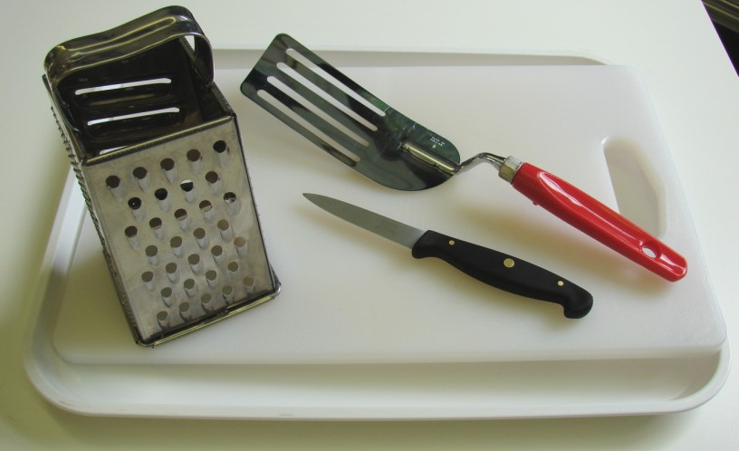
Croque-monsieur

Chopping board
Grater
Vegetable knife
Fish slice

Pizza toast

Chopping board
Vegetable knife
Grater
Fish slice
Measuring spoons
Dessert spoon

Other
A bowl for peelings and waste.

Containers

If pupils take home, they will need to bring (or be provided with by the school) a suitable container, such as a plastic tub or foil container with a lid.

