Caribbean-style turkey curry

Ingredients
Complexity: medium
1cm piece fresh ginger
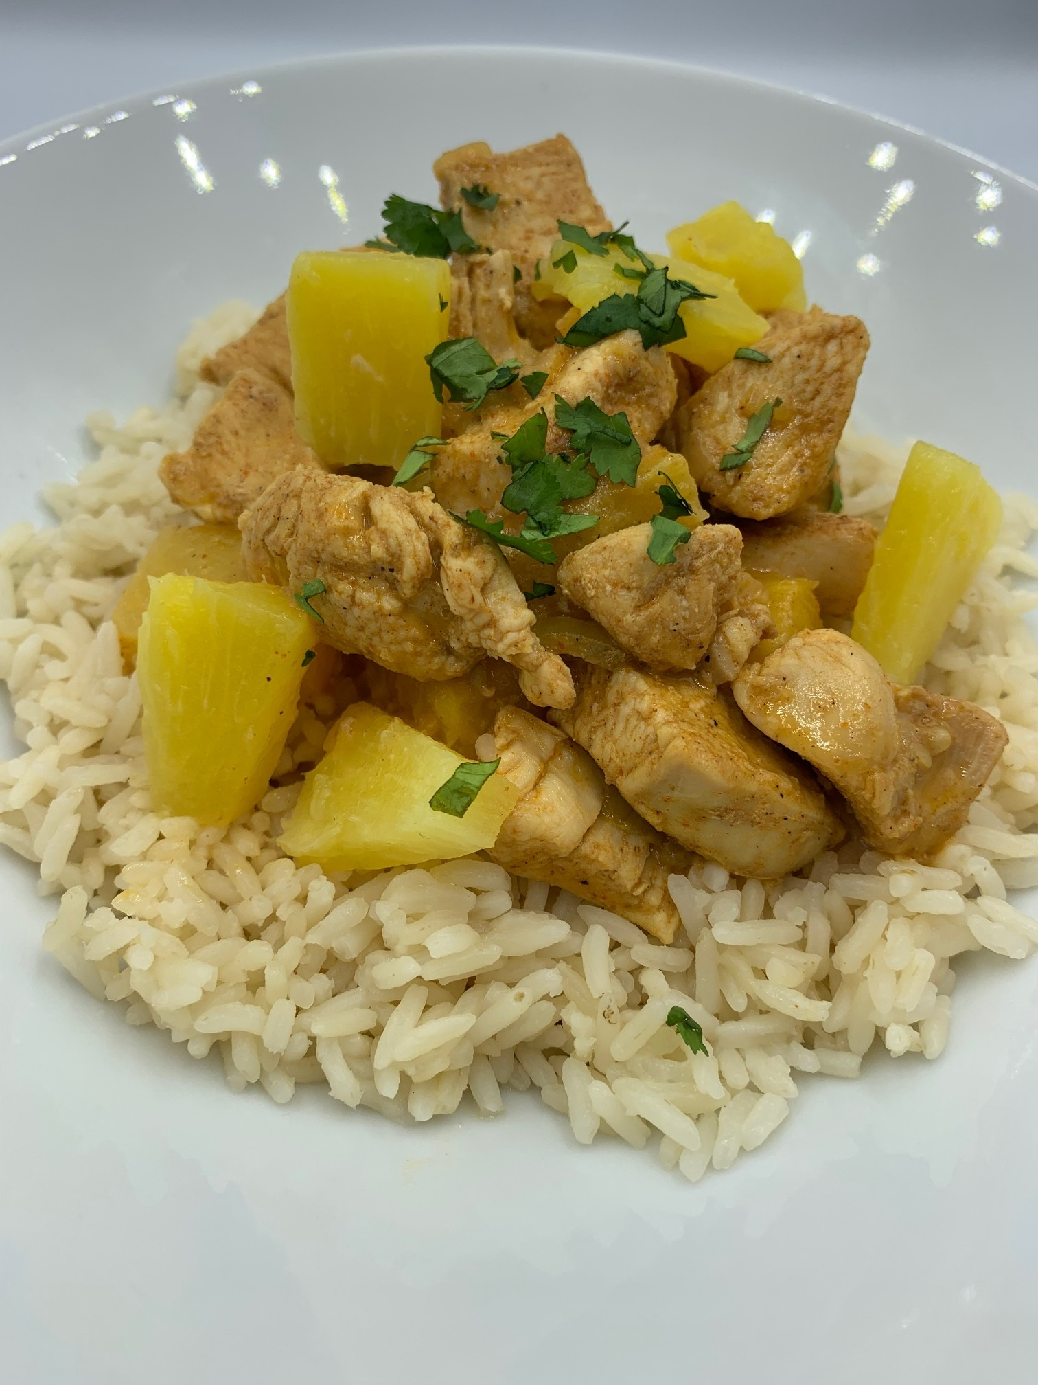
1 small onion
1 small can pineapple chunks in juice
200g turkey stir-fry breast strips
Spray oil
1 x 5ml spoon mild chilli powder
1 x 5ml spoon mild curry powder
400ml light coconut milk

Equipment
Chopping board, vegetable knife, grater, sieve, red board, frying pan or wok, mixing spoon, measuring spoons, measuring jug.

Method
- Prepare the ingredients:
  - peel and grate the ginger;
  - peel and finely dice the onion;
  - drain the pineapple;
  - cut the turkey into chunks, thoroughly washing and drying your hands after touching the raw meat.
- Spray the frying pan or work with oil and add the onion, ginger, chilli powder and curry powder. Stir-fry gently for 3 minutes.
- Add the turkey and fry for 5 minutes, until browned.
- Stir in the coconut milk and the pineapple.
- Simmer for 20 minutes until the sauce is reduced, and the turkey cooked with no pink meat remaining.
- Serve with boiled rice.

Top tips
- Use peeled and diced mango as an alternative to pineapple.
- For a vegetarian option use firm tofu cut into cubes or canned, drained chickpeas reducing the cooking time as necessary.
- Serve with brown rice for added fibre.

Food skills
- Weigh
- Measure
- Peel
- Cut
- Slice
- Drain
- Grate
- Mix
- Stir fry
- Simmer

Did you know?
The name ‘curry’ comes from the Portuguese, who used the word ‘caril’ to describe the spicy, fragrant dishes they found after arriving in India. It then became ‘curry’ when adopted by the English. As those countries formed trade routes and colonised the globe, curry travelled with them and today, curry of different types can be found around the world.

Caribbean curries are generally made with pre-made curry blends high in turmeric. They often include cumin, paprika, cardamom, garlic, and fenugreek. Those are then made into a paste or powder that is added to a protein and left to marinate before cooking. The powder is also added to the pan before cooking, creating popular dishes like curry goat and curry chicken.

This recipe was adapted from a recipe for Caribbean turkey curry, which was kindly donated by Tesco plc.

