Carbohydrates and their functional

properties in food products

- Name the three chemical elements that make up carbohydrates.
  - _________________________________
  - _________________________________
  - _________________________________

- Explain the difference between monosaccharides, disaccharides and polysaccharides.

______________________________________________________________________

______________________________________________________________________

______________________________________________________________________

- Match the carbohydrates (right) to the group of carbohydrates they belong to (left).
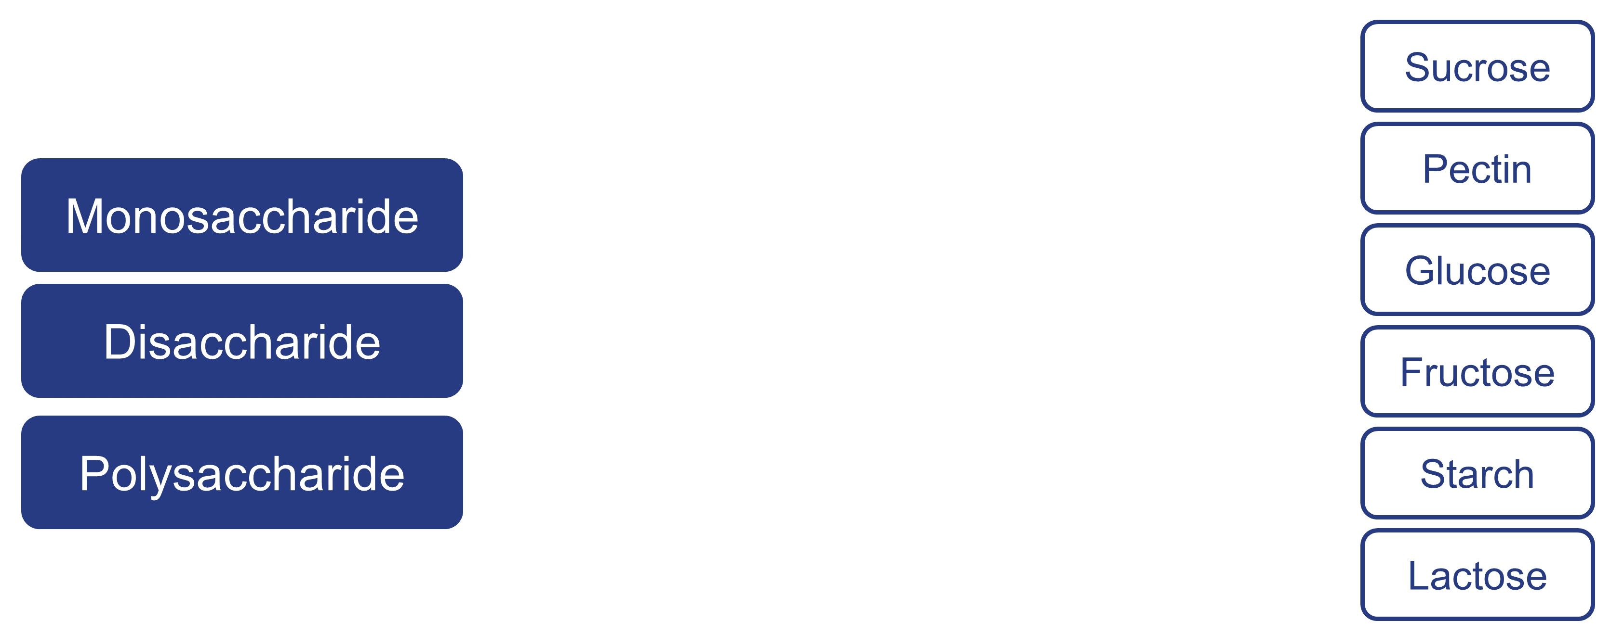

- Define the term ‘fibre’.

______________________________________________________________________

______________________________________________________________________

______________________________________________________________________

- Name the two types of fibre that can be found in food.
  - _________________________________
  - _________________________________

- Name three non-enzymic browning reactions.
  - _________________________________
  - _________________________________
  - _________________________________
- Which of the following definitions best describes the Maillard reaction?
  - Reactions involving amino acids (from protein) and reducing sugars.
  - Reactions involving heat breaking down large starch polysaccharides.
  - Reactions involving sugar being heated above its melting point.
- Describe the process of gelatinisation, using starch as an example.
______________________________________________________________________

______________________________________________________________________

______________________________________________________________________

- Describe what happens to caramel if it is overheated.

______________________________________________________________________

______________________________________________________________________

- Complete the table below, describing the functional properties of carbohydrates. Give at least one example of a food that uses each property.

Functional property | Description | Examples in food
Dextrinisation
Caramelisation
Gelatinisation

Maillard reaction

Preserving

Gelling

