How to grow chives

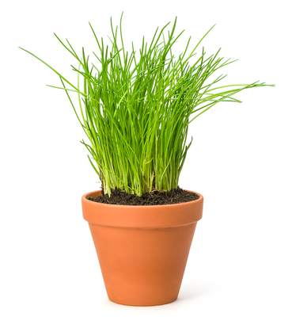
You will need:
- A plant pot (with drainage holes in the bottom);
- A saucer/plate on which to rest the plant pot, and catch drained water;
- A small trowel;
- Compost – enough to fill the pot;
- A small watering can or jug;
- A packet of chive seeds.

Instructions:
- Using the trowel, fill the plant pot ¾ full of compost.
- Water the compost until damp.
- Sprinkle the seeds evenly across the top of the compost.
- Cover the seeds lightly with a little more compost.
- Place the pot on the saucer and put it on a window sill.
- Water the seeds every few days to keep the compost damp.
- When the chives are about 15cm tall they will be ready to be harvested. Use kitchen scissors to snip them about 3cm from the bottom.
- You can keep snipping the chives each time they re-grow.

Handy hints:
- A plastic plant pot will be safer when working with children and easier to move around.
- You could plant your chives outside, do this from March to May and they will be ready in about 3 months.
- When children water the plants, only fill the watering can with the amount of water they will need so they do not over water the plant. Encourage them to pour slowly, carefully and evenly over the surface of the pot so the seeds or plant are not damaged.

