Pea and mint falafel

Ingredients
Complexity: medium

1 x 400g can chickpeas

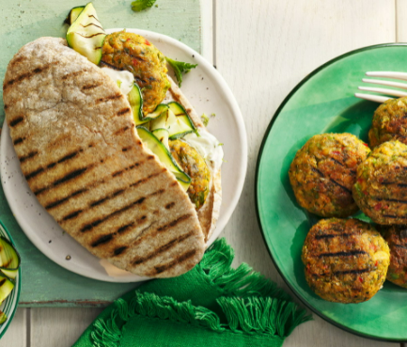
1 red chilli or ½ 5ml spoon chilli powder or flakes

1 garlic clove

10g fresh mint

75g plain flour

1 lime

200g frozen peas

1 x 5ml spoon smoked paprika

Black pepper

Spray oil

Optional

Pitta bread, lettuce and natural yogurt/tzatziki to serve

Equipment

Baking tray, greaseproof paper, sieve or colander, chopping board, vegetable knife, garlic press, zester or grater, lemon juicer, kitchen paper, plate, food processor or stick blender.

Method
- Preheat the oven to 180°C or Gas mark 5.
- Line a baking tray with greaseproof paper.
- Prepare the ingredients:
- drain and rinse the canned chickpeas;
- deseed and dice the chillies (if using);
- peel and crush the garlic cloves;
- pick the mint leaves and roughly chop;
- zest and juice the lime;
- defrost the peas.
- Pat the chickpeas and peas dry with kitchen paper. Place in a food processor with the paprika, fresh chilli or ground chilli/flakes, garlic, most of the mint, lime zest and 50g of the flour.
- Add a quarter of the lime juice and season with black pepper.
- Blitz to a coarse paste.
- Remove from the food processor and place on a plate. If the mixture feels too wet add the rest of the flour.
- Divide the mixture into 8. Lightly damp your hands and roll the mixture into even sized patties.
- Place on the lined baking tray and chill for 20-30 minutes to firm up, if time allows.
- Spray lightly with oil and bake for 15-20 minutes until golden brown. Turn the falafel halfway through baking to get an even colour.
- Optional – to serve, toast the pitta and split down one side. Shred the lettuce. Stuff the pitta with the falafel and shredded lettuce and serve with natural yogurt or tzatziki.

Top tips
- Make sure the chickpeas are well drained and dried – if not the mixture may be too wet and will not hold together.
- If you do not have a food processor or blender mash the chickpeas and peas and other ingredients with a potato masher and mix well.

Food skills
- Drain
- Dice
- Peel
- Crush
- Chop
- Zest
- Juice
- Blitz
- Divide and portion
- Form and shape
- Bake

Did you know?

Falafel is a popular Middle Eastern fast food made of a mixture of chickpeas (or sometimes fava/broad beans), fresh herbs, and spices that are formed into a small patties or balls. It is thought that falafel originated in Egypt as Coptic Christians looked for a replacement for meat during long seasons of fasting or lent. It has also become a popular vegan food in Egypt and throughout the Middle East.

Middle Eastern vendors often serve falafel with hummus and/or tahini sauce, which is known as a falafel plate. In Israel, the falafel is often named as the country's national dish and is served with tahini sauce which is a mixture of tahini paste (made from sesame seeds), lemon juice, garlic, and water.

The largest recorded falafel weighed 101.5 kg and was achieved by Hilton Dead Sea Resort & Spa in the Dead Sea, Jordan, on 31 May 2020!

Have you tried?
Roasted chickpeas: Chickpeas can be roasted with spices such as smoked paprika, ground cumin and coriander, cayenne pepper and a small amount of oil for a crunchy, healthy snack. Using spray oil instead of olive or vegetable oil, reduces the energy content of the dish.

This recipe was adapted from a recipe for Pea and mint falafel, which was kindly donated by Tesco plc.

