Lamb korma

Ingredients
Complexity: medium
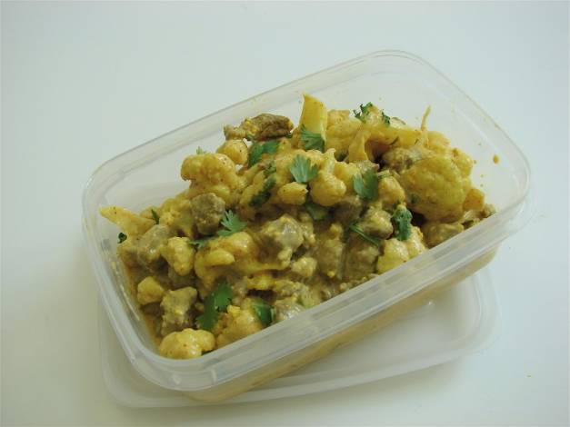
1 clove
1 clove of garlic
1 black peppercorn
1 cardamom pod
1x10ml spoon oil
200g lamb leg steaks
1/2 small cauliflower
1/2 green chilli
1/2x5ml spoon turmeric
1/2x5ml spoon ground cumin
1/2x5ml spoon chilli powder
3x15ml spoons plain yogurt
pinch black pepper
1x15ml spoon coriander
Equipment
Chopping boards, knives, frying pan, fish slice, measuring spoons, garlic press, spoon.
Method
1. Prepare the garlic, chilli and cauliflower:
- peel and crush the garlic;
- de-seed and chop the chilli;
- break the cauliflower into florets.
2. On a different chopping board using a fresh knife, cut the lamb into cubes.
Thoroughly wash and dry hands after handling the raw meat.
3. Fry the clove, peppercorn and cardamom in the oil until they sizzle.
4. Stir-in the garlic and chilli.
5. Add the lamb and cauliflower, cover and slowly cook for about 10 minutes.
6. Mix the turmeric, chilli powder, pepper and cumin into the yogurt.
7. Increase the heat and stir-in the yogurt mix to the frying pan.
8. Allow to cook for a further 10 minutes.
9. Chop the coriander and stir into the korma.
Top tips
- Try a variety of vegetables such as broccoli or peas and sweetcorn.
- Serve with brown rice for added fibre.

Food skills
- Measure.
- Peel.
- Crush.
- Chop.
- Cut.
- Fry.
- Stir.
- Simmer.
- Boil (if serving with rice).

This recipe is from the original Licence to Cook programme and is provided under the Open Government Licence.

