Fish and veg stack

Ingredients
Complexity: low-medium
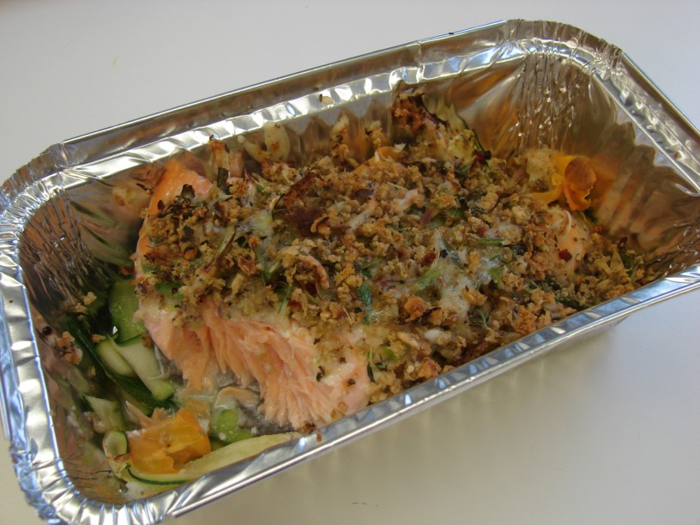
1 carrot
½ a courgette
1 piece of fresh fish e.g. salmon (approx 200g)
25 g cheddar cheese
1 spring onion
½ slice bread e.g. granary
1 x 5ml dried mixed herbs
Black pepper

Equipment
Chopping board, knife, peeler, oven proof/foil dish, baking tray ,food processor, grater, spoon, oven gloves, weighing scales.
Method
- Preheat the oven to 200c or gas mark 6.
- Top and tail the carrot and courgette, then run the vegetable peeler lengthways along each vegetable to make ribbons. Place an oven proof dish or foil tray on a baking tray and place the vegetable ribbons in the bottom.
- Lay the fish on top of the vegetables.
- Grate the cheese.
- Put spring onion and bread into the food processor and blitz until it resembles breadcrumbs.
- Stir in the cheese, herbs and a few twists of black pepper.
- Spoon the mixture on top of the fish and bake in the oven for 20 minutes.
- Serve.

Top tips
- Use different types of vegetables and/or fish.
- Mix ready cooked pasta or rice with the vegetables for a complete meal.
- Try different herbs and spices e.g. basil, coriander, ginger or chilli.
Food skills
- Weigh.
- Measure.
- Trim.
- Peel.
- Grate.
- Blitz.
- Stir.
- Bake.
This recipe is from the original Licence to Cook programme and is provided under the Open Government Licence.

