Fruity muffins

Ingredients
Complexity: low-medium
250g self raising flour
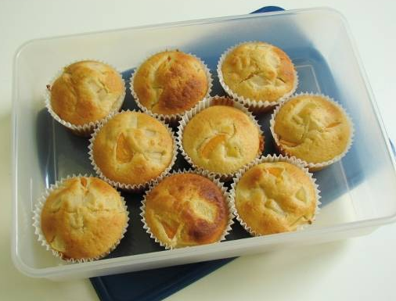
2 x 5ml spoons baking powder
100g caster sugar
230ml semi-skimmed milk
1 egg
60ml oil
150g canned fruit (in juice)

Equipment
12 muffin cases, muffin tin, weighing scales, measuring spoons, measuring jug, mixing bowl, wooden spoons, can opener, 2 spoons, cooling rack.

Method
- Preheat oven to 180°C or gas mark 4
- Mix all the ingredients together to form a smooth batter.
- Drain the juice from the canned fruit.
- Stir in the fruit.
- Divide the mixture equally between the muffin cases using 2 spoons.
- Bake for 20-25 minutes, until golden.
- Allow to cool on a cooling rack.

Top tips
- Vary the type of fruit you use. Try bananas, cherries or blueberries. Go for fresh, frozen, canned or dried fruits.
- Experiment with different spices, such as cinnamon, ginger or mixed spice.

Food skills
- Weigh.
- Measure.
- Mix, stir and combine.
- Drain.
- Divide.
- Bake.

This recipe is from the original Licence to Cook programme and is provided under the Open Government Licence.

