Sustainable healthy diets pick and mix
  Design your future farm. It should be able to produce food effectively considering climate change.  Consider your crop choices, water management, energy use and waste management.  Draw your farm including features like greenhouses, water -saving systems, renewable energy sources or sustainable practices. |   Have a food waste review.  Track your food waste over a week. Note down the type of food wasted, how much and the reason why.  After the review, create a list of all leftover foods from the week.  Develop a recipe using the leftovers from the week. |   Biodiversity is a measure of how many different species live in an ecosystem.  We need to protect biodiversity as it is under threat from many different factors.  Research the top five threats to biodiversity in relation to food production. Identify solutions to reduce the threats. | 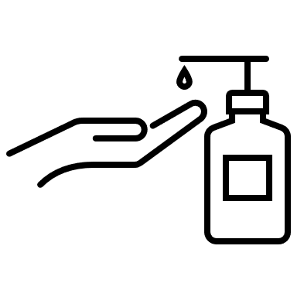  Create a 3-minute video based on a region or country regarding their food security.  You should focus on;  the current food safety situation, challenges affecting food safety and solutions that have been implemented to address food security and, in particular, food safety in their area.
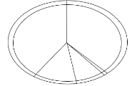  Create a sustainable meal plan for one week that follows the Eatwell Guide.  Include sustainable food choices e.g. plant-rich meals, seasonal foods and locally soured ingredients.  Also consider how food waste can be reduced or whether leftovers be transformed into new and exciting dishes. |   Food traditions can be adapted to reduce environmental impact.  Pick a country with a distinctive food tradition. Choose a traditional meal from that country and explore how it can be made more sustainable.  Consider if the ingredients are more sustainable, e.g. locally sourced or seasonal? Are the cooking techniques sustainable? | 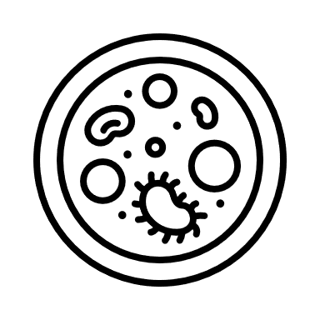  You have been employed by a local farmer who is concerned about protecting the soil health of his land.  Investigate and create a sustainable soil management plan.  Include five pieces of advice which the farmer can implement. | 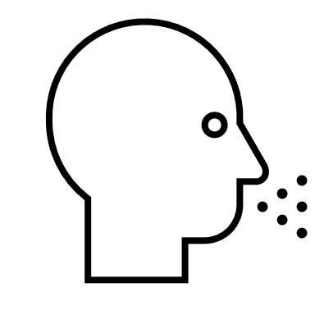  A sustainable, healthy balanced diet is important to reduce the risk of diet related ill health.  A family eats mostly processed foods, high in fat, sugars and salt.  Produce a set of guidelines which the family could follow to help improve their diet and reduce the risk of diet-related diseases.
Try these sustainable healthy diets activities from this pick and mix selection!

