Fruit fusion

Ingredients
Complexity: Low-medium
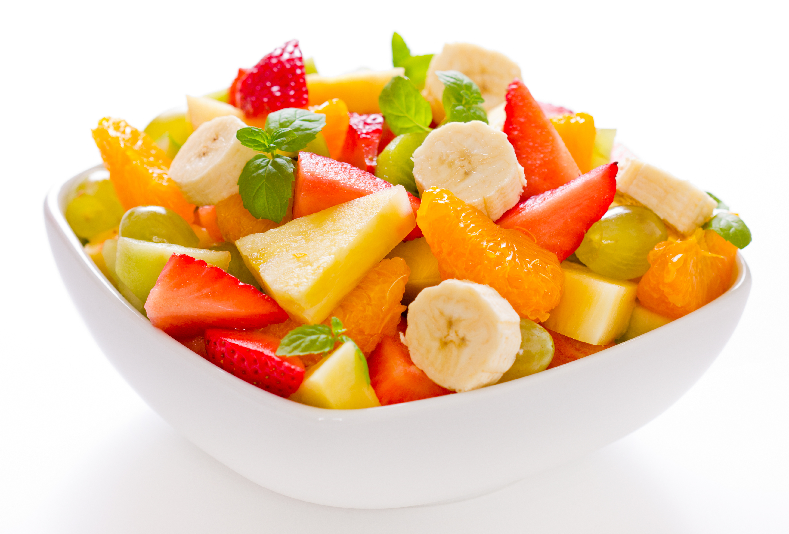
1 clementine
6 red grapes
6 green grapes
1 kiwi fruit
1 banana
1 apple
2 x 15ml spoons orange juice

Equipment
Knife, chopping board, bowl, measuring spoons, spoon.

Method
- Peel the clementine and separate into segments.
- Cut the grapes in half and remove any seeds.
- Peel the kiwi fruit and slice.
- Peel the banana and slice.
- Quarter the apple, remove the core and slice.
- Place all the fruit in a bowl.
- Add the orange juice and mix together.

Top tips
- Try using different types of fruit such as sliced peaches, chunks of fresh mango or canned pineapple pieces.
- Use other types of fruit juice instead of orange juice.
- Cut the fruit into very small, even sized pieces to make a fruit cocktail.
- Wash the grapes and apple before using them.

Food skills
- Measure
- Peel.
- Cut and slice.
- Core.
- Mix.

This recipe is from the original Licence to Cook programme and is provided under the Open Government Licence.

