Raita
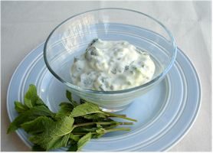
Ingredients
150ml low fat plain yogurt
Complexity: low
¼ cucumber
4-5 sprigs of mint

Equipment
Chopping board, grater, knife, mixing spoon, mixing bowl.

Method
- Grate the cucumber.
- Chop the mint.
- Stir all the ingredients together in a mixing bowl.

Top tips
- Try adding a pinch of ground cumin seeds or cayenne pepper to add a kick.

Food skills
- Weigh
- Measure.
- Grate.
- Chop.
- Stir.

