Tomato, bean and pasta soup
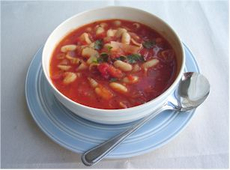
Ingredients
1 onion
Complexity: medium
2 celery sticks
1 clove of garlic
Spray oil
2 large cans chopped tomatoes
1x5ml spoon mixed herbs
1 can cannellini beans
600ml water (1 reduced salt stock cube, optional)
50g small pasta shells
A few fresh basil leaves
Parmesan cheese, grated (optional)
Black pepper to taste

Equipment
Chopping board, knife, measuring spoons, garlic press, can opener, saucepan, wooden spoon.

Method
- Prepare the vegetables:
  - peel and finely dice the onion;
  - wash and slice the celery;
  - peel and crush the garlic.
- Fry the onions, celery, and garlic in the oil for 3-4 minutes until soft.
- Add the canned tomatoes and herbs.
- Simmer gently for about 10 minutes, covered, stirring occasionally.
- Drain the beans and to the pan with the water.
- Add the stock cube if using.
- Bring to the boil and then simmer for 20 minutes.
- Add the pasta and cook for another 5–10 minutes, until the pasta is cooked.
- Taste the soup and season with black pepper, if liked.
- Serve the soup. Pour into a bowl and sprinkle with torn basil leaves and parmesan cheese, if desired.

Top tips
- Replace the beans with chopped courgette or peppers.
- Add plenty of vegetables, rice, pasta or lentils to make it go further.
- Swap the pasta for rice or potatoes.
- Allow the soup to cool and freeze in a suitable container.

Food skills
- Weigh.
- Measure.
- Peel.
- Dice and slice.
- Crush.
- Fry.
- Stir.
- Boil and simmer.

