Tortilla toasties
Ingredients
2 tortillas
Complexity: low-medium
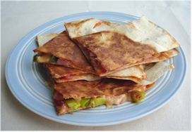
1x10ml spoon tomato sauce topping
25g sliced cheese, e.g. Cheddar, Emmental
1 slice ham (optional)
1 spring onion

Equipment
Chopping board, knife, non-stick frying pan, measuring spoon, fish slice.

Method
- Prepare the filling:
  - top and tail the spring onion and slice into rings;
  - chop the ham into small pieces.
- Place one of the tortillas in the pan.
- Spread the tomato sauce over the tortilla.
- Arrange the ham, spring onion and cheese over the tortilla.
- Cook for 5 minutes, or until the cheese starts to melt.
- Place the 2nd tortilla on top.
- Flip the tortilla over and cook for 4-5 minutes.
- Serve.

Top tips
- Add chilli for a kick.
- Be adventurous - try adding tuna, pesto, mushrooms, tomatoes, red onion, green pepper, courgette, sweetcorn, chicken or sliced beef.
- Use different varieties of tortilla, e.g. wholemeal, tomato.
- Freeze a pack of tortillas and use only what you need.
- Use left overs in your toasties!

Food skills
- Weigh.
- Measure.
- Trim, slice and chop.
- Spread.
- Grate.
- Fry.

