Fruit jelly
Ingredients
1 pack sugar free raspberry jelly
Complexity: low
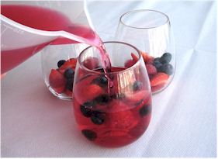
50g strawberries
50g raspberries
25g blueberries (optional)

Equipment
Measuring jug, spoon, chopping board, knife, large bowl, four glasses/small bowls.

Method
- Make up the jelly, as per instructions on the packaging.
- Wash the fruit.
- Remove the green stalk from the strawberries and cut into quarters.
- Place the fruit into a large bowl or individual small bowls/glasses.
- Pour the jelly over the fruit.
- Allow to cool, then set in the fridge.

Top tips
- Use different types of jelly and fresh fruit.
- Canned fruit (in natural juice) could be used.
- Be creative! Why not use different flavoured jelly and make a layered desert?

Food skills
- Weigh.
- Measure.
- Cut and slice.
- Stir.
- Chill.

