Fruit smoothie
Ingredients
6 large strawberries
Complexity: low
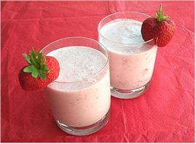
300ml semi-skimmed cold milk
1 small pot of reduced fat yogurt

Equipment
Small knife, chopping board, blender, measuring jug, spoon, two glasses.

Method
- Remove the green tops from the strawberries.
- Slice the strawberries.
- Place the strawberries into the blender.
- Pour the milk and spoon in the yogurt into the blender.
- Put the lid on the blender and switch on for 30-45 seconds, until smooth.
- Pour the smoothie into two glasses.

Top tips
- Remember that smoothies and fruit juice count towards your 5 A DAY but you should only drink a combined maximum of 150ml a day.
- You may wish to use fresh fruits that are in season, or add frozen or canned fruit. Try experimenting with different fruits and flavours of yogurt, such as banana and vanilla or orange and mango.
- Hold the lid of the blender with a clean dishcloth.
- Always get help from an adult when using a blender.

Food skills
- Measure.
- Cut and slice.
- Blend.

