Greek yogurt with honey
Ingredients
1x15ml spoon flaked almonds
Complexity: low-medium
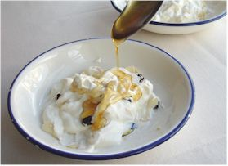
200ml 0% or low fat Greek yogurt
1x15ml spoon raisins
1x10ml spoon honey

Equipment
Baking tray, foil, measuring spoons, spoon, two serving dishes.

Method
- Toast the almonds:
  - heat the grill;
  - line a baking tray with foil;
  - scatter with almond flakes and toast.
- Scoop the yogurt into 2 small serving dishes.
- Stir-in the toasted almonds and raisins.
- Drizzle the honey on top.

Top tips
- Almonds burn easily, so do not leave them unattended.
- You could buy almonds that are already toasted.

Food skills
- Measure.
- Grill.
- Stir.

