Hummus, pepper and grated carrot

pockets
Ingredients
½ red or green pepper
Complexity: low-medium
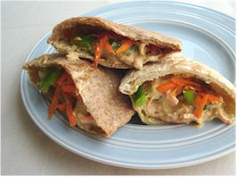
1 ½ carrot
2-3x15ml spoons of reduced fat hummus
2 wholemeal pitta breads

Equipment
Chopping board, knife, vegetable peeler, grater, measuring spoon, small bowl.

Method
- Prepare the filling:
- wash the pepper and carrot;
- deseed the pepper and cut into long thin strips;
- top, tail and peel the carrot;
- grate the carrot.
- Mix the hummus with the carrot and pepper.
- Cut the pitas in half.
- Spoon the hummus mix between the pitta bread.

Top tips
- You may like to toast the pitta bread before filling.
- Use different types of pitta bread, e.g. garlic, wholemeal.
- Vary the crunchy vegetables and fruit in the pockets, e.g. celery, spring onion, grated apple.
- Want to try something different? Go for a tuna-mayo mix, reduced fat grated cheese or sliced hard-boiled egg.

Food skills
- Measure.
- Cut and trim.
- Peel.
- Grate.
- Mix.

