Fruit pancakes
Ingredients
Complexity: low-medium
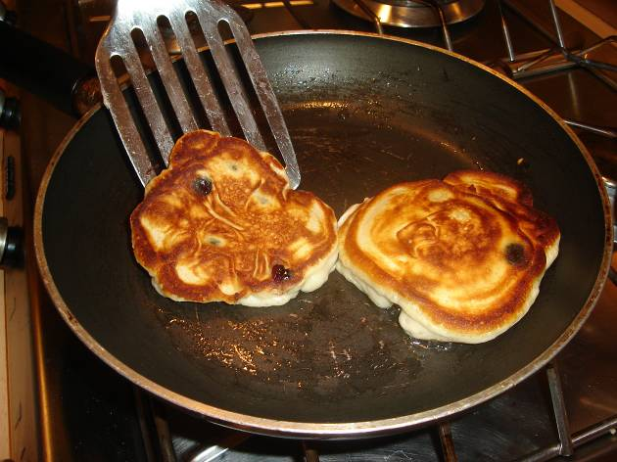
50g fruit, e.g. blueberries, raspberries, banana
125g self-raising flour
1x15ml spoon sugar
1 egg
180ml semi-skimmed milk
Spray oil

Equipment
Chopping board, knife, sieve, whisk, bowl, measuring jug, non-stick frying pan, fish slice, metal spoon.

Method
- Chop the fruit into small chunks or keep whole (depending on size of fruit).
- Sift the flour into a bowl and add the sugar.
- Whisk in the egg and milk.
- Stir in the fruit.
- Heat the frying pan and add a little spray oil.
- Pour in 2x15ml spoons of mixture for each pancake.
- Cook for 2 minutes, until golden, and turn over.
- Cook for a further minute.
- Serve.

Top tips
- Instead of using sugar, try adding a small amount of sweetener instead.
- Use half wholemeal and half white self-raising flour for added fibre.
- Remove the sugar and add chopped ham and sweetcorn instead of the fruit for a savoury version.

Food skills
- Weigh.
- Measure.
- Sift.
- Whisk.
- Fry.

