Herby mash
Ingredients
Complexity: low-medium
250g potatoes
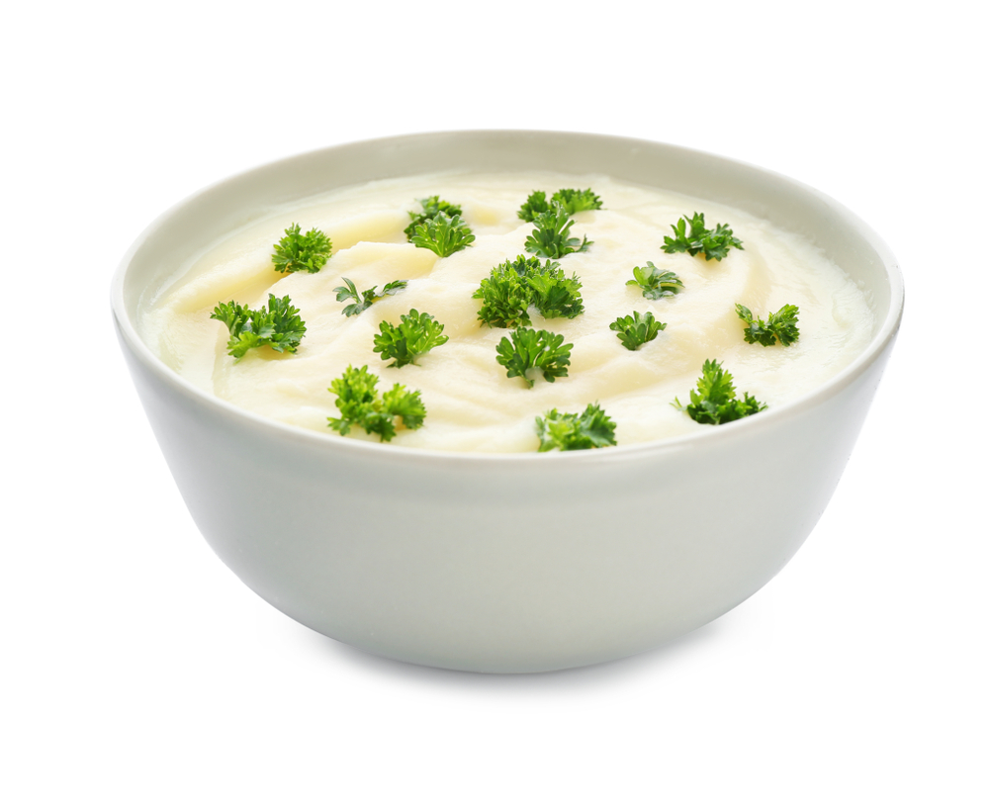
50ml semi-skimmed milk
Handful of parsley
Black pepper

Equipment
Vegetable peeler, chopping board, knife, saucepan, colander, potato masher.

Method
- Peel the potatoes. Cut in half.
- Bring potatoes to the boil, simmer until tender (about 15-20 minutes).
- Drain the potatoes using a colander.
- Mash the potatoes with the milk until smooth.
- Stir in the parsley.

Top tips
- Add a spoon of grainy mustard for a twist.
- Stir in chopped spring onions for extra crunch.
- Add interest by adding parsley, reduced fat cheese or mustard.
- Add cooked vegetables, like cabbage or Brussels sprouts.

Food skills
- Peel.
- Cut.
- Boil and simmer.
- Drain.
- Mash.
- Stir.

